Unit 6 Lesson 13: Graphing the Standard Form (Part 2)

1 Equivalent Expressions (Warm up)

Student Task Statement
- Complete each row with an equivalent expression in standard form or factored form.
- standard form | - factored form
- $x^{2}$
 | - $x(x+9)$
- $x^{2}−18x$
 | - $x(6−x)$
- $\text{-}x^{2}+10x$
 | - $\text{-}x(x+2.75)$
- What do the quadratic expressions in each column have in common (besides the fact that everything in the left column is in standard form and everything in the other column is in factored form)? Be prepared to share your observations.

2 What about the Linear Term? (Optional)

Student Task Statement
- Using graphing technology:
  - Graph $y=x^{2}$, and then experiment with adding different linear terms (for example, $x^{2}+4x$, $x^{2}+20x$, $x^{2}−50x$). Record your observations.
  - Graph $y=\text{-}x^{2}$, and then experiment with adding different linear terms. Record your observations.
- Use your observations to help you complete the table without graphing the equations.
- equation | - $x$-intercepts | - $x$-coordinate of vertex
- $y=x^{2}+6x$
- $y=x^{2}−10x$
- $y=\text{-}x^{2}+50x$
- $y=\text{-}x^{2}−36x$
- Some quadratic expressions have no linear terms. Find the $x$-intercepts and the $x$-coordinate of the vertex of the graph representing each equation. (Note it is possible for the graph to not intersect the $x$-axis.) If you get stuck, try graphing the equations.
  - $y=x^{2}−25$
  - $y=x^{2}+16$

3 Writing Equations to Match Graphs (Optional)

Student Task Statement
Use graphing technology to graph a function that matches each given graph. Make sure your graph goes through all 3 points shown!

A
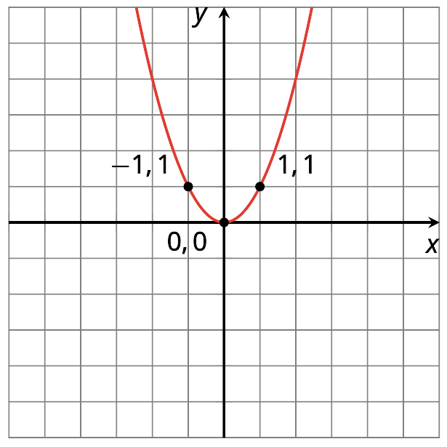
Equation:

B
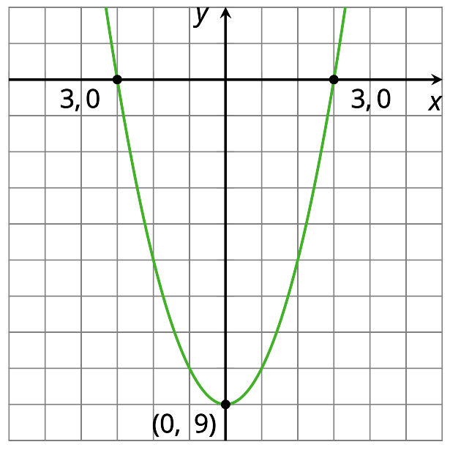
Equation:

C
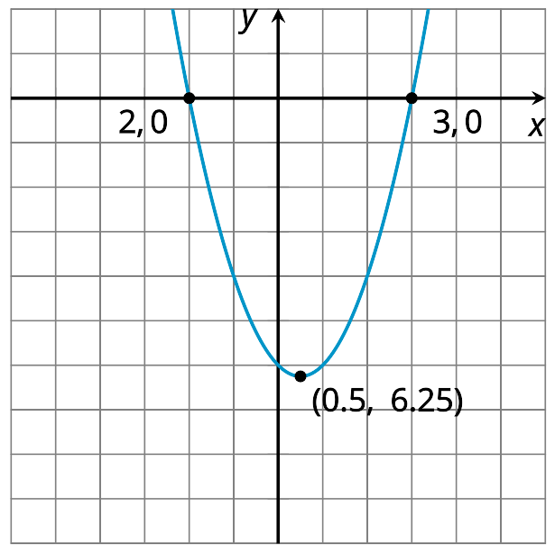
Equation:

D
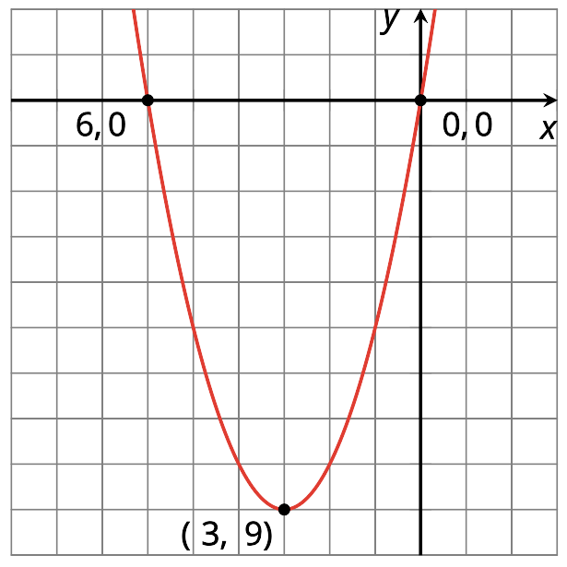
Equation:

E
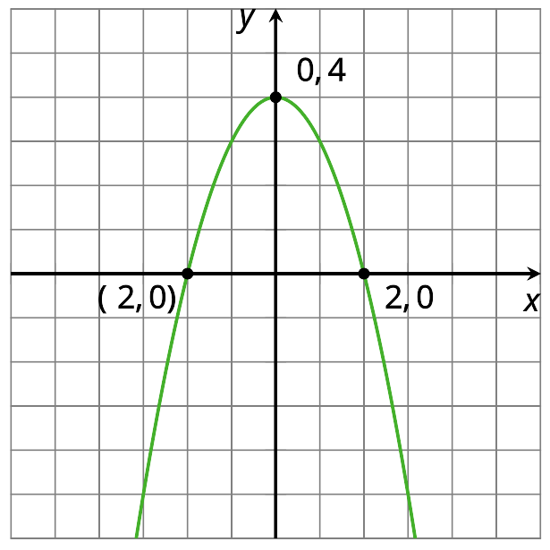
Equation:

F
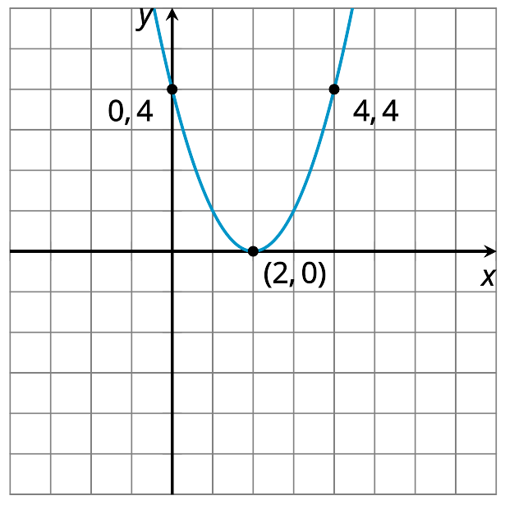
Equation:

G
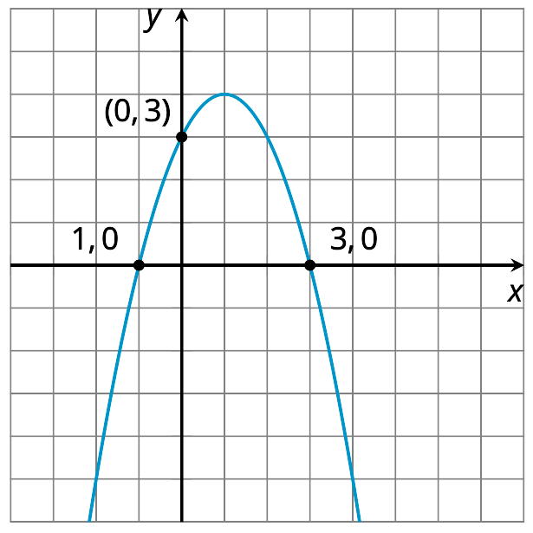
Equation:

H
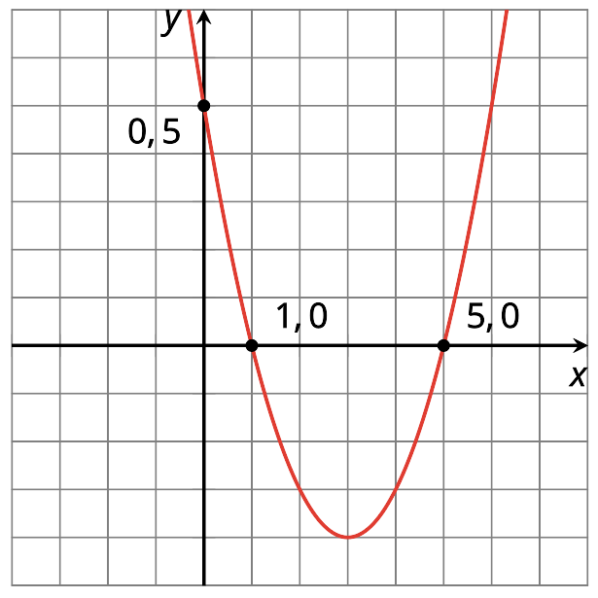
Equation:

I
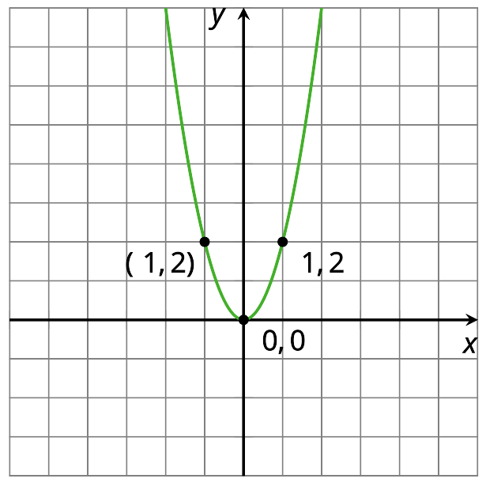
Equation:

J
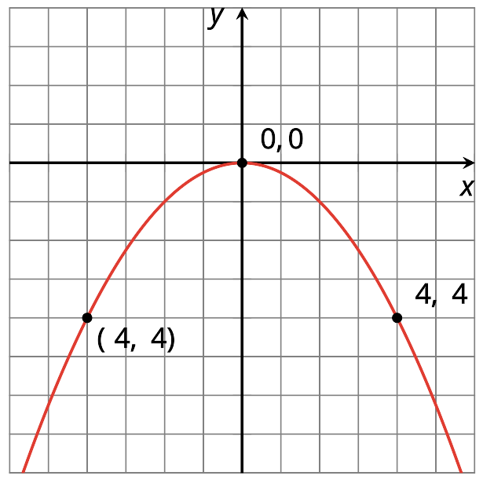
Equation:
© CC BY 2019 by Illustrative Mathematics

