Lesson 5: Represent Products as Areas
- Let’s connect multiplication expressions to area.

Warm-up: How Many Do You See: One More
How many do you see? How do you see them?
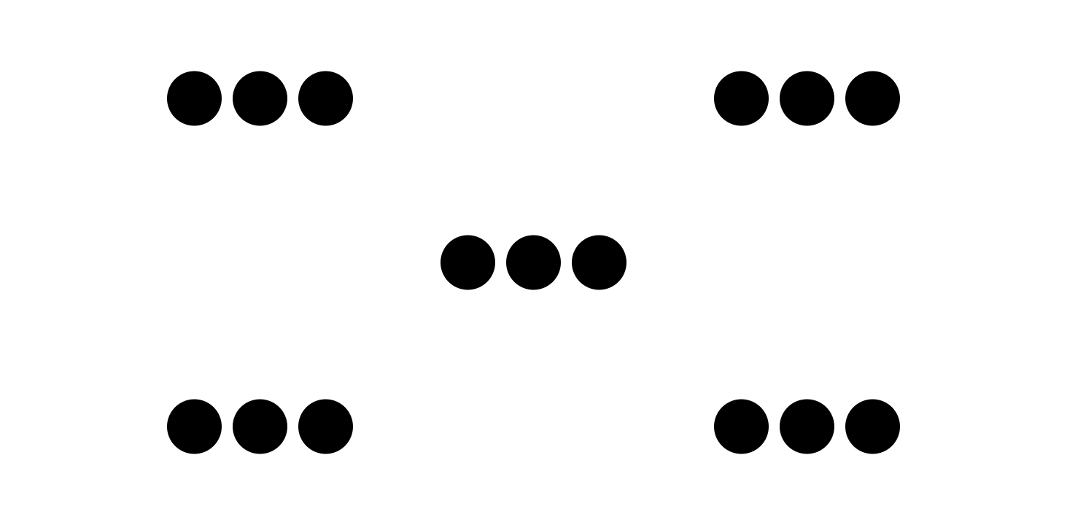
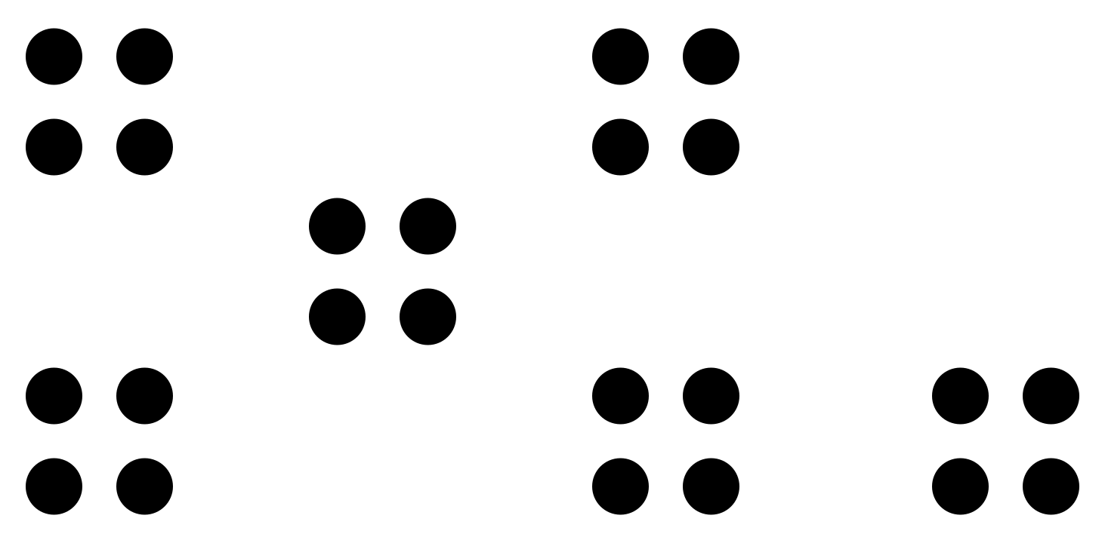

5.1: Match Expressions and Areas
Your teacher has posted images of rectangles around the room. Match each expression with a rectangle that can represent it. Be prepared to explain your reasoning.
- $9×5$
- $8×2$
- $7×10$
- $3×3$
- $2×6$
- $8×4$
- $5×7$

5.2: Create from Expressions
- The numbers in each expression represent the number of rows (or columns) in a rectangle and how many squares are in each row (or column).
- On the grid, draw each rectangle, label it with the numbers, and find its area.
  - $3×4$
  - $4×6$
  - $6×3$
  - $7×4$
  - $3×2$
- Explain why multiplying the numbers in each expression gives us the area of the rectangle.
© CC BY 2021 Illustrative Mathematics®

