Unit 7 Lesson 10: Angle Measurement and Perpendicular Lines

WU Number Talk: Quotients (Warm up)

Student Task Statement
Find the value of each expression mentally.
- $180÷2$
- $180÷4$
- $360÷8$
- $360÷16$

1 Angles Here, There, Everywhere

Student Task Statement
- Use a protractor to find the value of each angle measurement in degrees.
- 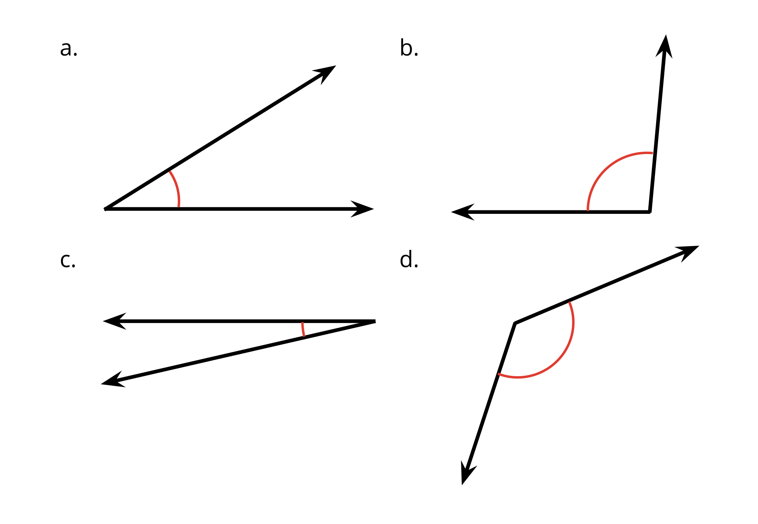
- Use a protractor to measure the labeled angles in each figure.
- 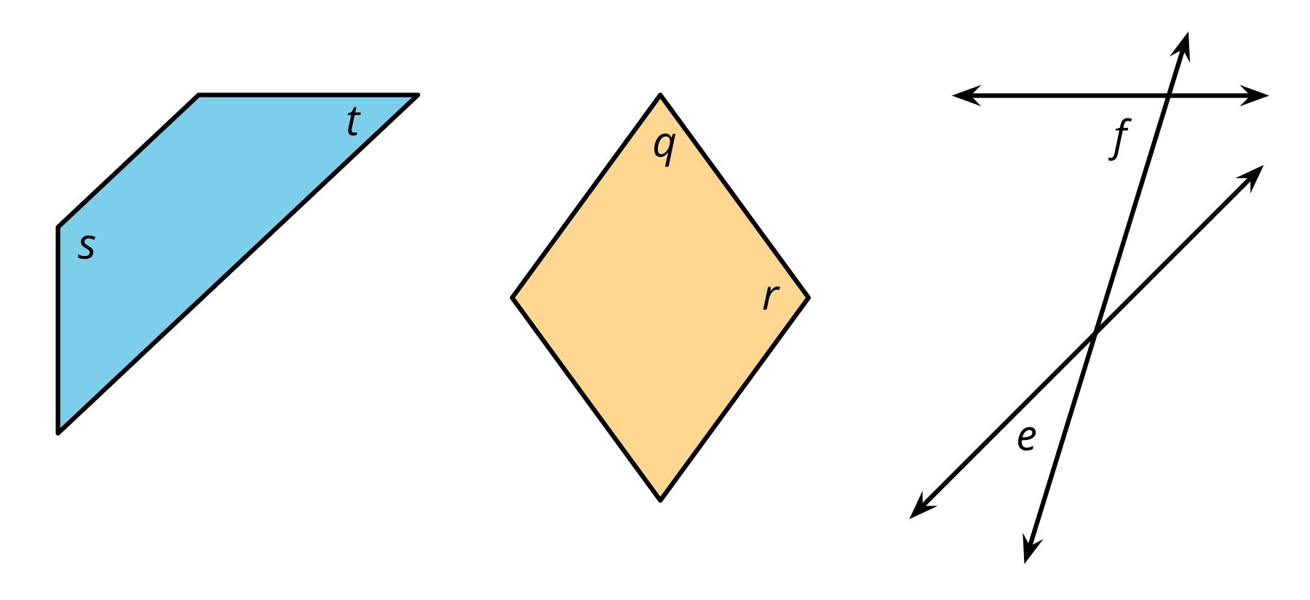

2 A Folding Challenge

Student Task Statement
Tyler gave Lin a challenge: “Without using a protractor, draw four ${90}^{∘}$ angles. All angles have their vertex at point $P$.”
Lin folded the paper twice, making sure each fold goes through point $P$. Then, she traced the creases.
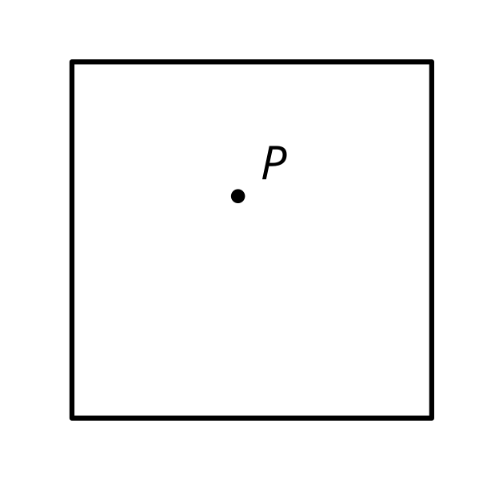
- Your teacher will give you a sheet of paper. Draw a point on it. Then, show how Lin might have met the challenge.
- When Lin folded the paper, the creases formed a pair of perpendicular lines. What do you think “perpendicular lines” mean?
- Use Lin’s method to create a new pair of perpendicular lines through the same point. Trace the creases with a different color. Be prepared to explain how you know the lines you created are perpendicular.
- Which shapes have sides that are perpendicular to one another?
- 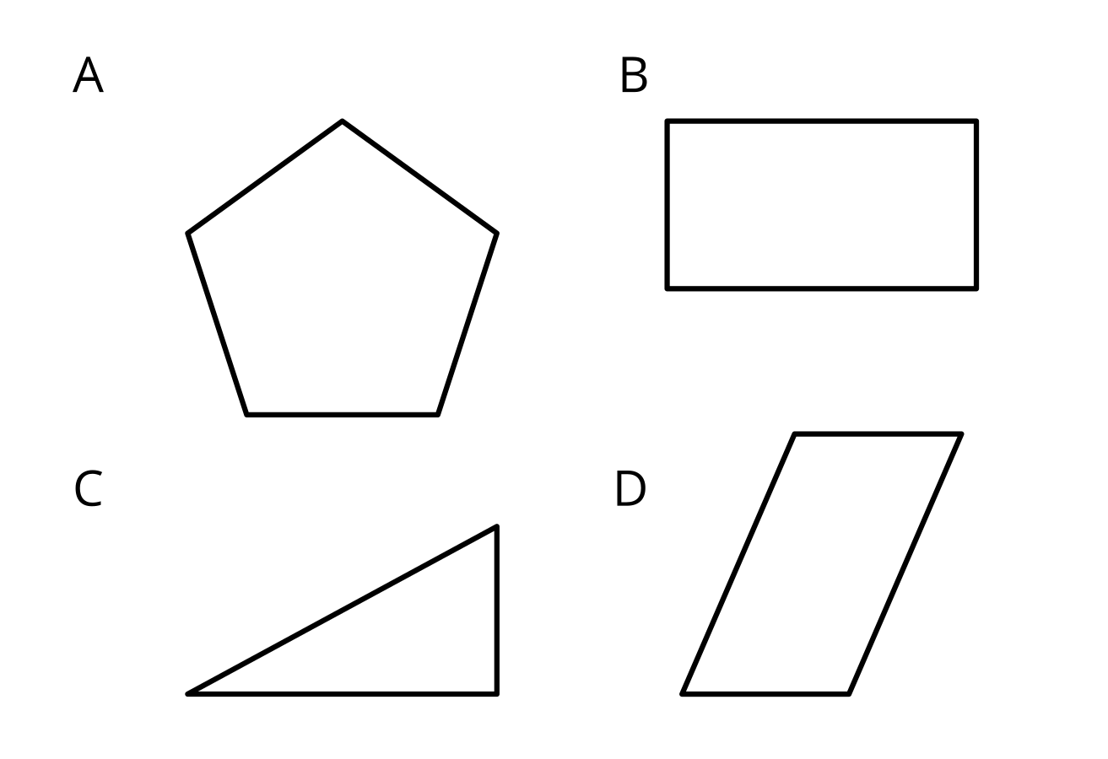
- Mark the perpendicular sides. Be prepared to explain how you know the sides are perpendicular.

Images for Activity Synthesis
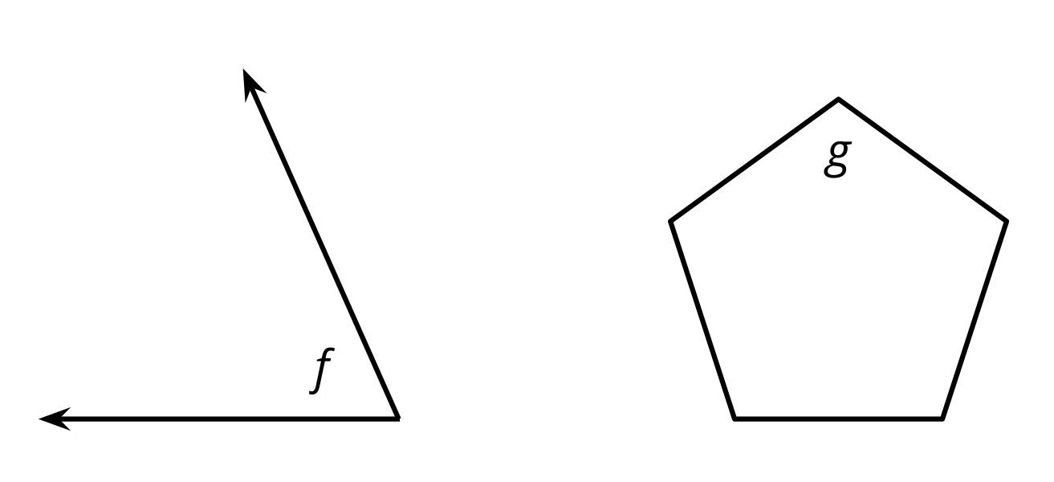
© CC BY 2021 Illustrative Mathematics®

