Unit 2 Lesson 3 Cumulative Practice Problems
- Noah is running a portion of a marathon at a constant speed of 6 miles per hour.
- Complete the table to predict how long it would take him to run different distances at that speed, and how far he would run in different time intervals.
- time  in hours | - miles traveled at  6 miles per hour
- 1
- $\frac{1}{2}$
- $1\frac{1}{3}$
 | - $1\frac{1}{2}$
 | - 9
 | - $4\frac{1}{2}$
- One kilometer is 1000 meters.
  - Complete the tables. What is the interpretation of the constant of proportionality in each case?
- meters | - kilometers
- 1,000 | - 1
  - 250
  - 12
  - 1
- kilometers | - meters
- 1 | - 1,000
  - 5
  - 20
  - 0.3
  - The constant of proportionality tells us that:
  - The constant of proportionality tells us that:
  - What is the relationship between the two constants of proportionality?
- Jada and Lin are comparing inches and feet. Jada says that the constant of proportionality is 12. Lin says it is $\frac{1}{12}$. Do you agree with either of them? Explain your reasoning.
- The area of the Mojave desert is 25,000 square miles. A scale drawing of the Mojave desert has an area of 10 square inches. What is the scale of the map?
- (From Unit 1, Lesson 12.)
- Which of these scales is equivalent to the scale 1 cm to 5 km? Select all that apply.
  - 3 cm to 15 km
  - 1 mm to 150 km
  - 5 cm to 1 km
  - 5 mm to 2.5 km
  - 1 mm to 500 m
- (From Unit 1, Lesson 11.)
- Which one of these pictures is not like the others? Explain what makes it different using ratios.
- 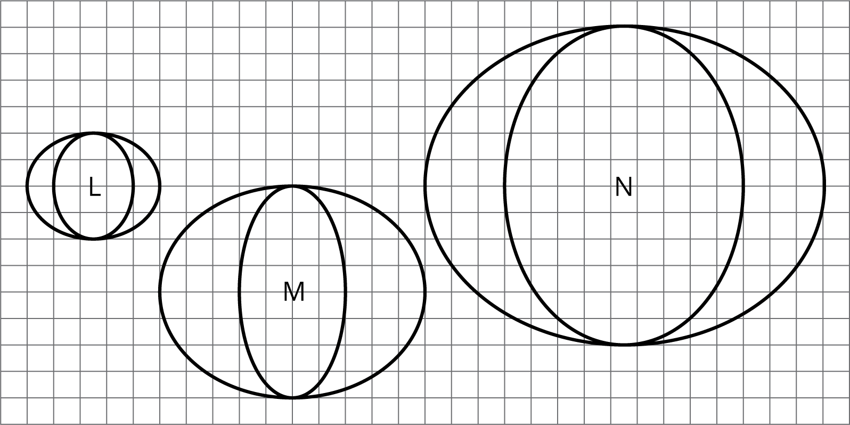
- (From Unit 2, Lesson 1.)
© CC BY Open Up Resources. Adaptations CC BY IM.

