## Unit 1 Lesson 2: Corresponding Parts and Scale Factors

### 1 Number Talk: Multiplying by a Unit Fraction (Warm up)

#### Student Task Statement

Find each product mentally.

### 2 Corresponding Parts

#### Student Task Statement

Here is a figure and two copies, each with some points labeled.

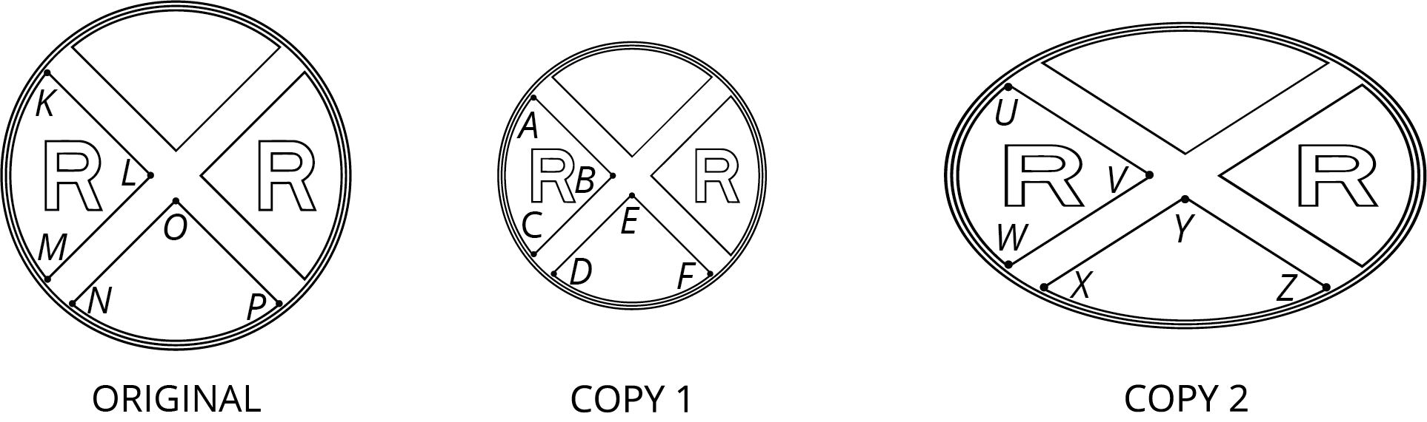

1. Complete this table to show **corresponding parts** in the three figures.

|  |  |  |
| --- | --- | --- |
| * original | * copy 1 | * copy 2 |
| * point |  |  |
| * segment |  |  |
|  | * segment |  |
|  |  | * point |
| * angle |  |  |
|  |  | * angle |

1. Is either copy a scaled copy of the original figure? Explain your reasoning.
2. Use tracing paper to compare angle  with its corresponding angles in Copy 1 and Copy 2. What do you notice?
3. Use tracing paper to compare angle with its corresponding angles in Copy 1 and Copy 2. What do you notice?

### 3 Scaled Triangles

#### Student Task Statement

Here is Triangle O, followed by a number of other triangles.

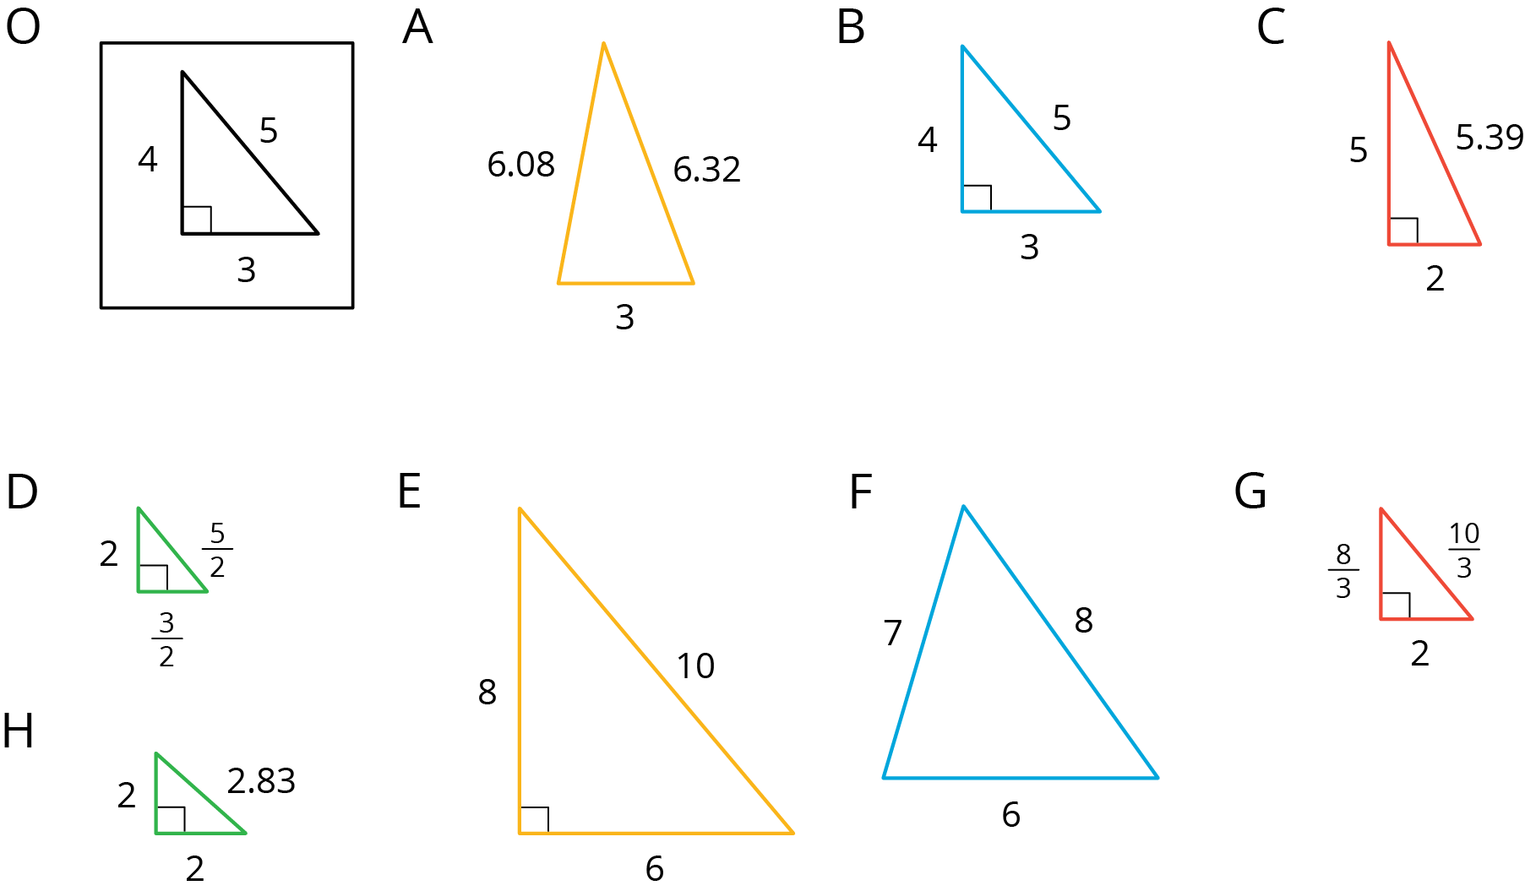

Your teacher will assign you two of the triangles to look at.

1. For each of your assigned triangles, is it a scaled copy of Triangle O? Be prepared to explain your reasoning.
2. As a group, identify *all* the scaled copies of Triangle O in the collection. Discuss your thinking. If you disagree, work to reach an agreement.
3. List all the triangles that are scaled copies in the table. Record the side lengths that correspond to the side lengths of Triangle O listed in each column.

|  |  |  |  |
| --- | --- | --- | --- |
| * Triangle O | * 3 | * 4 | * 5 |
|  |  |  |  |
|  |  |  |  |
|  |  |  |  |
|  |  |  |  |

1. Explain or show how each copy has been scaled from the original (Triangle O).

#### Activity Synthesis

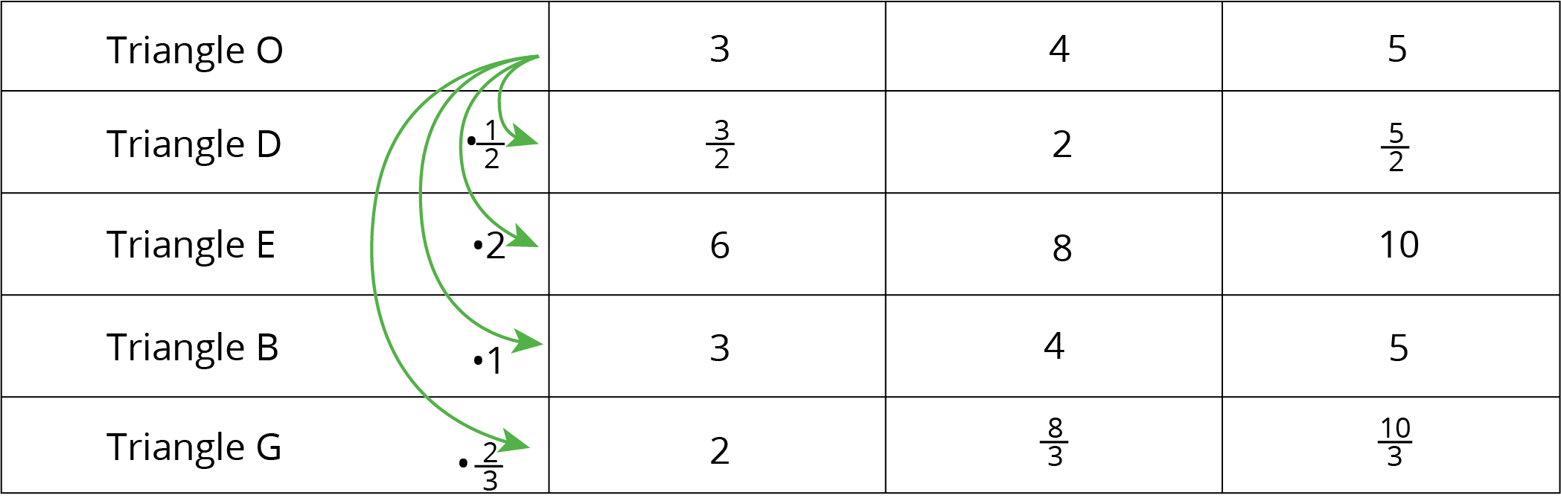

#### Images for Activity Synthesis

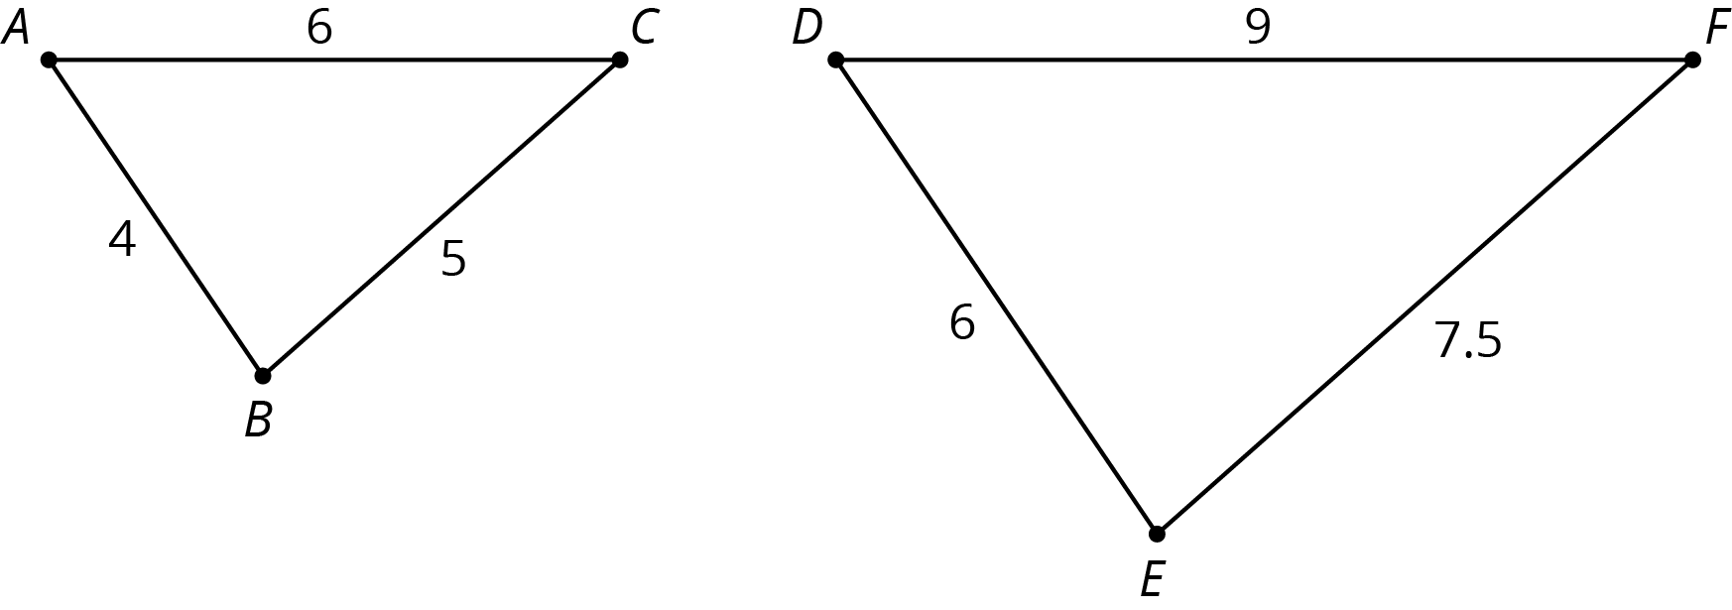



© CC BY Open Up Resources. Adaptations CC BY IM.