Lesson 15 Practice Problems
- Twenty students participated in a psychology experiment which measured their heart rates in two different situations.
- 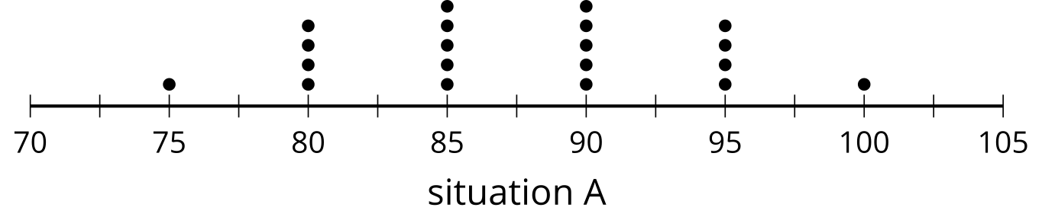
- 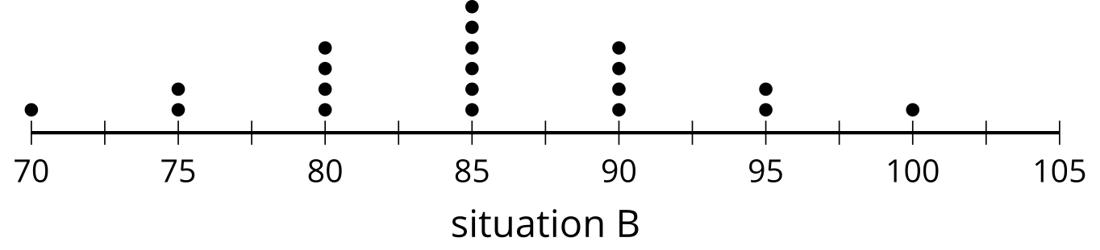
  - What are the appropriate measures of center and variability to use with the data? Explain your reasoning.
  - Which situation shows a greater typical heart rate?
  - Which situation shows greater variability?

  - Invent two situations that you think would result in distributions with similar measures of variability. Explain your reasoning.
  - Invent two situations that you think would result in distributions with different measures of variability. Explain your reasoning.
- The data set and some summary statistics are listed.
- 11.5, 12.3, 13.5, 15.6, 16.7, 17.2, 18.4, 19, 19.5, 21.5
  - mean: 16.52
  - median: 16.95
  - standard deviation: 3.11
  - IQR: 5.5
  - How does adding 5 to each of the values in the data set impact the shape of the distribution?
  - How does adding 5 to each of the values in the data set impact the measures of center?
  - How does adding 5 to each of the values in the data set impact the measures of variability?
- Here are two box plots:
- 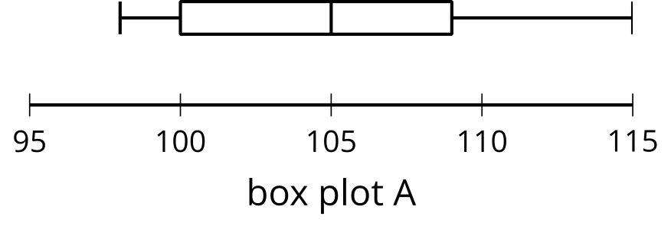
- 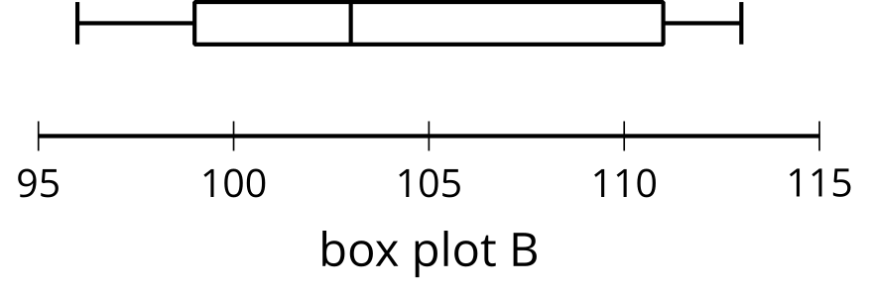
  - Which box plot has a greater median?
  - Which box plot has a greater measure of variability?
- The depth of two lakes is measured at multiple spots. For the first lake, the mean depth is about 45 feet with a standard deviation of 8 feet. For the second lake, the mean depth is about 60 feet with a standard deviation of 27 feet.
- Noah says the second lake is generally deeper than the first lake. Do you agree with Noah?
- (From Unit 1, Lesson 13.)
- The dot plots display the height, rounded to the nearest foot, of maple trees from two different tree farms.
- 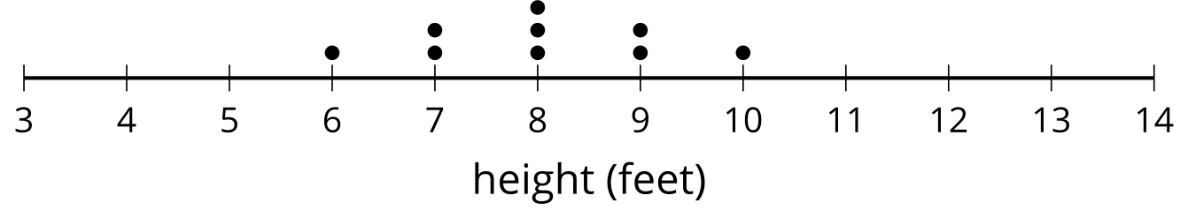
- 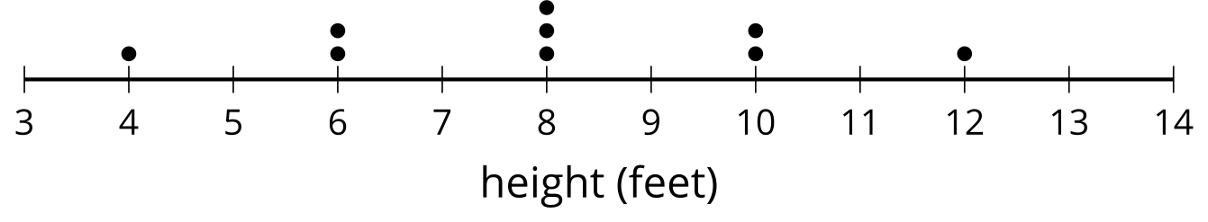
  - Compare the mean and standard deviation of the two data sets.
  - What does the standard deviation tell you about the trees at these farms?
- (From Unit 1, Lesson 12.)
- Which box plot has an IQR of 10?
  - 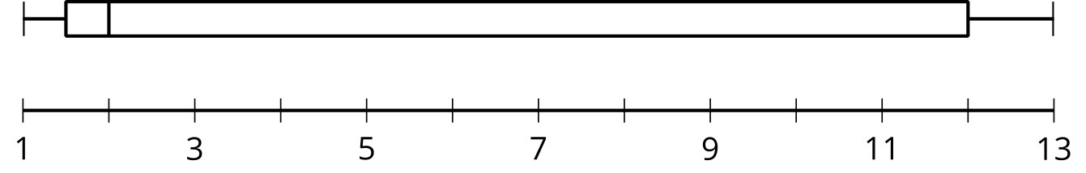
  - 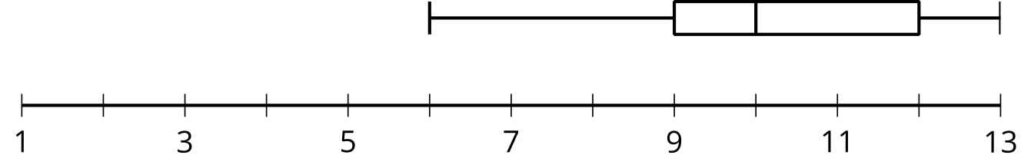
  - 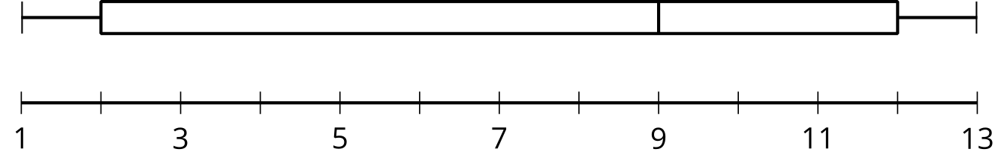
  - 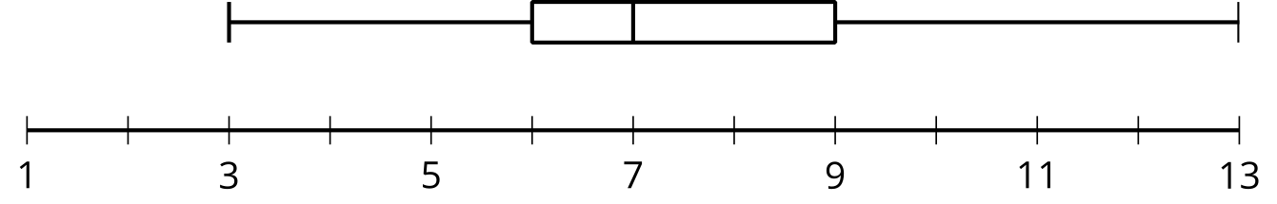
- (From Unit 1, Lesson 11.)
- What effect does eliminating the lowest value, -6, from the data set have on the mean and median?
- -6, 3, 3, 3, 3, 5, 6, 6, 8, 10
- (From Unit 1, Lesson 9.)
© CC BY 2019 by Illustrative Mathematics®

