Lesson 6 Practice Problems
- Find a sequence of rigid motions and dilations that takes square $ABCD$ to square $EFGH$.
- 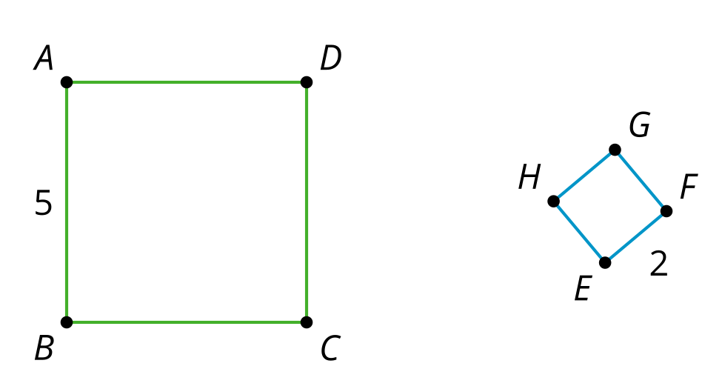
- Quadrilaterals $Q$ and $P$ are similar.
  - What is the scale factor of the dilation that takes $P$ to $Q$?
  - What is the scale factor of the dilation that takes $Q$ to $P$?
- 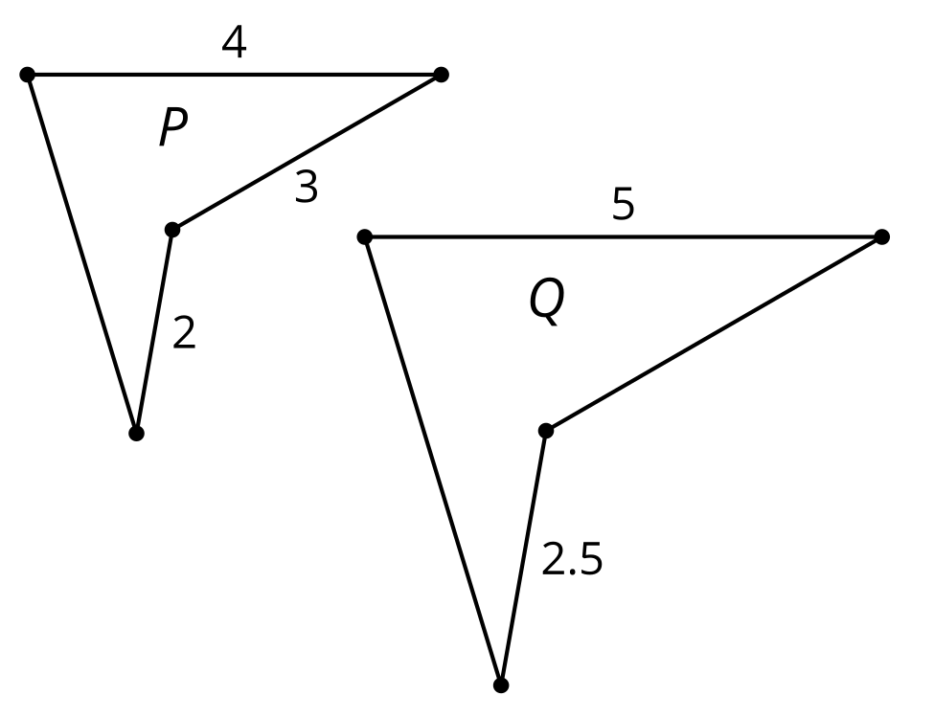
- What is our definition of similarity?
  - If 2 figures have the same angles, then they are similar.
  - If 2 figures have proportional side lengths, then they are similar.
  - If there is a sequence of rigid transformations taking one figure to another, then they are similar.
  - If there is a sequence of rigid transformations and dilations that take one figure to the other, then they are similar.
- Triangle $DEF$ is formed by connecting the midpoints of the sides of triangle $ABC$. The lengths of the sides of $DEF$ are shown. What is the length of $BC$?
- 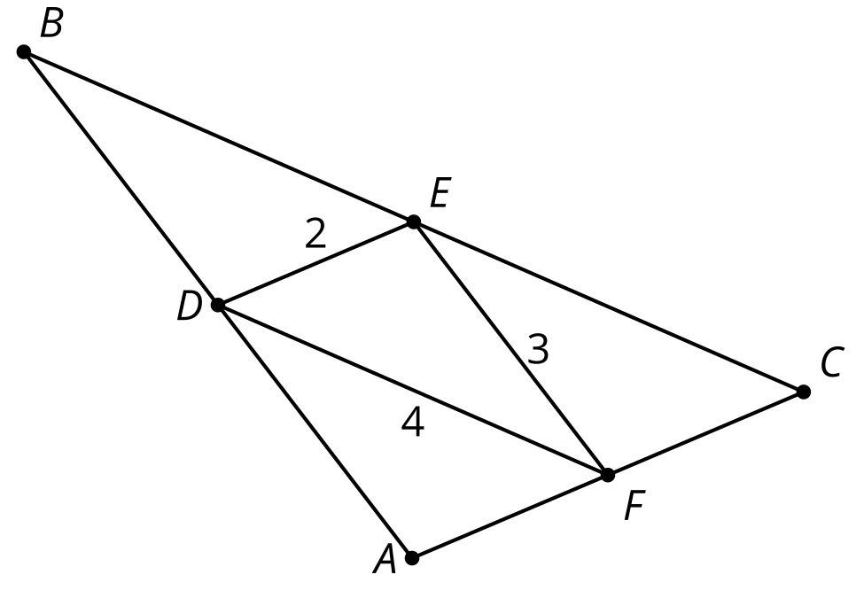
  - 3 units
  - 4 units
  - 6 units
  - 8 units
- (From Unit 3, Lesson 5.)
- If $AB$ is 12, what is the length of $A^{′}B^{′}$?
- 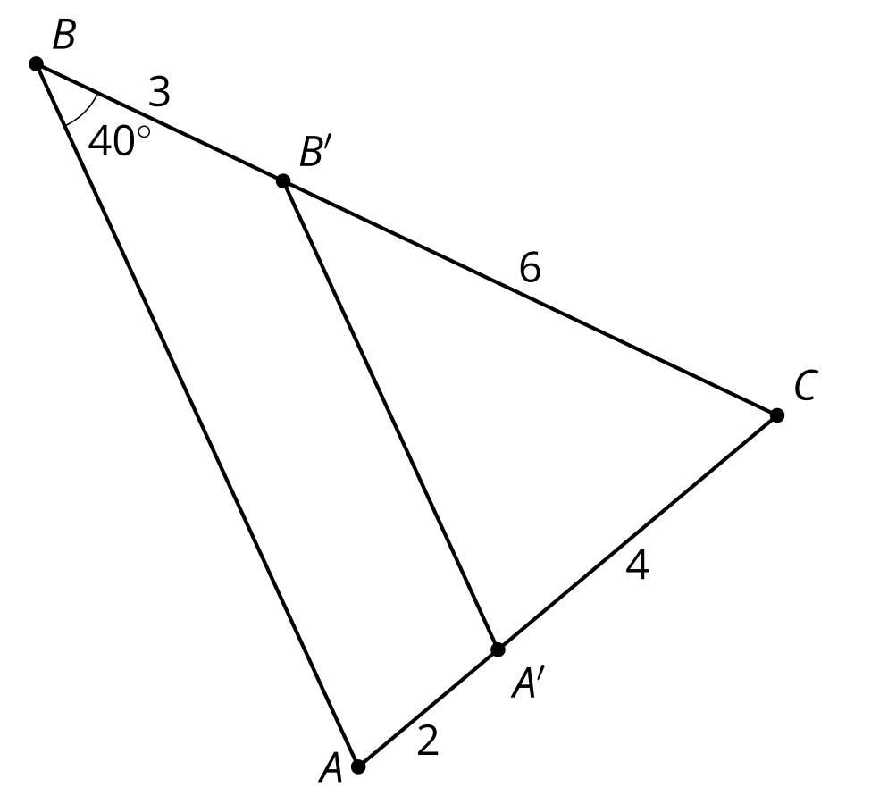
- (From Unit 3, Lesson 5.)
- Right angle $ABC$ is taken by a dilation with center $P$ and scale factor $\frac{1}{2}$ to angle $A^{′}B^{′}C^{′}$. What is the measure of angle $A^{′}B^{′}C^{′}$?
- (From Unit 3, Lesson 4.)

  - Dilate point $C$ using center $D$ and scale factor $\frac{3}{4}$.
  - Dilate segment $AB$ using center $D$ and scale factor $\frac{1}{2}$.
- 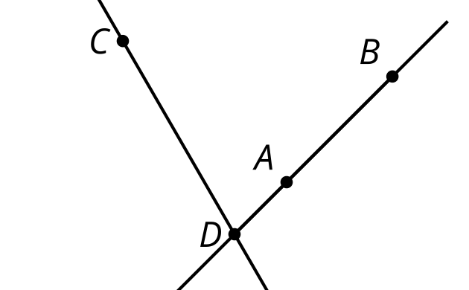
- (From Unit 3, Lesson 4.)
- A polygon has perimeter 12. It is dilated with a scale factor of $k$ and the resulting image has a perimeter of 8. What is the scale factor?
  - $\frac{1}{2}$
  - $\frac{2}{3}$
  - $\frac{3}{4}$
  - $\frac{4}{3}$
- (From Unit 3, Lesson 3.)
- Select all the statements that must be true.
  - Parallelograms have four congruent sides.
  - Both sets of opposite sides of a parallelogram are parallel and congruent.
  - A trapezoid is a parallelogram.
  - Diagonals of a parallelogram bisect each other.
  - Diagonals of a parallelogram are congruent.
- (From Unit 2, Lesson 13.)
© CC BY 2019 by Illustrative Mathematics®

