Lesson 6 Practice Problems
- The table displays the number and type of tickets bought for a play that was performed in both the afternoon and evening.
 | - child ticket | - adult ticket
- afternoon | - 36 | - 127
- evening | - 12 | - 188
- The addition rule states that given events A and B, $P\left(\text{A or B}\right)=P\left(\text{A}\right)+P\left(\text{B}\right)−P\left(\text{A and B}\right)$. Show how to apply the addition rule for the events “a child ticket is bought for a play” and “the play is performed in the afternoon.”
- A biologist studies two different invasive species, purple loosestrife and the common reed, at sites in both wetland and coastal habitats. Purple loosestrife is present in 35% of the sites. Common reed is present in 55% of the sites. Both purple loosestrife and common reed are present in 23% of the sites. What percentage of the sites have purple loosestrife or common reed present?
  - 12%
  - 22%
  - 67%
  - 90%
- 30 teachers and students participate in a student-faculty basketball game as a fundraiser. They are surveyed after the game by the sports medicine class to find out how many of them stretched before the game. The results of the survey are shown in the table.
 | - younger than 18 years old | - 18–30 years old | - more than 30 years old
- stretched before the game | - 5 | - 9 | - 4
- did not stretch before the game | - 10 | - 1 | - 1
- One of the sports medicine students, Han, wants to know the probability that one of the participants in the game selected at random is younger than 18 years old or stretched before the game. To figure this out, he adds the three values in the first row of the table (5, 9, and 4) to the two values listed under the heading “younger than 18 years old” (5 and 10). He then divides that answer by 30 and obtains a probability of $\frac{33}{30}$. Han realizes that $\frac{33}{30}$ is greater than 1 and determines that he must have made a mistake.
  - What is Han’s mistake? Explain your reasoning.
  - How does the addition rule account for this kind of mistake?
- Two classes of elementary school students were asked what activity they want to do during recess. Each student selects one recess option. The table summarizes the recess preference of each student in the class.
 | - tag | - playground | - kickball
- class A | - 2 | - 7 | - 9
- class B | - 7 | - 10 | - 5
  - What is the probability that a student selected at random prefers to play tag at recess?
  - What is the probability that a student selected at random prefers to play tag or kickball at recess?
  - What is the probability that a student in class A selected at random prefers to play kickball at recess?
  - What is the probability that a student selected at random is in class B and prefers to play tag at recess?
- (From Unit 8, Lesson 5.)
- A student picks a random letter from the word ”dog” and a random letter from the word ”barks.”
  - How many outcomes are in the sample space?
  - What is the probability that an “o” is chosen?
  - What is the probability that a “k” is chosen?
  - What is the probability that a “o” and a “k” are chosen?
- (From Unit 8, Lesson 3.)
- The table shows information from a survey about the resting heart rate in beats per minute (bpm), for 200 college students who are in the marching band and who are not in the marching band.
 | - below 80 bpm | - above 80 bpm | - total
- in the marching band | - 56 | - 28 | - 84
- not in the marching band | - 66 | - 50 | - 116
- total | - 122 | - 78 | - 200
  - Create a two-way table that shows the relative frequency for each of the values in the table relative to all 200 people in the survey.
  - What is the probability that a person surveyed, selected at random, has a heart rate above 80 bpm or is in the marching band?
  - What is the probability that a person surveyed, selected at random, has a heart rate below 80 bpm and is not in the marching band?
- (From Unit 8, Lesson 4.)
- The circle in the image has been divided into congruent sectors. What is the measure of the central angle of the shaded region in radians?
- 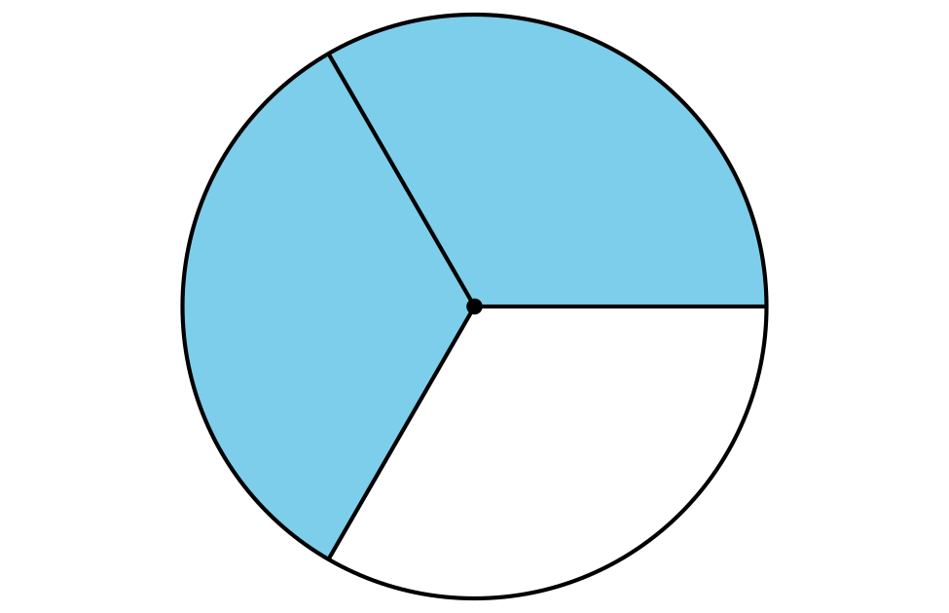
- (From Unit 7, Lesson 12.)
© CC BY 2019 by Illustrative Mathematics®

