Unit 4 Lesson 19: Trash Talk

WU Notice and Wonder: Trash and Ice (Warm up)

Student Task Statement
What do you notice? What do you wonder?

1 Square Kilometers

Student Task Statement
- Mai walked around a soccer field 2 times. She thinks she walked about a kilometer. Do you agree with Mai? Show or explain your reasoning.
- Decide whether each distance is less than a kilometer, about a kilometer, or more than a kilometer.
  - the distance across the state you live in
  - the distance from your home to school
  - the distance from your school room to the restroom
  - the distance you travel on a vacation in the car

2 So Much Trash

Student Task Statement
The Great Pacific Garbage Patch is a large area in the Pacific Ocean where trash has accumulated. Some estimates indicate that the garbage covers about 1,000,000 square kilometers.
- Rhode Island is the smallest state. It is about 77 km long and 60 km wide. Which is larger, the garbage patch or Rhode Island? Explain or show your reasoning.
- Delaware is about 154 km long and 48 km wide. Which is larger, the garbage patch or Delaware? Explain or show your reasoning.
- New Mexico is about 596 km long and 552 km wide. Which is larger, the garbage patch or New Mexico?
- Circle an area on the map of the U.S. that you think estimates the area of the garbage patch. Explain your thinking.
- 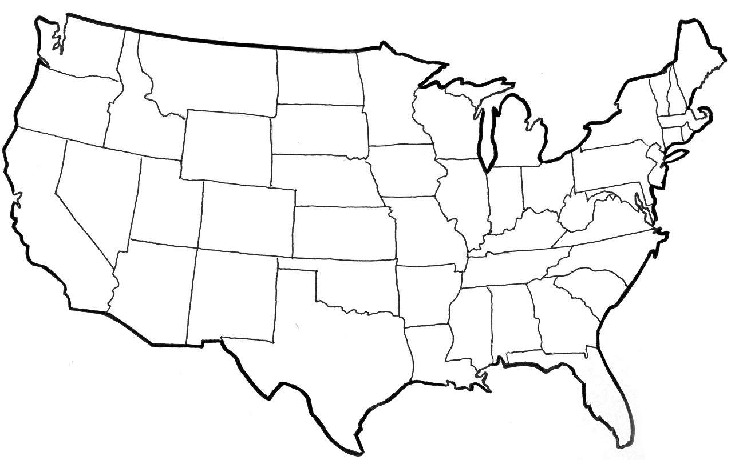
© CC BY 2021 Illustrative Mathematics®

