Unit 6 Lesson 14: Graphs That Represent Situations

1 A Jumping Frog (Warm up)

Student Task Statement
The height in inches of a frog's jump is modeled by the equation $h(t)=60t−75t^{2}$ where the time, $t$, after it jumped is measured in seconds.
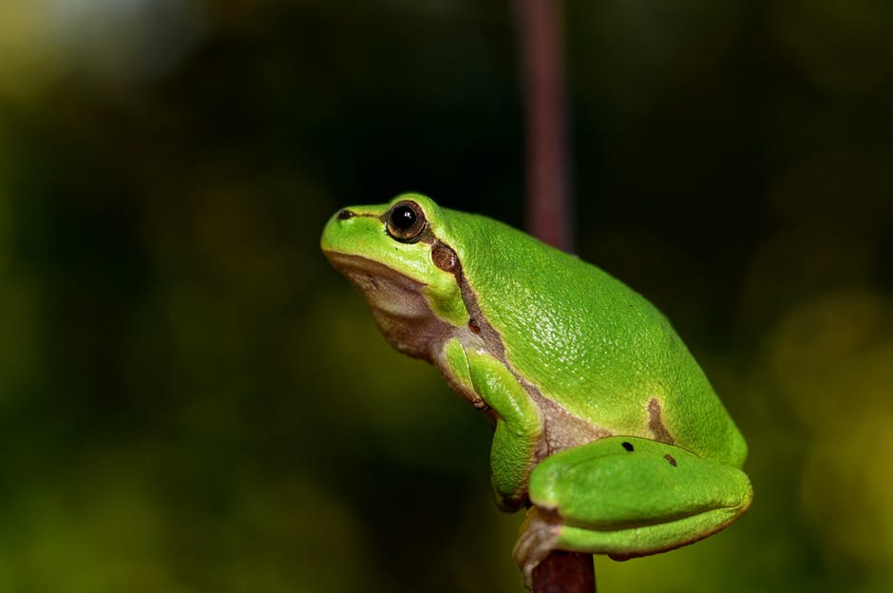
- Find $h(0)$ and $h(0.8)$. What do these values mean in terms of the frog’s jump?
- How much time after it jumped did the frog reach the maximum height? Explain how you know.

Activity Synthesis
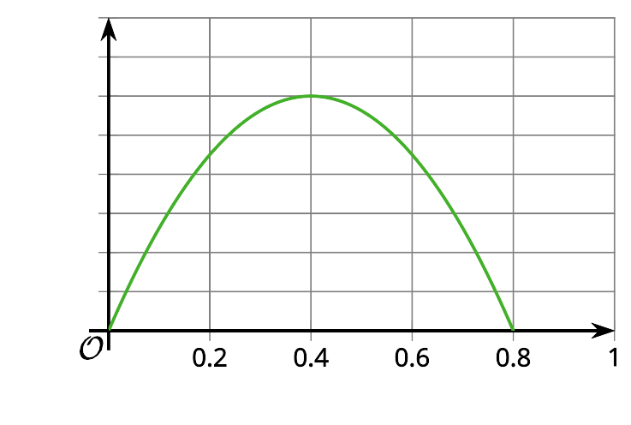

2 A Catapulted Pumpkin

Student Task Statement
The equation $h=2+23.7t−4.9t^{2}$ represents the height of a pumpkin that is catapulted up in the air as a function of time, $t$, in seconds. The height is measured in meters above ground. The pumpkin is shot up at a vertical velocity of 23.7 meters per second.
- Without writing anything down, consider these questions:
  - What do you think the 2 in the equation tells us in this situation? What about the $\text{-}4.9t^{2}$?
  - If we graph the equation, will the graph open upward or downward? Why?
  - Where do you think the vertical intercept would be?
  - What about the horizontal intercepts?
- Graph the equation using graphing technology.
- Identify the vertical and horizontal intercepts, and the vertex of the graph. Explain what each point means in this situation.

3 Flight of Two Baseballs

Student Task Statement
Here is a graph that represents the height of a baseball, $h$, in feet as a function of time, $t$, in seconds after it was hit by Player A.
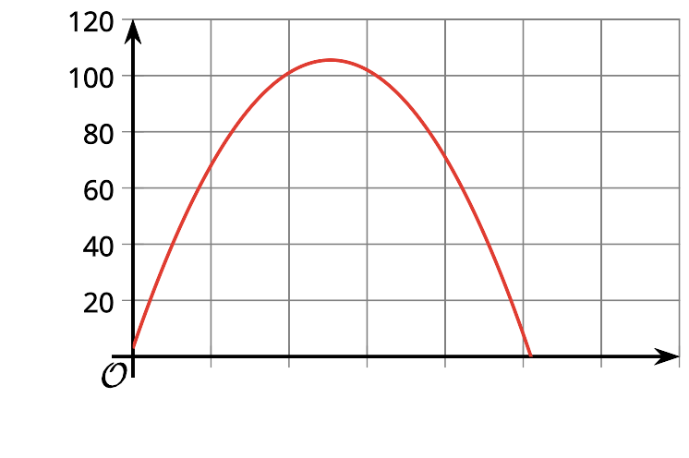
The function $g$ defined by $g(t)=(\text{-}16t−1)(t−4)$ also represents the height in feet of a baseball $t$ seconds after it was hit by Player B. Without graphing function $g$, answer the following questions and explain or show how you know.
- Which player’s baseball stayed in flight longer?
- Which player’s baseball reached a greater maximum height?
- How can you find the height at which each baseball was hit?

4 Info Gap: Rocket Math (Optional)

Student Task Statement
Your teacher will give you either a problem card or a data card. Do not show or read your card to your partner.
If your teacher gives you the data card:
- Silently read the information on your card.
- Ask your partner “What specific information do you need?” and wait for your partner to ask for information. Only give information that is on your card. (Do not figure out anything for your partner!)
- Before telling your partner the information, ask “Why do you need to know (that piece of information)?”
- Read the problem card, and solve the problem independently.
- Share the data card, and discuss your reasoning.
If your teacher gives you the problem card:
- Silently read your card and think about what information you need to answer the question.
- Ask your partner for the specific information that you need.
- Explain to your partner how you are using the information to solve the problem.
- When you have enough information, share the problem card with your partner, and solve the problem independently.
- Read the data card, and discuss your reasoning.
Pause here so your teacher can review your work. Ask your teacher for a new set of cards and repeat the activity, trading roles with your partner.

Images for Activity Synthesis
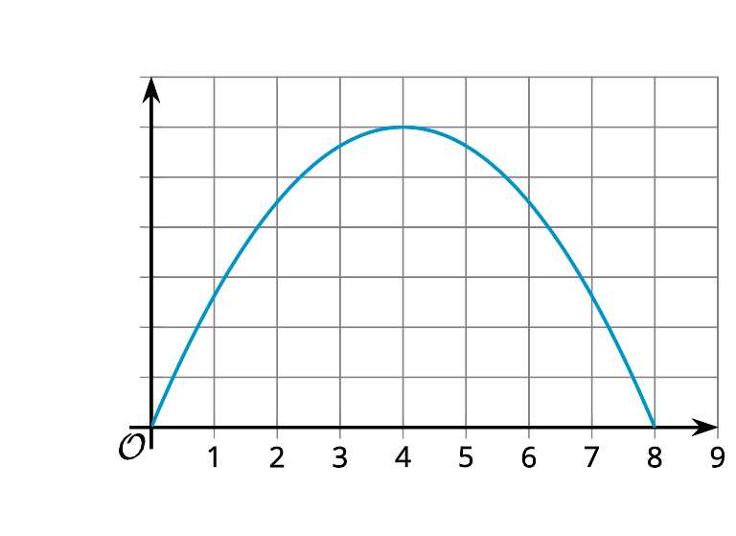
© CC BY 2019 by Illustrative Mathematics

