Unit 7 Lesson 8: Find the Perimeter

WU Number Talk: Decreasing Dividend (Warm up)

Student Task Statement
Find the value of each expression mentally.
- $90÷9$
- $81÷9$
- $45÷9$
- $54÷9$

1 Ways to Find Perimeter

Student Task Statement
What do you notice? What you wonder?
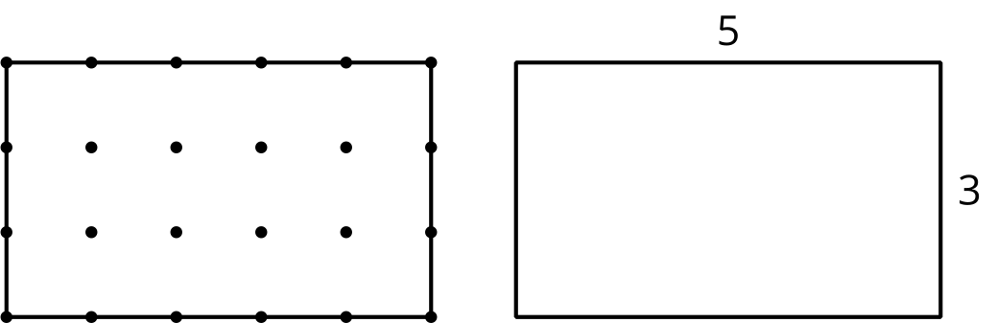
Find the perimeter of each shape. Explain or show your reasoning.

- 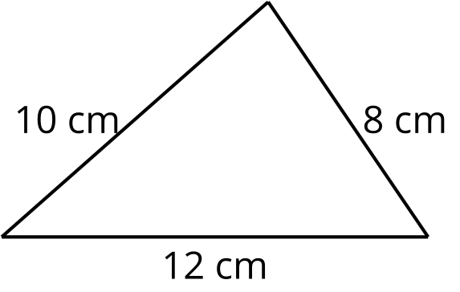

- 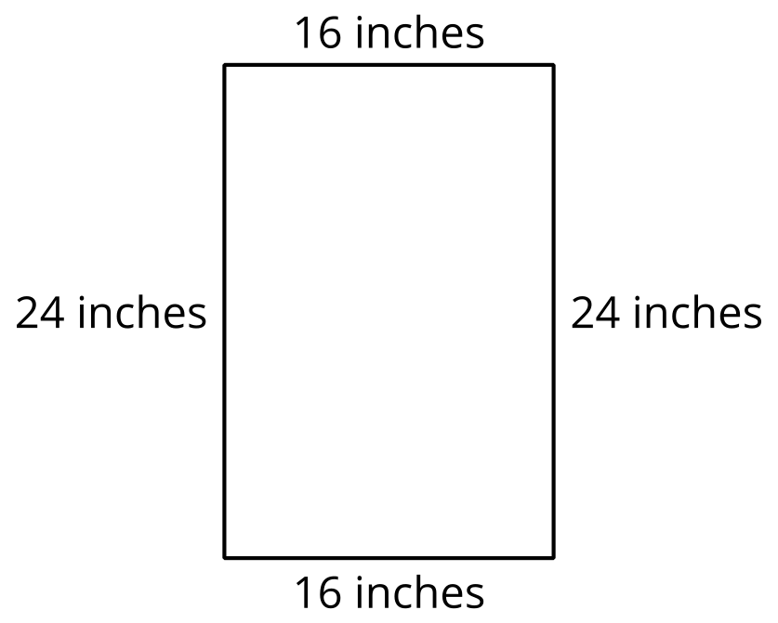

- 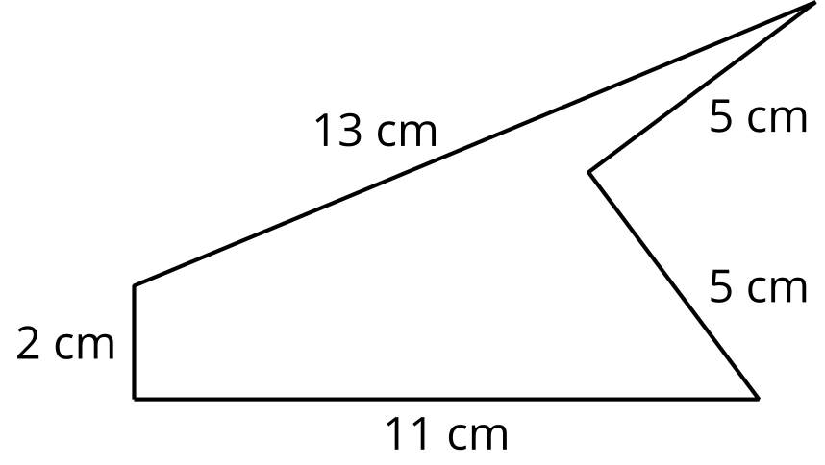

- 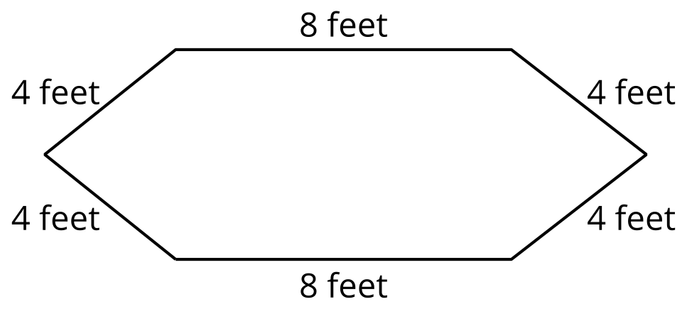

- 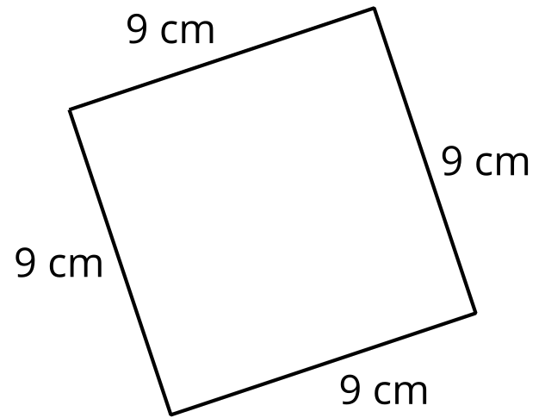

2 Something is Missing

Student Task Statement
- Find the perimeter of this rectangle. Explain or show your reasoning.
- 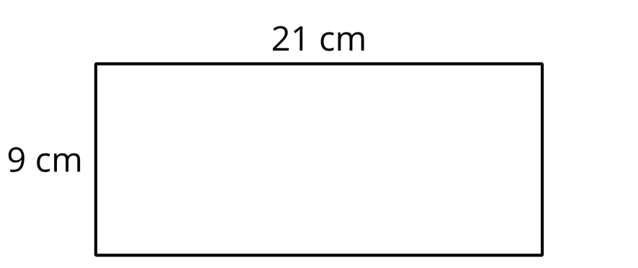

- All the short sides of this figure are the same length, and all the angles are right angles. Find the perimeter. Explain or show your reasoning.
- 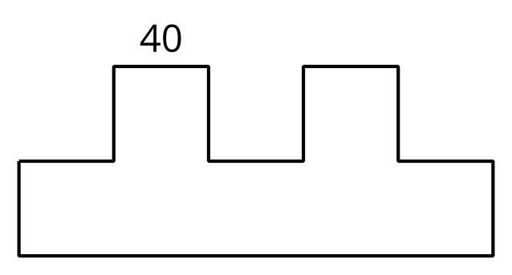
- All the sides of the octagon are the same length. Find the perimeter. Explain or show your reasoning.
- 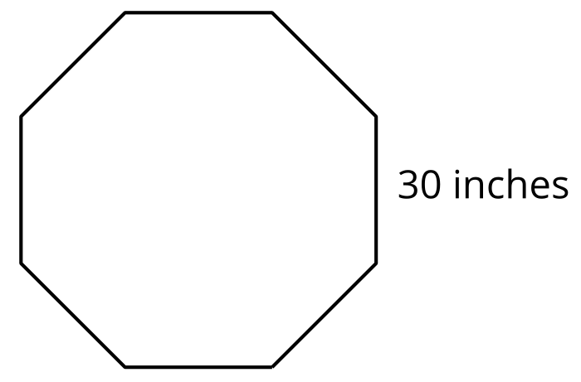

Images for Activity Synthesis
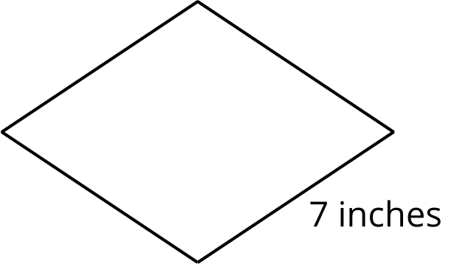
© CC BY 2021 Illustrative Mathematics®

