Lesson 5: One- and Two-step Comparison Problems
- Let’s solve multiplicative comparison word problems.

Warm-up: Which One Doesn’t Belong: Something's Missing
Which one doesn’t belong?

- 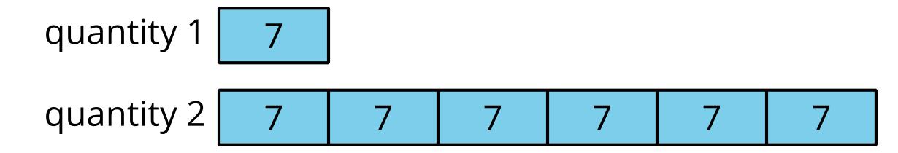

- $6×7=42$

- 42 is 6 times as many as _____.

5.1: The Book Fair
For this year’s book fair, a school ordered 16 science books and 6 times as many picture books.
Last year, the school ordered 4 times as many picture books and 4 times as many science books than they did this year.
- How many picture books were ordered this year?
- How many picture books were ordered last year?
- How many more science experiment books were ordered last year than this year?

5.2: More Book Fair Purchases
- At the book fair, they collected $13 Tuesday morning and 8 times as much as that in the afternoon. How much money did they collect at the book fair on Tuesday?
- On Thursday, Mai purchased a biography for $16 and a comic book for $3. That day, the book fair's amount of total sales was 9 times as much money as Mai spent.
- What was the amount of total sales for the book fair on Thursday?
© CC BY 2021 Illustrative Mathematics®

