Unit 7 Lesson 11: Use a Protractor to Draw Angles

WU Estimation Exploration: Long Hand and Short Hand (Warm up)

Student Task Statement
How many degrees is the angle formed by the long hand and the short hand of the clock?
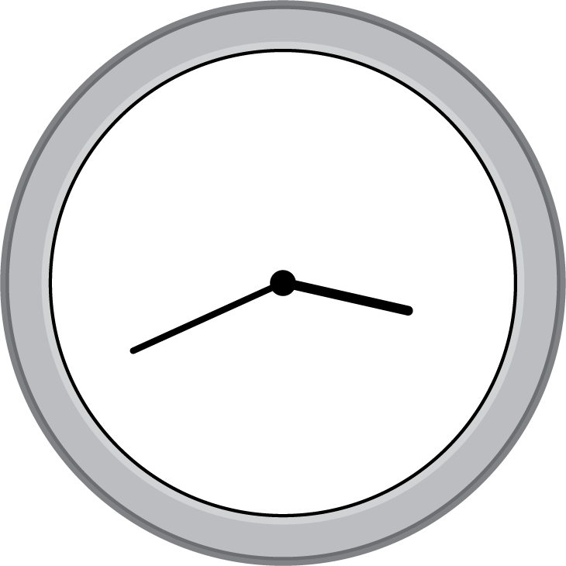
Make an estimate that is:
too low | about right | too high

1 Draw These Angles

Student Task Statement
- Draw a line that is neither vertical nor horizontal. Put a point somewhere on that line. Use your protractor to draw a perpendicular line through that point. Be as precise as possible. (No folding this time!)
- Here is a ray that starts at point $M$.
- 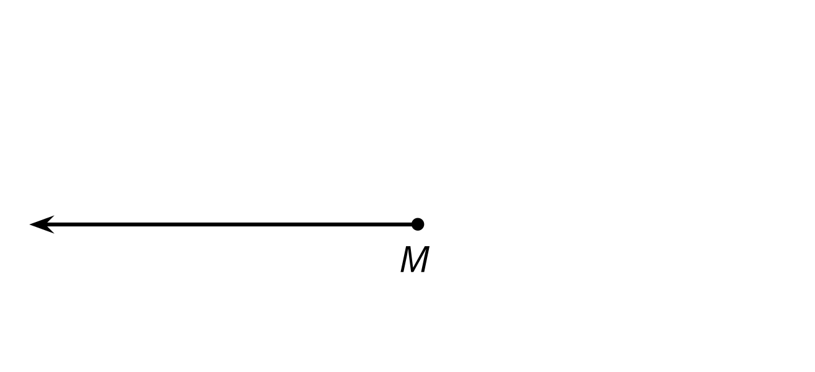
- Use a protractor to draw:
  - A ray starting at point $M$ to create a ${40}^{∘}$ angle.
  - Another ray starting at point $M$ to create a ${20}^{∘}$ angle.
  - One more ray starting at point $M$ to create a ${95}^{∘}$ angle. Label each angle with its measurement.
- In your drawing, there should be one angle that is not labeled with a measurement and is larger than ${180}^{∘}$ . Label the angle with an arc. How many degrees is this angle? Be prepared to explain how you know.

2 Angles Made to Order

Student Task Statement
Your teacher will give you some blank cards. Label them a–d.
- On each card, draw an angle that meets one requirement. Use a ruler and a protractor.
  - an angle that is less than ${35}^{∘}$
  - an angle that is between ${35}^{∘}$ and ${80}^{∘}$
  - an angle that is greater than ${80}^{∘}$ but less than ${120}^{∘}$
  - an angle that is greater than ${120}^{∘}$ but less than ${180}^{∘}$
- Trade cards with your partner.
  - Measure and record each angle your partner drew. Check to make sure each angle meets the requirement.
  - If a requirement is not met, return it to your partner so it can be corrected. Save the cards for the next lesson.
If you have time:
- Create a drawing that shows several angles. Then, write some descriptions of your drawing. Be as specific as possible.
- Ask a partner to recreate the drawing based on your descriptions. Does their drawing turn out as you had drawn? If not, adjust your descriptions and ask them to try again.
© CC BY 2021 Illustrative Mathematics®

