Lesson 24: Quadratic Situations
- Let’s work with situations and quadratic equations.

24.1: Growing Plants
Plant A’s height over time is represented by $y=\frac{1}{2}x+4$. Plant B’s height is $y=\frac{1}{3}x+3$ for which $x$ represents the number of weeks since the plants were found, and $y$ represents the height in inches.
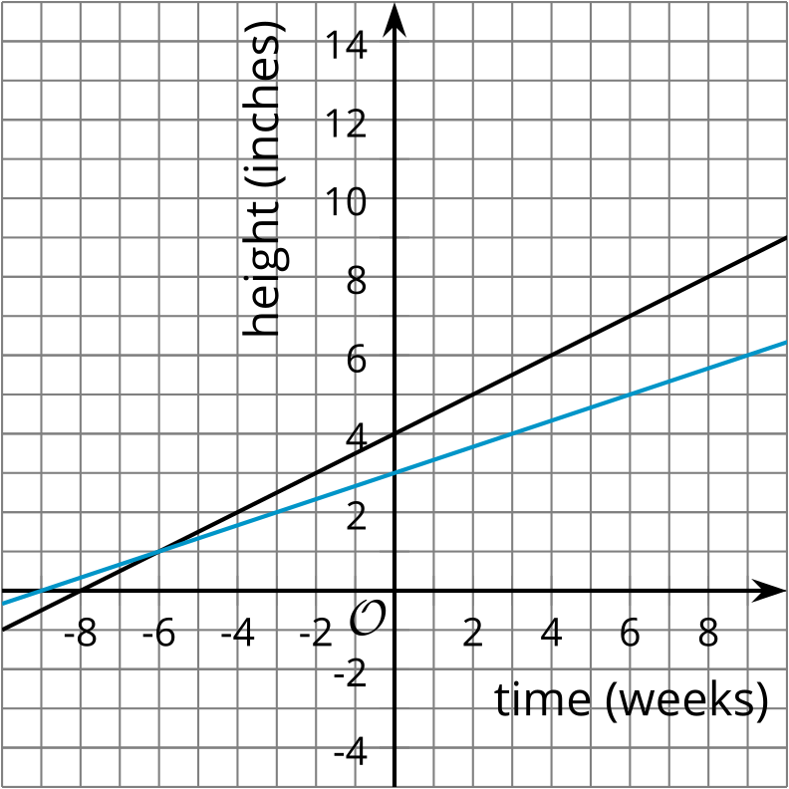
- Which graph goes with which equation? How do you know?
- What is a pair of values that works for Plant A but not B? What does it represent?
- What is a pair of values that works for Plant B but not A? What does it represent?
- What is a pair of values that works for both plants? What does it represent?

24.2: Diego’s Plant
- The height, in centimeters, of Diego’s plant is represented by the equation $p\left(t\right)=\text{-}0.5{\left(t−10\right)}^{2}+58$ where $t$ represents the number of weeks since Diego has started nurturing the plant. Determine if each statement is true or false. Explain your reasoning.
  - Diego’s plant shrinks each week.
  - Diego’s plant is 8 cm tall when he starts to nurture it.
  - Diego’s plant grows to be 58 cm tall.
  - The plant shrinks 4 weeks after Diego begins to nurture it.
- Write your own true statement about Diego’s plant.

24.3: Making the Grades
Jada’s quiz grade after $h$ hours of studying is given by the equation $Q\left(h\right)=10h+70$. Her test grade after $h$ hours of studying is given by the equation $T\left(h\right)=6h+76$.
Here’s a graph of both functions:
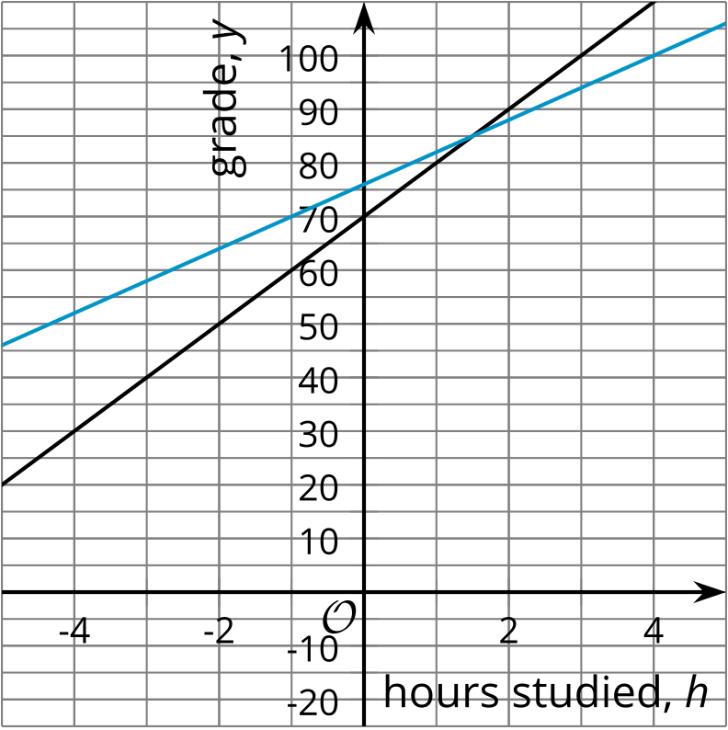
- Which graph represents Jada’s quiz grade after $h$ hours of studying?
- What do the $y$-intercepts of the lines mean in this situation?
- Find the coordinates of the $y$-intercepts.
- The 2 lines intersect at a point. What does that point represent in this situation?
- Find the coordinates of the intersection point. Explain or show your reasoning.
© CC BY 2019 by Illustrative Mathematics®

