Lesson 18 Practice Problems
- Clare solves the quadratic equation $4x^{2}+12x+58=0$, but when she checks her answer, she realizes she made a mistake. Explain what Clare's mistake was.
- $\begin{matrix}x & =\frac{\text{-}12±\sqrt{{12}^{2}−4⋅4⋅58}}{2⋅4} \\ x & =\frac{\text{-}12±\sqrt{144−928}}{8} \\ x & =\frac{\text{-}12±\sqrt{\text{-}784}}{8} \\ x & =\frac{\text{-}12±28i}{8} \\ x & =\text{-}1.5±28i\end{matrix}$
- Write in the form $a+bi$, where $a$ and $b$ are real numbers:
  - $\frac{5±\sqrt{\text{-}4}}{3}$
  - $\frac{10±\sqrt{\text{-}16}}{2}$
  - $\frac{\text{-}3±\sqrt{\text{-}144}}{6}$
- Priya is using the quadratic formula to solve two different quadratic equations.
- For the first equation, she writes $x=\frac{4±\sqrt{16−72}}{12}$
- For the second equation, she writes $x=\frac{8±\sqrt{64−24}}{6}$
- Which equation(s) will have real solutions? Which equation(s) will have non-real solutions? Explain how you know.
- Find the exact solution(s) to each of these equations, or explain why there is no solution.
  - $x^{2}=25$
  - $x^{3}=27$
  - $x^{2}=12$
  - $x^{3}=12$
- (From Unit 3, Lesson 8.)
- Kiran is solving the equation $\sqrt{x+2}−5=11$ and decides to start by squaring both sides. Which equation results if Kiran squares both sides as his first step?
  - $x+2−25=121$
  - $x+2+25=121$
  - $x+2−10\sqrt{x+2}+25=121$
  - $x+2+10\sqrt{x+2}+25=121$
- (From Unit 3, Lesson 9.)
- Plot each number on the real or imaginary number line.
  - $\text{-}\sqrt{4}$
  - $\sqrt{\text{-}1}$
  - $3\sqrt{4}$
  - $\text{-}3\sqrt{\text{-}1}$
  - $4\sqrt{\text{-}1}$
  - $2\sqrt{2}$
- 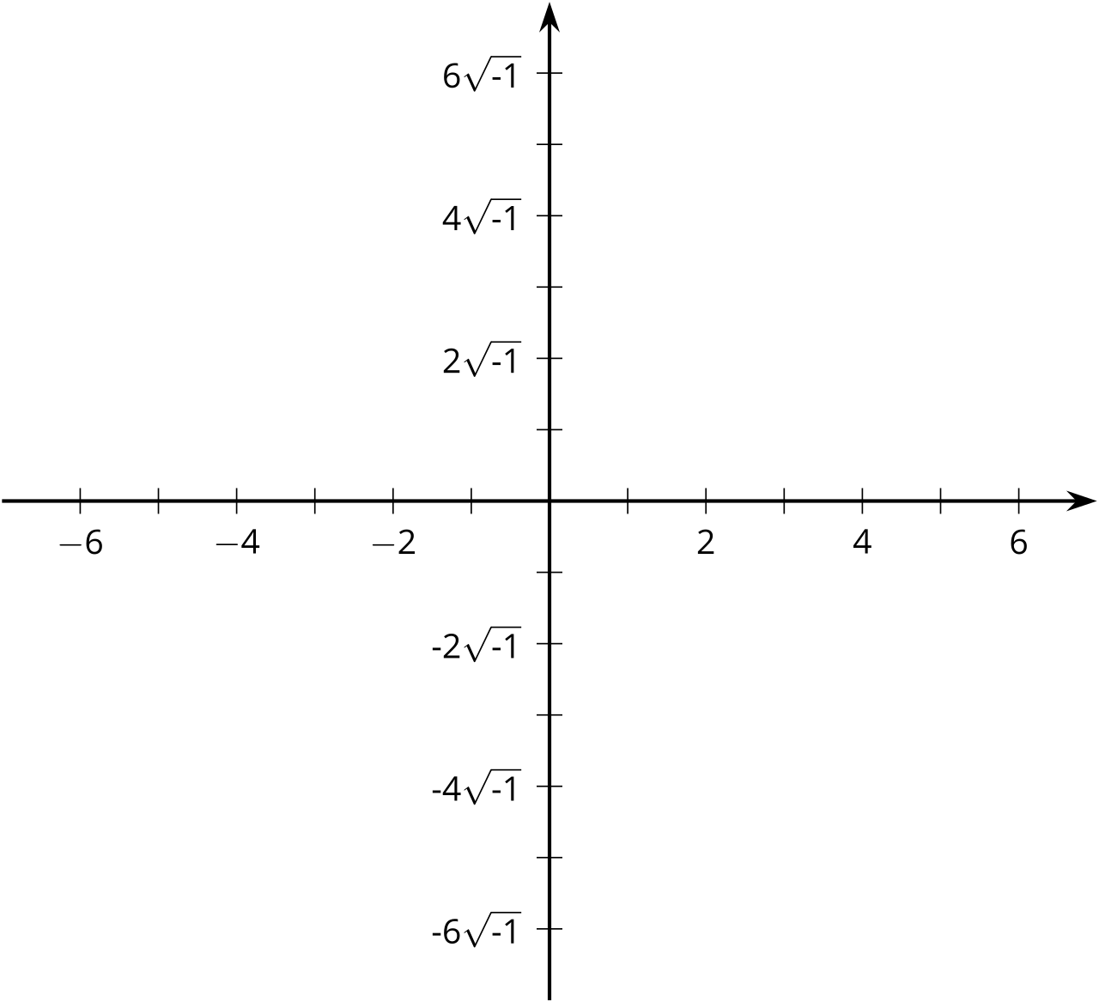
- (From Unit 3, Lesson 10.)
© CC BY 2019 by Illustrative Mathematics®

