Lesson 16 Practice Problems
- Here are the statistics for the high temperatures in a city during October:
  - mean of 65.3 degrees Fahrenheit
  - median of 63.5 degrees Fahrenheit
  - standard deviation of 9.3 degrees Fahrenheit
  - IQR of 7.1 degrees Fahrenheit
- Recall that the temperature $C$, measured in degrees Celsius, is related to the temperature $F$, measured in degrees Fahrenheit, by $C=\frac{5}{9}\left(F−32\right)$.
  - Describe how the value of each statistic changes when 32 is subtracted from the temperature in degrees Fahrenheit.
  - Describe how the value of each statistic further changes when the new values are multiplied by $\frac{5}{9}$.
  - Describe how to find the value of each statistic when the temperature is measured in degrees Celsius.
- (From Unit 1, Lesson 15.)
- Here is a box plot.
- 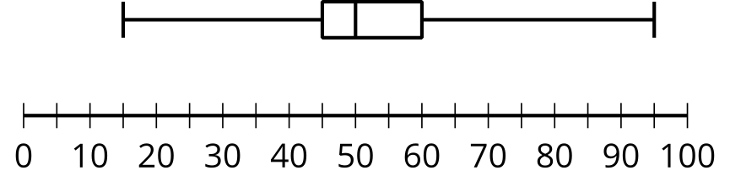
- Give an example of a box plot that has a greater median and a greater measure of variability, but the same minimum and maximum values.
- (From Unit 1, Lesson 15.)
- The mean vitamin C level for 20 dogs was 7.6 milligrams per liter, with a standard deviation of 2.1 milligrams per liter.
- One dog’s vitamin C level was not in the normal range. It was 0.9 milligrams per liter, which is a very low level of vitamin C.
  - If the value 0.9 is eliminated from the data set, does the mean increase or decrease?
  - If the value 0.9 is eliminated from the data set, does the standard deviation increase or decrease?
- (From Unit 1, Lesson 14.)
- The data set represents the number of hours that fifteen students walked during a two-week period.
- 6 | - 6 | - 7 | - 8 | - 8 | - 8 | - 9 | - 10
- 10 | - 12 | - 13 | - 14 | - 15 | - 16 | - 30

- The median is 10 hours, Q1 is 8, Q3 is 14, and the IQR is 6 hours. Are there any outliers in the data? Explain or show your reasoning.
- (From Unit 1, Lesson 14.)
- Here are some summary statistics about the number of accounts that follow some bands on social media.
  - mean: 15,976 followers
  - median: 16,432 followers
  - standard deviation: 3,279 followers
  - Q1: 13,796
  - Q3: 19,070
  - IQR: 5,274 followers
  - Give an example of a number of followers that a very popular band might have that would be considered an outlier for this data. Explain or show your reasoning.
  - Give an example of a number of followers that a relatively unknown band might have that would be considered an outlier for this data. Explain or show your reasoning.
- (From Unit 1, Lesson 14.)
- The weights of one population of mountain gorillas have a mean of 203 pounds and standard deviation of 18 pounds. The weights of another population of mountain gorillas have a mean of 180 pounds and standard deviation of 25 pounds. Andre says the two populations are similar. Do you agree? Explain your reasoning.
- (From Unit 1, Lesson 13.)
- The box plot represents the distribution of the amount of change, in cents, that 50 people were carrying when surveyed.
- 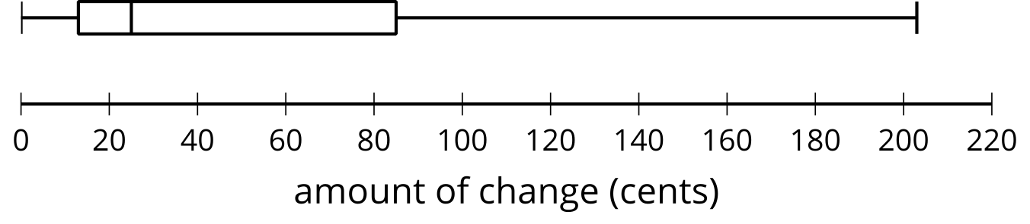
- The box plot represents the distribution of the same data set, but with the maximum, 203, removed.
- 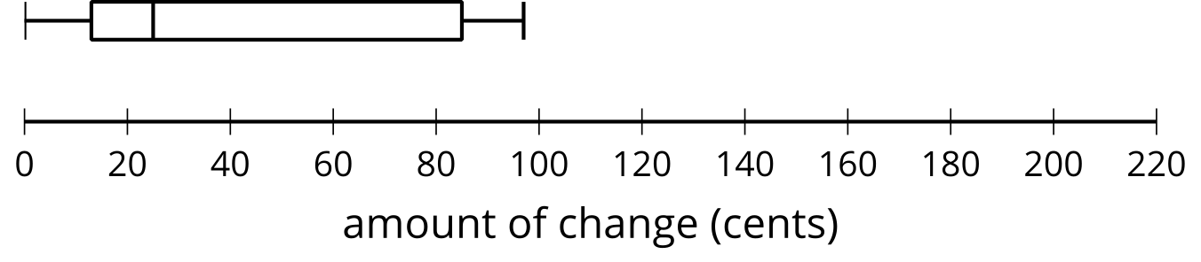
- The median is 25 cents for both plots. After examining the data, the value 203 is removed since it was an error in recording.
  - Explain why the median remains the same when 203 cents was removed from the data set.
  - When 203 cents is removed from the data set, does the mean remain the same? Explain your reasoning.
- (From Unit 1, Lesson 10.)
© CC BY 2019 by Illustrative Mathematics®

