Lesson 16: Surface Area and Volume
- Let’s use volume and surface area to solve problems.

16.1: Maximize Area
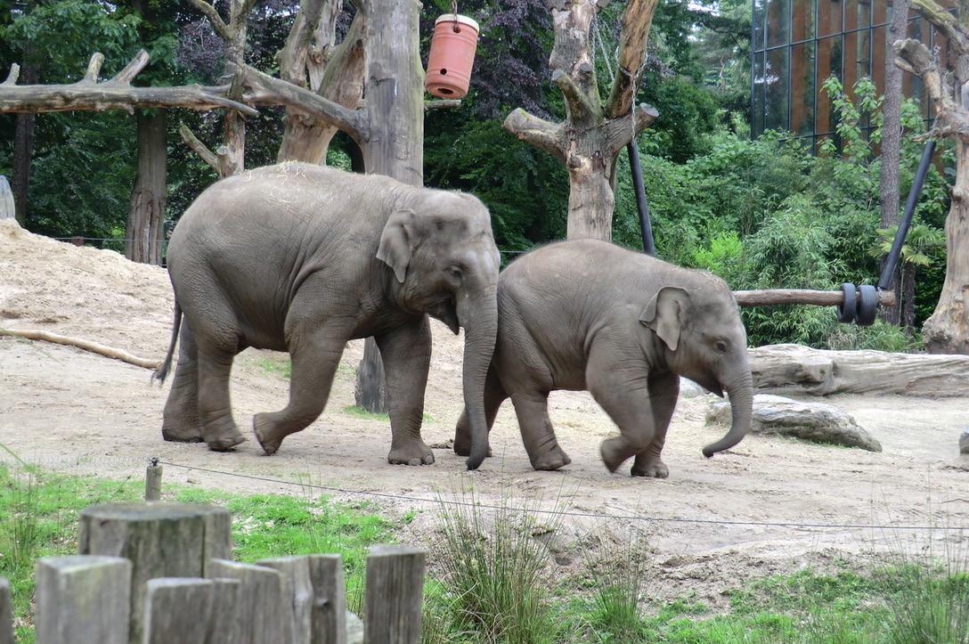
The zoo wants to give the elephants as much space as possible in a rectangular enclosure meant for feeding. The zoo has 180 feet of fencing. What should the dimensions of the rectangle be? Be prepared to share your reasoning.

16.2: Maximize in Three Dimensions
- Find a set of dimensions for a rectangular prism with volume 60 cubic units. Calculate the surface area of your prism. Add your data to the class chart.
- A lithium ion battery contains a rectangular prism made of lithium. The energy in the battery is proportional to the surface area of this prism. Assume the lithium has a fixed volume of 60 cubic millimeters. Find the dimensions of a rectangular prism with this volume that maximizes its surface area. What is its surface area?

Are you ready for more?
Minimizing surface area plays a large role in manufacturing. Companies try to use the smallest amount of resources possible to package products in order to save money.
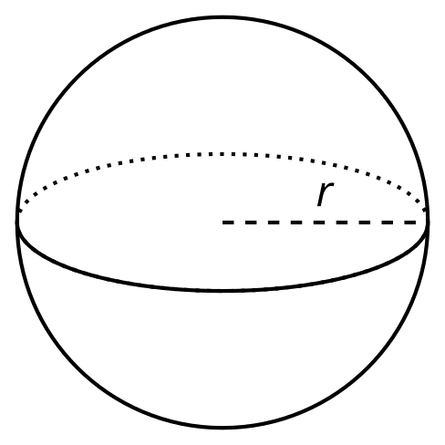
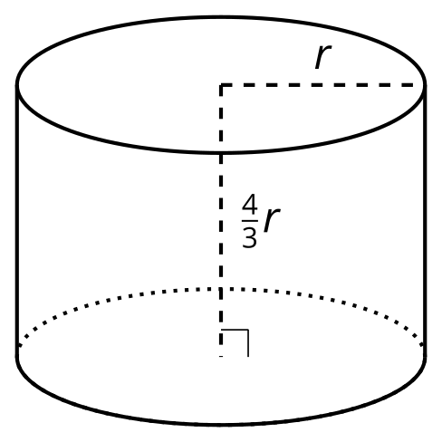
- Calculate the surface area of the 2 figures shown, which both enclose the same volume.
- Which container would you recommend a company use to package small candies? Explain your reasoning.

16.3: Assume a Spherical Elephant
For a sphere with radius $r$, its volume is $\frac{4}{3}πr^{3}$ and its surface area is $4πr^{2}$.
- Let’s model an elephant with a sphere that has a radius of 4.5 feet.
  - What is the volume of the elephant?
  - What is the surface area of the elephant?
- Let’s model a snake with a cylinder of length 3 feet and diameter 0.2 feet.
  - What is the volume of the snake?
  - What is the surface area of the snake?
- Compute the surface area to volume ratio, or $\frac{SA}{V}$, for each animal.

16.4: Measuring Strength
Suppose a human is a sphere with a radius of 1 unit, an ant is a sphere with a radius of $\frac{1}{200}$ unit, and an elephant is a sphere with a radius of 5 units.
- The raw strength of a living creature is the cross-sectional area of its muscles. The cross section of each of our spherical beings is a circle of radius $r$ where $r$ is the creature’s radius. Order the human, ant, and elephant by their raw strength from least to greatest. Show your reasoning.
- Relative strength is given by the ratio of raw strength to volume. It measures how strong a creature is for its size. Create an expression for the relative strength of a spherical being with radius $r$. (Remember that the raw strength formula is $πr^{2}$ and the volume formula for a sphere is $\frac{4}{3}πr^{3}$.)
- Order the human, the ant, and the elephant by their relative strength. Which is the strongest for its size?

Lesson 16 Summary
The three prisms shown each have a volume of 216 cubic centimeters. Which prism do you think has the largest surface area? Which do you think has the smallest surface area?

1 cm by 12 cm by 18 cm

9 cm by 8 cm by 3 cm
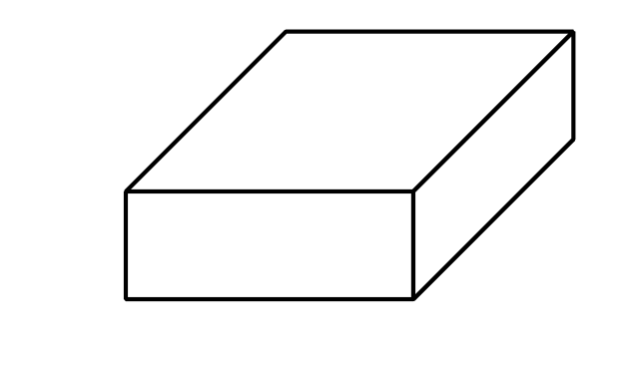

6 cm by 6 cm by 6 cm
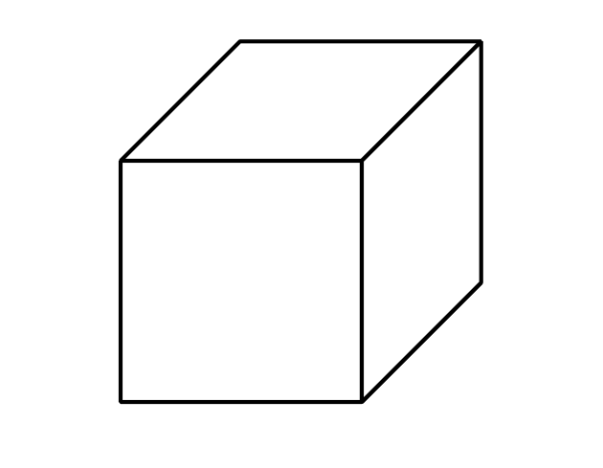
The surface area of the first prism is 492 square centimeters, the surface area of the second is 246 square centimeters, and the surface area of the third is 216 square centimeters. The cube, then, has the smallest surface area. In general, the cube is the rectangular prism with the least amount of surface area for its volume. The 1 by 12 by 18 cm prism has the greatest surface area of the three. If we want a rectangular prism to have more surface area, the best design is to make it wide and long.
Shapes that are more compact, like a cube, have the least surface area for a given volume. But it turns out spheres do even better than cubes. A sphere with radius 3.72 centimeters, shown in the figure, has an approximate volume of 216 cubic centimeters like the earlier prisms, but its approximate surface area is just 174 square centimeters.
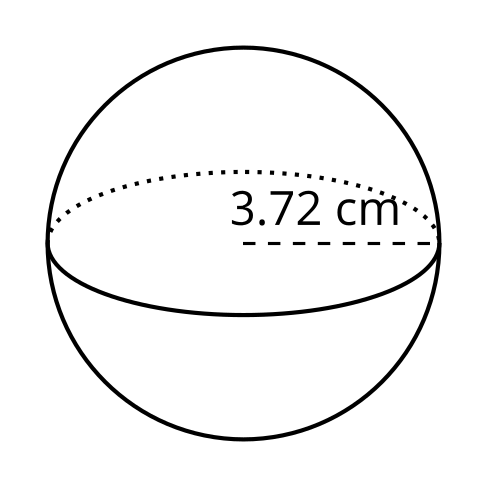
We can see examples of maximizing or minimizing surface area in nature. For instance, a snake is cold-blooded, meaning that it gets its heat from the environment. Its long, narrow shape helps it soak up more heat from the sun. On the other hand, large mammals such as elephants and cows are warm-blooded, which means that they produce their own heat internally. Their shapes are more compact, closer to spheres, and this allows them to lose as little heat as possible through their skin.
© CC BY 2019 by Illustrative Mathematics®

