Lesson 7 Practice Problems
- Each of the letters A through J are printed on tiles that are placed in a hat. Andre selects a tile at random and then replaces it. Clare then selects a tile at random.
  - What is the probability that Andre selects a tile labeled B?
  - What is the probability that Clare selects a tile labeled B?
  - What is the probability that both Andre and Clare select a tile labeled B?
  - Are the events of Andre selecting a tile and Clare selecting a tile dependent or independent? Explain your reasoning.
- The Bulldogs have won approximately 67% of their 30 baseball games this season. The Bulldogs won 9 of the 10 games they played when Diego was the starting pitcher. Are the events “the Bulldogs win the game” and “the Bulldogs win the game when Diego is the starting pitcher” dependent or independent events? Explain your reasoning.
- Describe two events that are independent. Explain your reasoning.
- The table displays the number and type of tickets bought for a baseball tournament held on a Saturday and Sunday.
 | - child ticket | - adult ticket
- Saturday | - 27 | - 41
- Sunday | - 14 | - 29
- The addition rule states that given events A and B, $P\left(\text{A or B}\right)=P\left(\text{A}\right)+P\left(\text{B}\right)−P\left(\text{A and B}\right)$. Show how to apply the addition rule for the events “a child ticket is bought for a baseball tournament” and “the day of the tournament is Sunday.”
- (From Unit 8, Lesson 6.)
- A researcher surveys 200 randomly selected college students to determine the number of education majors and mathematics majors. 16% of the students surveyed are education majors and 6% of the students surveyed are mathematics majors. 2% of the students are both education majors and mathematics majors. What percentage of the students surveyed are education majors or mathematics majors?
  - 2%
  - 20%
  - 22%
  - 24%
- (From Unit 8, Lesson 6.)
- 100 students were asked two survey questions:
  - Do you have a garden?
  - Are you a gamer?
- Their responses are summarized in the Venn diagram.
- How many students surveyed have a garden?
- 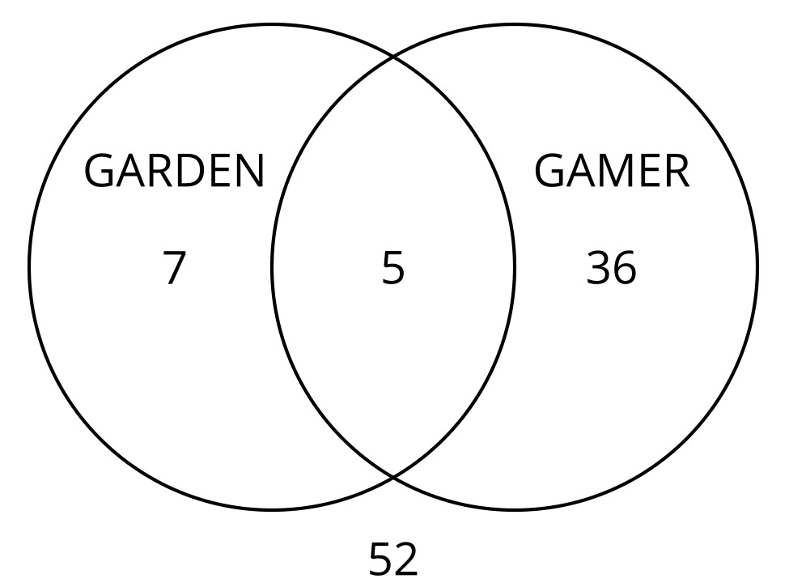
  - 5
  - 7
  - 12
  - 36
- (From Unit 8, Lesson 5.)
- The table shows the preferences of 40 students surveyed about the design of a new t-shirt for students who are graduating this year.
 | - short sleeves | - long sleeves
- pink | - 12 | - 5
- black | - 14 | - 9
- What is the probability that a student surveyed, selected at random, preferred a pink t-shirt with long sleeves?
- (From Unit 8, Lesson 4.)
- Write a formula that could be used to find the area of this sector.
- 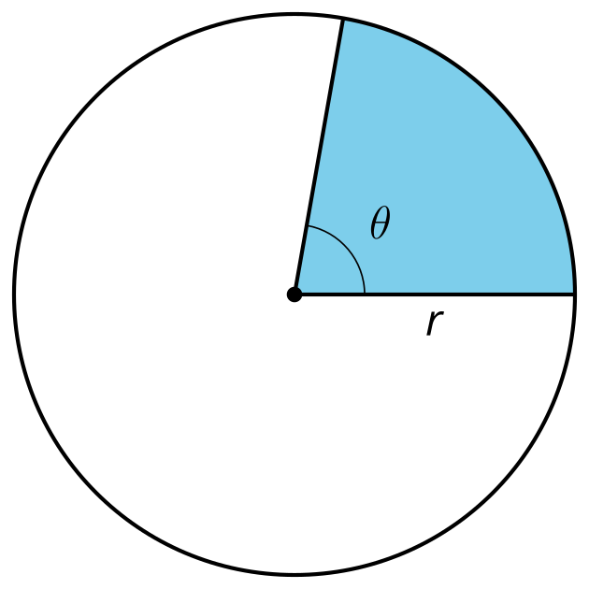
- (From Unit 7, Lesson 13.)
- Technology required. Find the missing measurements in triangle $ABC$.
- 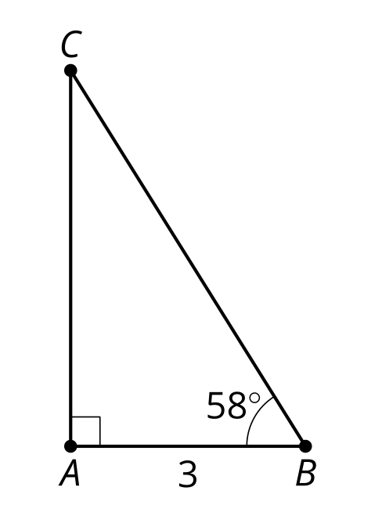
- (From Unit 4, Lesson 7.)
© CC BY 2019 by Illustrative Mathematics®

