Lesson 3 Practice Problems
- Select all points where relative minimum values occur on this graph of a polynomial function.
- 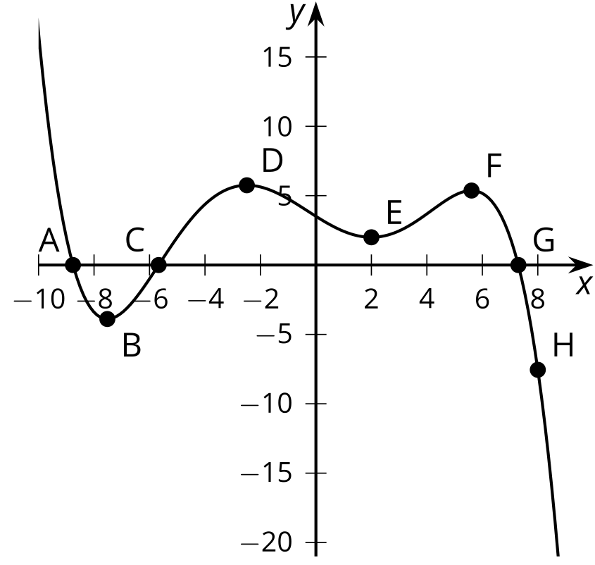
  - Point $A$
  - Point $B$
  - Point $C$
  - Point $D$
  - Point $E$
  - Point $F$
  - Point $G$
  - Point $H$
- Add one term to the polynomial expression $14x^{19}−9x^{15}+11x^{4}+5x^{2}+3$ to make it into a 22nd degree polynomial.
- Identify the degree, leading coefficient, and constant value of each of the following polynomials:
  - $f\left(x\right)=x^{3}−8x^{2}−x+8$
  - $h\left(x\right)=2x^{4}+x^{3}−3x^{2}−x+1$
  - $g\left(x\right)=13.2x^{3}+3x^{4}−x−4.4$
- We want to make an open-top box by cutting out corners of a square piece of cardboard and folding up the sides. The cardboard is a 9 inch by 9 inch square. The volume $V\left(x\right)$ in cubic inches of the open-top box is a function of the side length $x$ in inches of the square cutouts.
  - Write an expression for $V\left(x\right)$.
  - What is the volume of the box when $x=1$?
  - What is a reasonable domain for $V$ in this context?
- (From Unit 2, Lesson 1.)
- Consider the polynomial function $p$ given by $p\left(x\right)=7x^{3}−2x^{2}+3x+10$. Evaluate the function at $x=\text{-}3$.
- (From Unit 2, Lesson 2.)
- An open-top box is formed by cutting squares out of an 11 inch by 17 inch piece of paper and then folding up the sides. The volume $V\left(x\right)$ in cubic inches of this type of open-top box is a function of the side length $x$ in inches of the square cutouts and can be given by $V\left(x\right)=\left(17−2x\right)\left(11−2x\right)\left(x\right)$. Rewrite this equation by expanding the polynomial.
- (From Unit 2, Lesson 2.)
© CC BY 2019 by Illustrative Mathematics®

