Unit 7 Lesson 9: Perimeter Problems

WU Estimation Exploration: Statue of Liberty (Warm up)

Student Task Statement
The Statue of Liberty has two square bases—one larger than the other. The larger base has side lengths of 132 feet each.
Estimate the perimeter of the smaller square base.
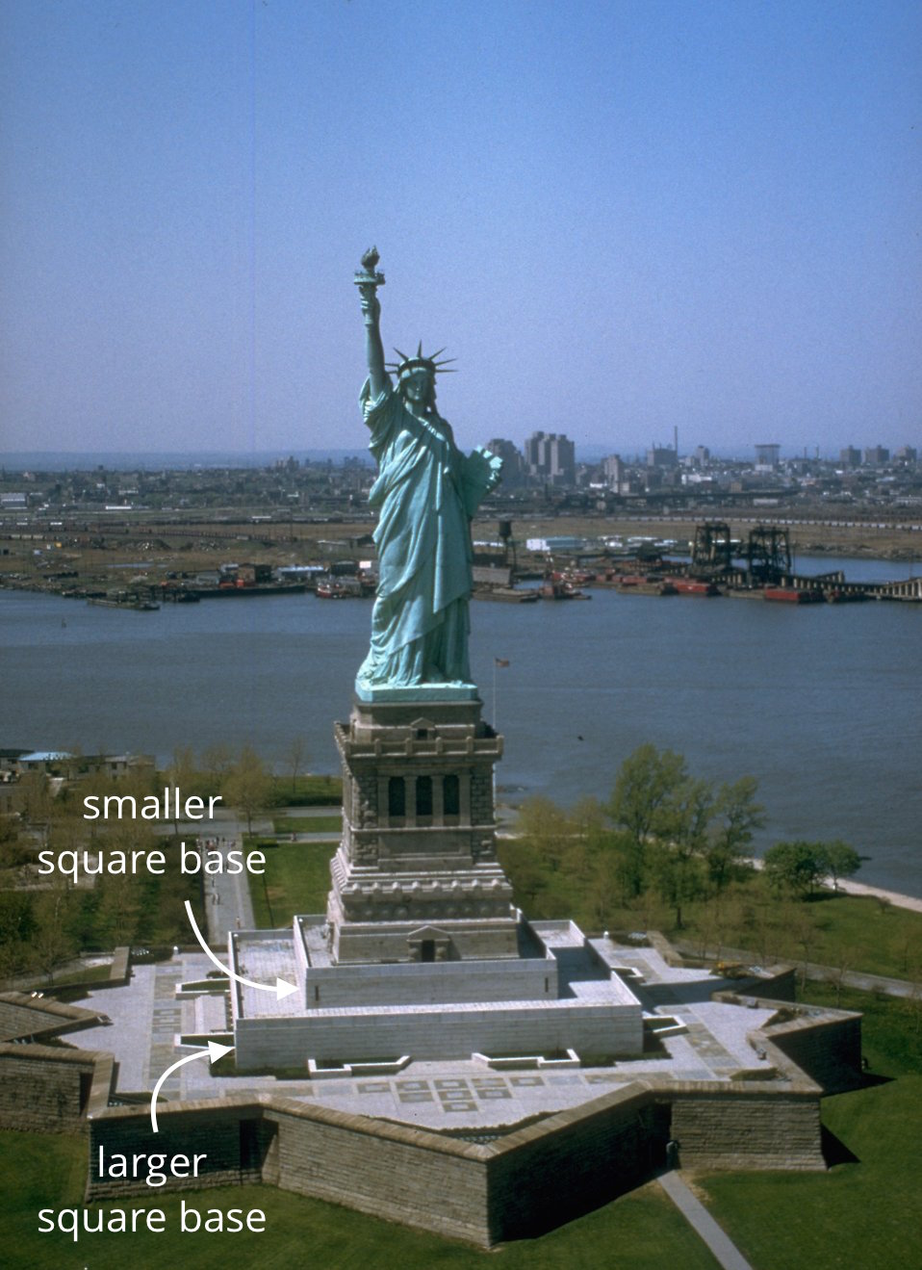
Record an estimate that is:
too low | about right | too high

1 Missing Measurements

Student Task Statement
- This pentagon has a perimeter of 32 cm. What is the length of the missing side? Explain or show your work.
- 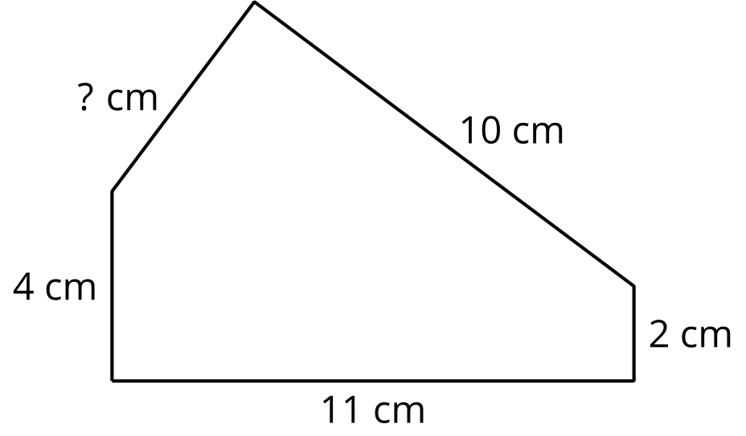
- This rectangle has a perimeter of 56 feet. What are the lengths of the unlabeled sides? Explain or show your work.
- This pentagon has a perimeter of 65 inches. All the sides are the same length. What is the length of each side? Explain or show your work.
- 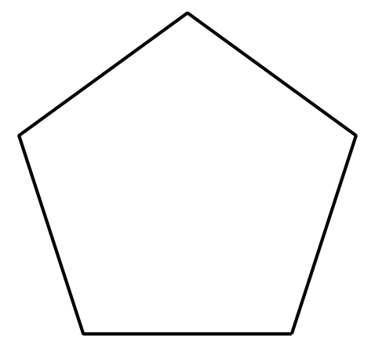

2 Can I Use Perimeter?

Student Task Statement
Solve each problem. Explain or show your reasoning.
- A rectangular park is 70 feet on the shorter side and 120 feet on the longer side. How many feet of fencing is needed to enclose the boundary of the park?
- Priya drew a picture and is framing it with a ribbon. Her picture is square and one side is 9 inches long. How many inches of ribbon will she need?
- A rectangular flower bed has a fence that measures 32 feet around. One side of the flower bed measures 12 feet. What are the lengths of the other sides?
- Kiran took his dog for a walk. Their route is shown. How many blocks did they walk?
- 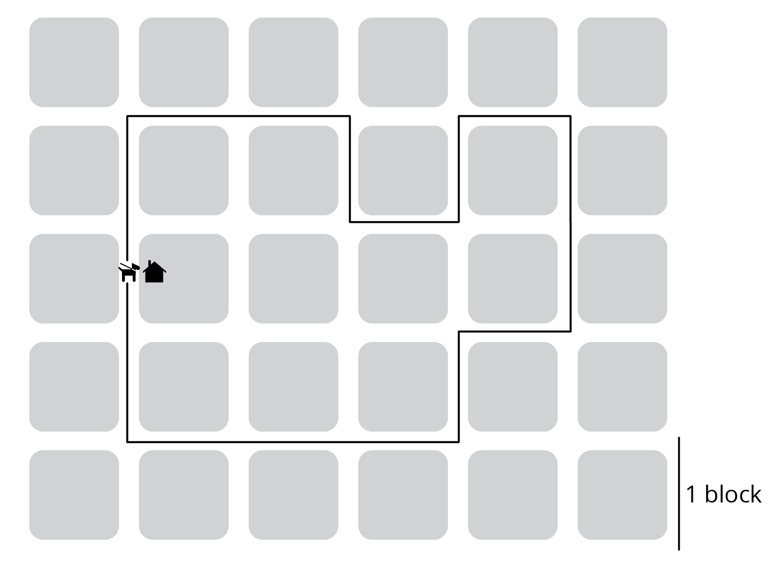
- A room is 10 feet by 8 feet. How many tiles will be needed to cover the floor if each tile is 1 square foot?
© CC BY 2021 Illustrative Mathematics®

