Unit 2 Lesson 3: More about Constant of Proportionality

1 Equal Measures (Warm up)

Student Task Statement
Use the numbers and units from the list to find as many equivalent measurements as you can. For example, you might write “30 minutes is $\frac{1}{2}$ hour.”
You can use the numbers and units more than once.
1
12
0.4
60
50
$\frac{1}{2}$
40
0.01
$3\frac{1}{3}$
30
0.3
24
$\frac{1}{10}$
6
2
$\frac{2}{5}$
centimeter
meter
hour
feet
minute
inch

2 Centimeters and Millimeters

Student Task Statement
There is a proportional relationship between any length measured in centimeters and the same length measured in millimeters.
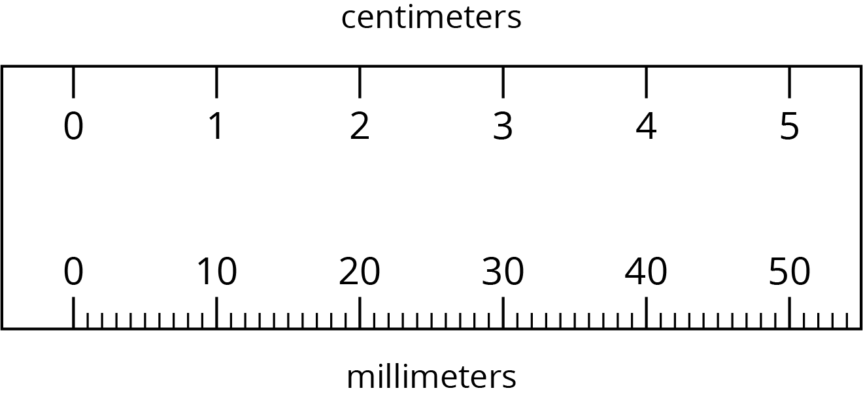
There are two ways of thinking about this proportional relationship.
- If you know the length of something in centimeters, you can calculate its length in millimeters.
  - Complete the table.
  - What is the constant of proportionality?
- length (cm) | - length (mm)
- 9
- 12.5
- 50
- 88.49
- If you know the length of something in millimeters, you can calculate its length in centimeters.
  - Complete the table.
  - What is the constant of proportionality?
- length (mm) | - length (cm)
- 70
- 245
- 4
- 699.1
- How are these two constants of proportionality related to each other?
- Complete each sentence:
  - To convert from centimeters to millimeters, you can multiply by ________.
  - To convert from millimeters to centimeters, you can divide by ________ or multiply by ________.

3 Pittsburgh to Phoenix

Images for Launch
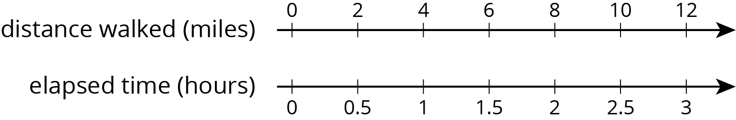

Student Task Statement
On its way from New York to San Diego, a plane flew over Pittsburgh, Saint Louis, Albuquerque, and Phoenix traveling at a constant speed.
Complete the table as you answer the questions. Be prepared to explain your reasoning.
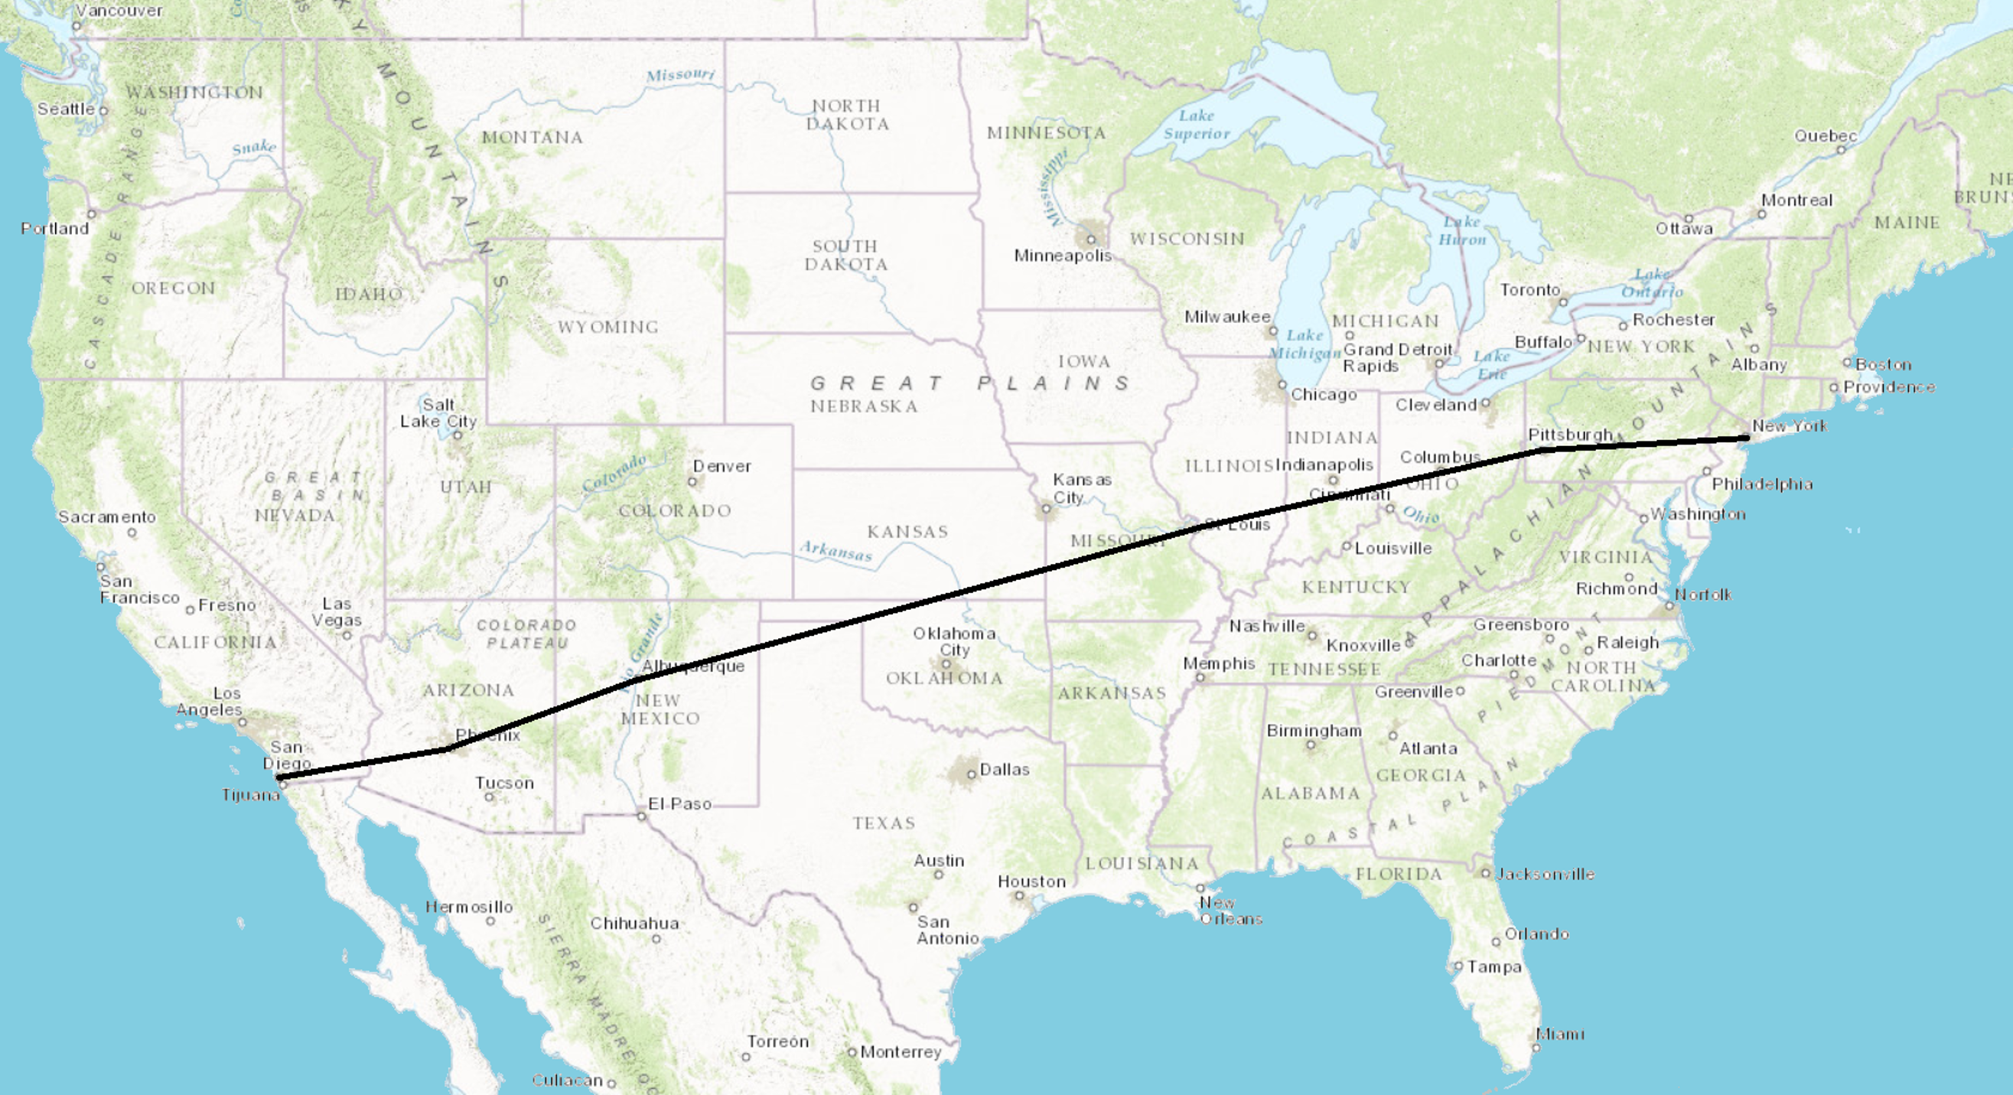
segment | time | distance | speed
Pittsburgh to Saint Louis | 1 hour | 550 miles
Saint Louis to Albuquerque | 1 hour 42 minutes
Albuquerque to Phoenix |  | 330 miles
- What is the distance between Saint Louis and Albuquerque?
- How many minutes did it take to fly between Albuquerque and Phoenix?
- What is the proportional relationship represented by this table?
- Diego says the constant of proportionality is 550. Andre says the constant of proportionality is $9\frac{1}{6}$. Do you agree with either of them? Explain your reasoning.
© CC BY Open Up Resources. Adaptations CC BY IM.

