Lesson 6: Ten Times as Many
- Let’s represent “10 times as many.”

6.1: Ten Times as Many
Here is a diagram that represents two quantities, A and B.
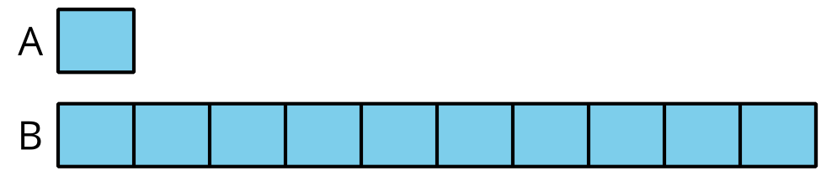
- What are some possible values of A and B?
- Select the equations that could be represented by the diagram.
  - $15×10=150$
  - $16×100=1,​600$
  - $30÷3=10$
  - $5,​000÷5=1,​000$
  - $80×10=800$
  - $12,​000÷10=1,​200$
- For the equations that can't be represented by the diagram:
  - Explain why the diagram does not represent these equations.
  - How would you change the equations so the diagram could represent them?
  - Compare your equations with your partner’s. Make at least two observations about the equations you and your partner wrote.

6.2: What Remains the Same?
- Use the diagram to complete the table.
- value of A | - value of B
- 14 | - 0000000000
- 0000000000 | - 1,000
- 160
 | - 850
- 1,000
 | - 2,070
 | - 3,900
- Select some values from your table to explain or show:
  - How you found the value of B when the value of A is known.
  - How you found the value of A when the value of B is known.

Section Summary
Section Summary
In this section, we learned to use multiplication and the phrase “_____ times as many” or “_____ times as much” for comparing two quantities.
At first, we used cubes and drawings to represent the quantities. For example: Andre has 3 cubes and Han has 12. We compared the number of cubes by:
- saying “Han has 4 times as many cubes as Andre”
- drawing diagrams that shows 3 pieces for Andre and 4 times as many pieces for Han
- 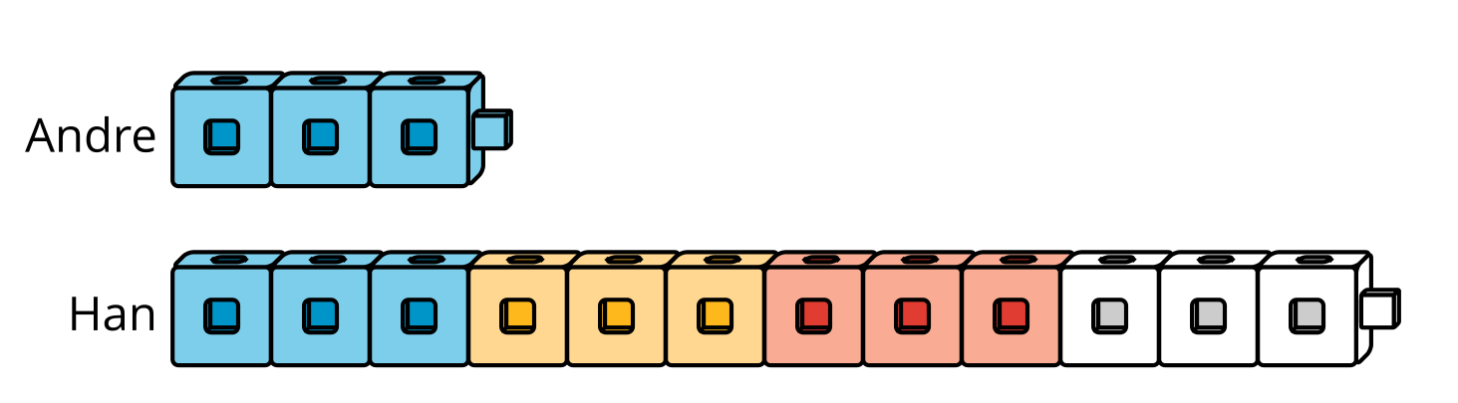
- 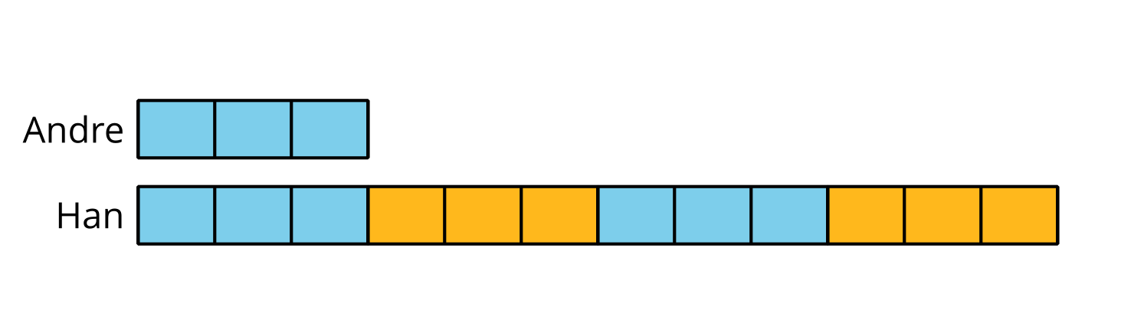
- writing an equation such as $4×3=12$
As the numbers got larger, drawing every unit of each quantity became less convenient, so we used simpler diagrams with numbers to represent the size of the quantities.
If Andre has 30 cubes and Han has 4 times as many, we can represent the comparison with a diagram like this:
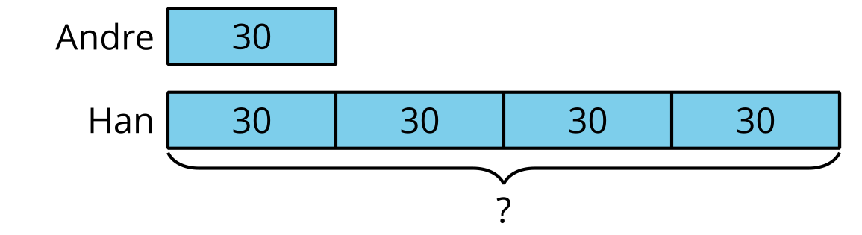
We ended by comparing quantities in which one quantity is ten times as much as another. We also recalled some patterns in the numbers when we multiplied a number by 10.
© CC BY 2021 Illustrative Mathematics®

