Unit 7 Lesson 12: Types of Angles

WU Number Talk: Fractions of 120 and 360 (Warm up)

Student Task Statement
Find the value of each expression mentally.
- $12×\frac{1}{12}$
- $120×\frac{1}{12}$
- $360×\frac{1}{12}$
- $360×\frac{3}{12}$

1 Sorting Angles

Student Task Statement
In an earlier lesson, you and your partner drew some angles on cards.
Put the cards together and sort the angles into two groups. Be prepared to explain why you sort them the way you do.

2 What is It, Really?

Student Task Statement
- Mai and Jada are looking at this drawing. Jada says it is just a line. Mai says it is an angle.
- With whom do you agree? Explain your reasoning.
- Tyler and Andre were measuring an angle in a letter Y.
- Andre said the angle he measured is obtuse. Tyler said the angle is acute.
- Explain why they could both be right.

3 Small Angles, Large Angles

Student Task Statement
- Identify each angle as acute, right, obtuse, or straight.
- 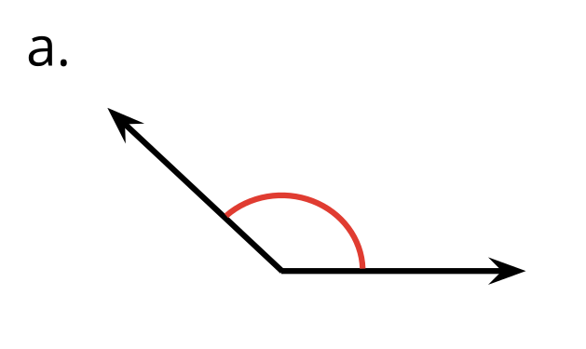
- 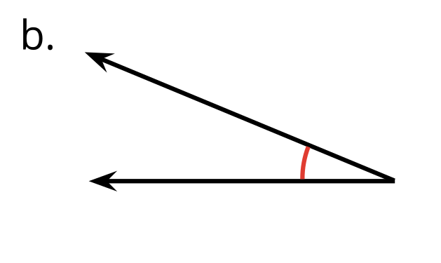
- 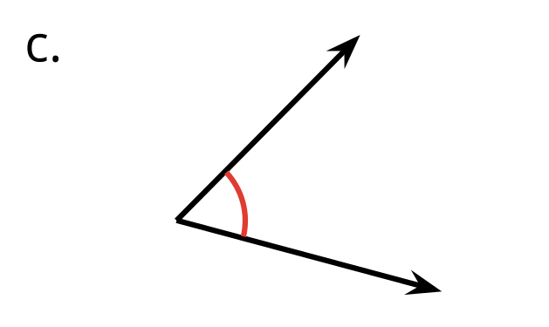
- 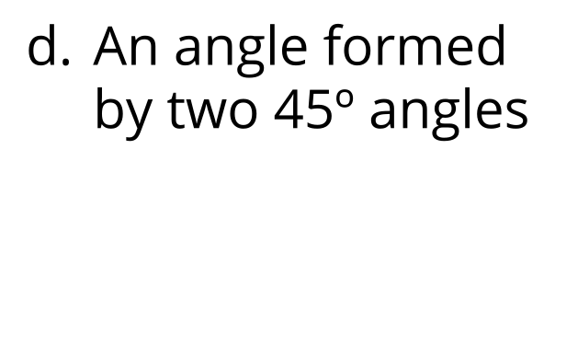
- 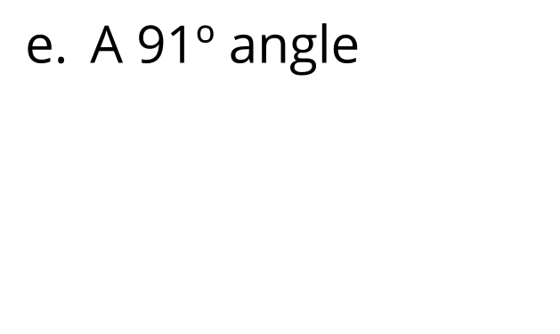
- 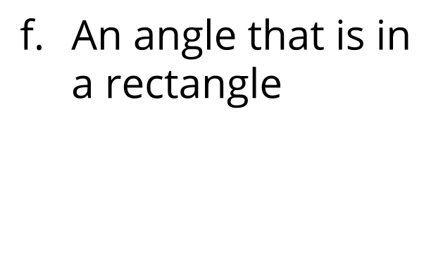
- 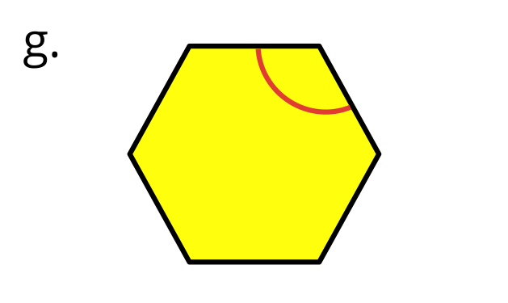
- 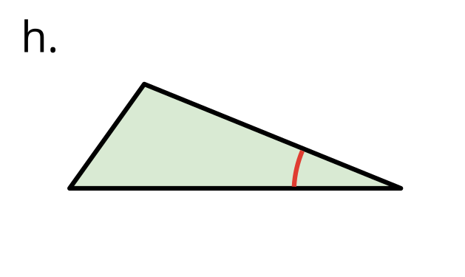
- 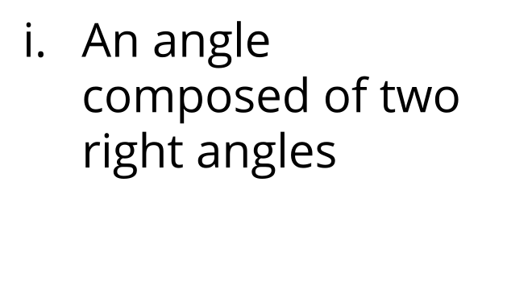
- 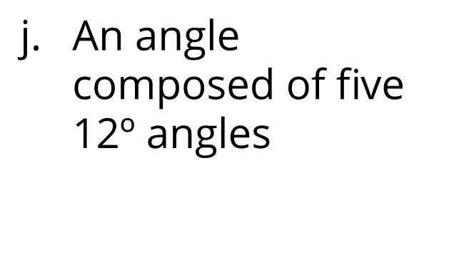
- Here is a drawing of the structure of a roof.
- 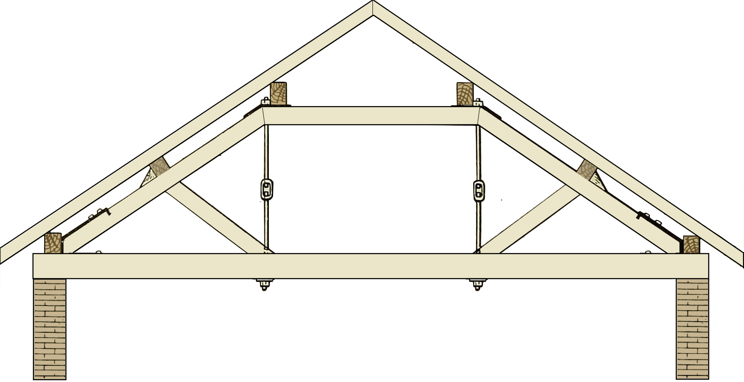
- Find as many acute and obtuse angles as you can in the drawing.
- Use an “A” to label acute angles, a square (◻) for right angles, and an “O” for obtuse angles.

- 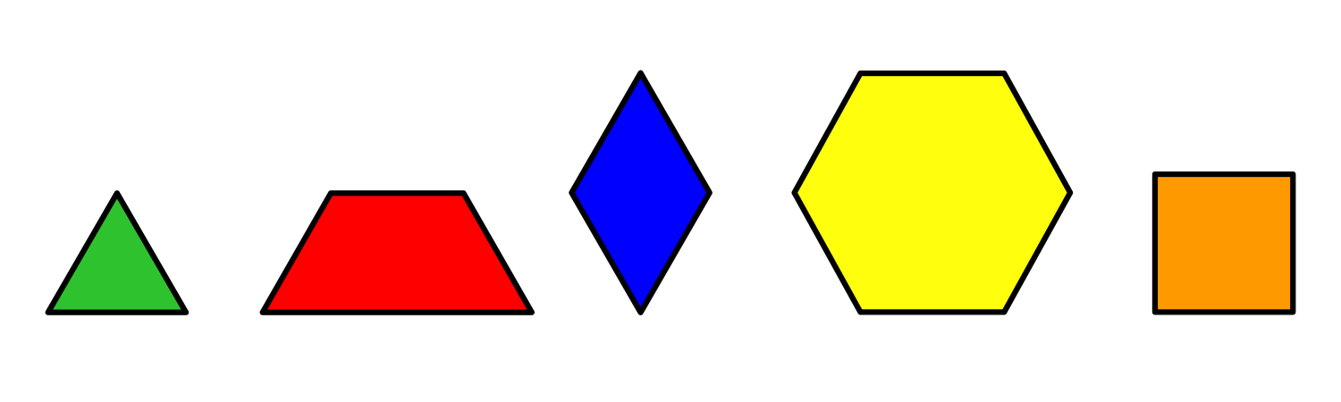
  - Diego is holding a pattern block that has 2 acute angles and 2 obtuse angles. Which pattern block could it be?
  - He then picks up a pattern block with no obtuse angles. Which pattern block could he be picking up? Explain your reasoning.

Images for Activity Synthesis
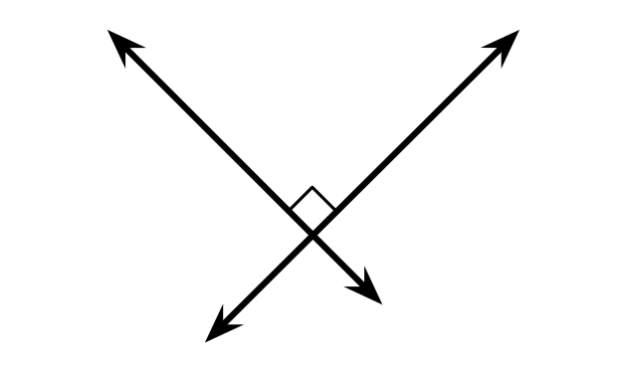
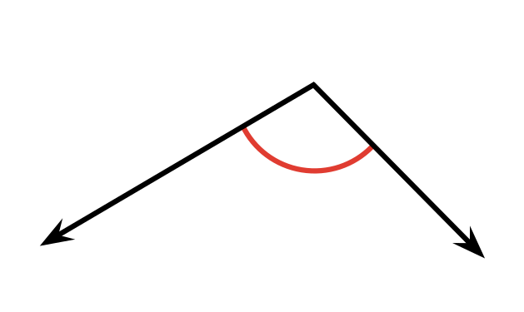
© CC BY 2021 Illustrative Mathematics®

