Unit 7 Lesson 10: Problem Solving With Perimeter and Area

WU True or False: Divide in Parts (Warm up)

Student Task Statement
Decide if each statement is true or false. Be prepared to explain your reasoning.
- $60÷6=10$
- $72÷6=\left(60÷6\right)+\left(12÷6\right)$
- $78÷6=\left(60÷10\right)+\left(18÷6\right)$
- $96÷8=\left(80÷8\right)−\left(16÷8\right)$

1 Rope Off the Garden

Student Task Statement
Andre wants to know how much rope is needed to enclose the new rectangular school garden. The length of the garden is 30 feet. The width of the garden is 8 feet.
- Clare says she can use multiplication to find the length of rope Andre needs.
- Diego says he can use addition to find the length of rope Andre needs.
Who do you agree with? Explain or show your reasoning.

2 Info Gap: A Garden and a Playground

Student Task Statement
Your teacher will give you either a problem card or a data card. Do not show or read your card to your partner.
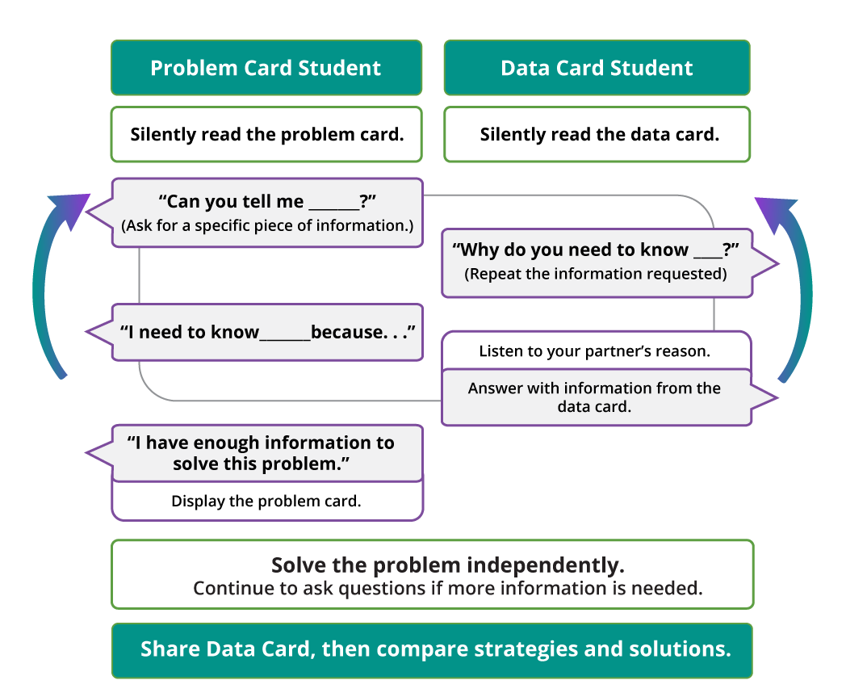
Pause here so your teacher can review your work.
Ask your teacher for a new set of cards and repeat the activity, trading roles with your partner.
© CC BY 2021 Illustrative Mathematics®

