Lesson 8: Area of Rectangles Without a Grid
- Let’s solve area problems without a grid.

Warm-up: How Many Do You See: One More, One Less
How many do you see? How do you see them?
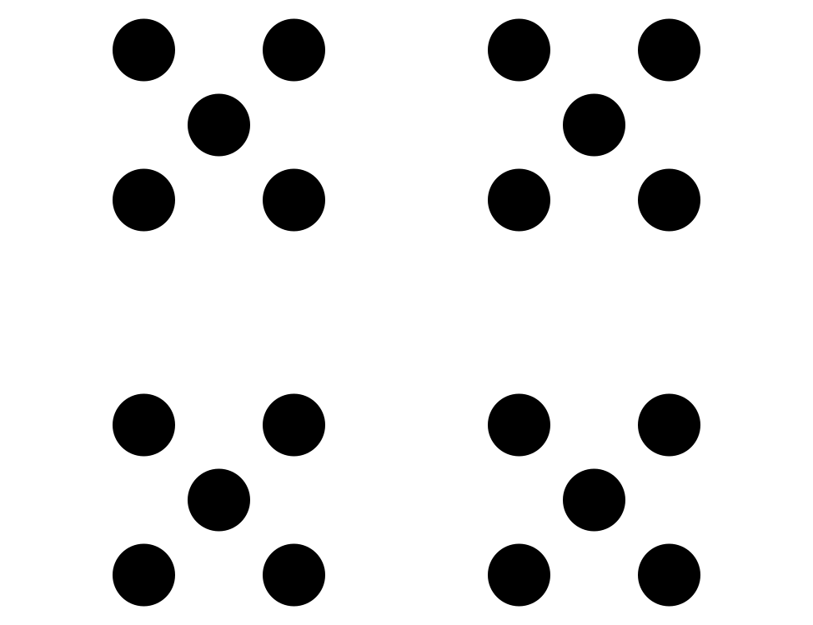
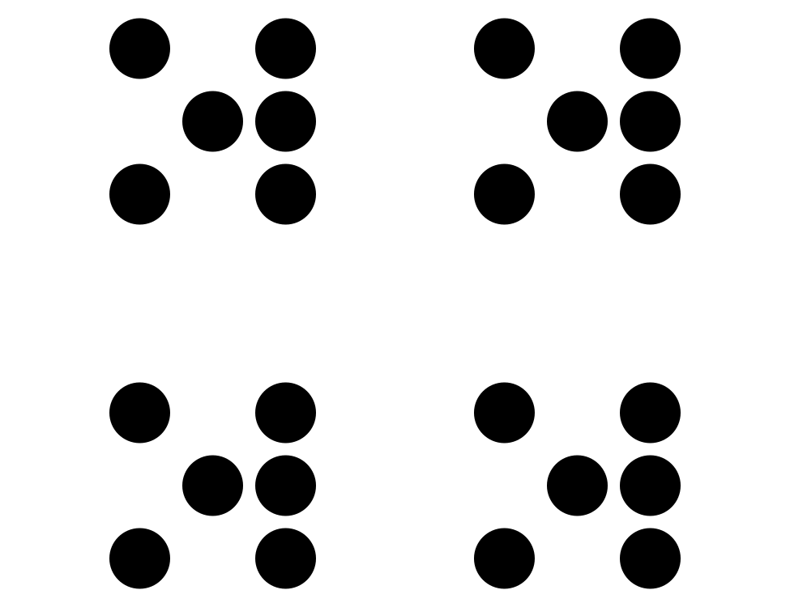
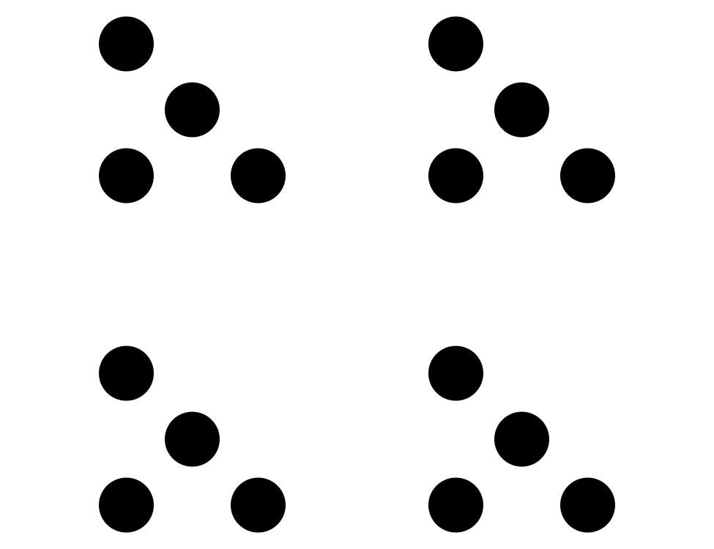

8.1: Partially Tiled
What do you notice? What do you wonder?
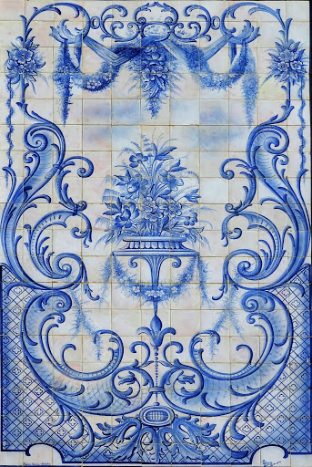
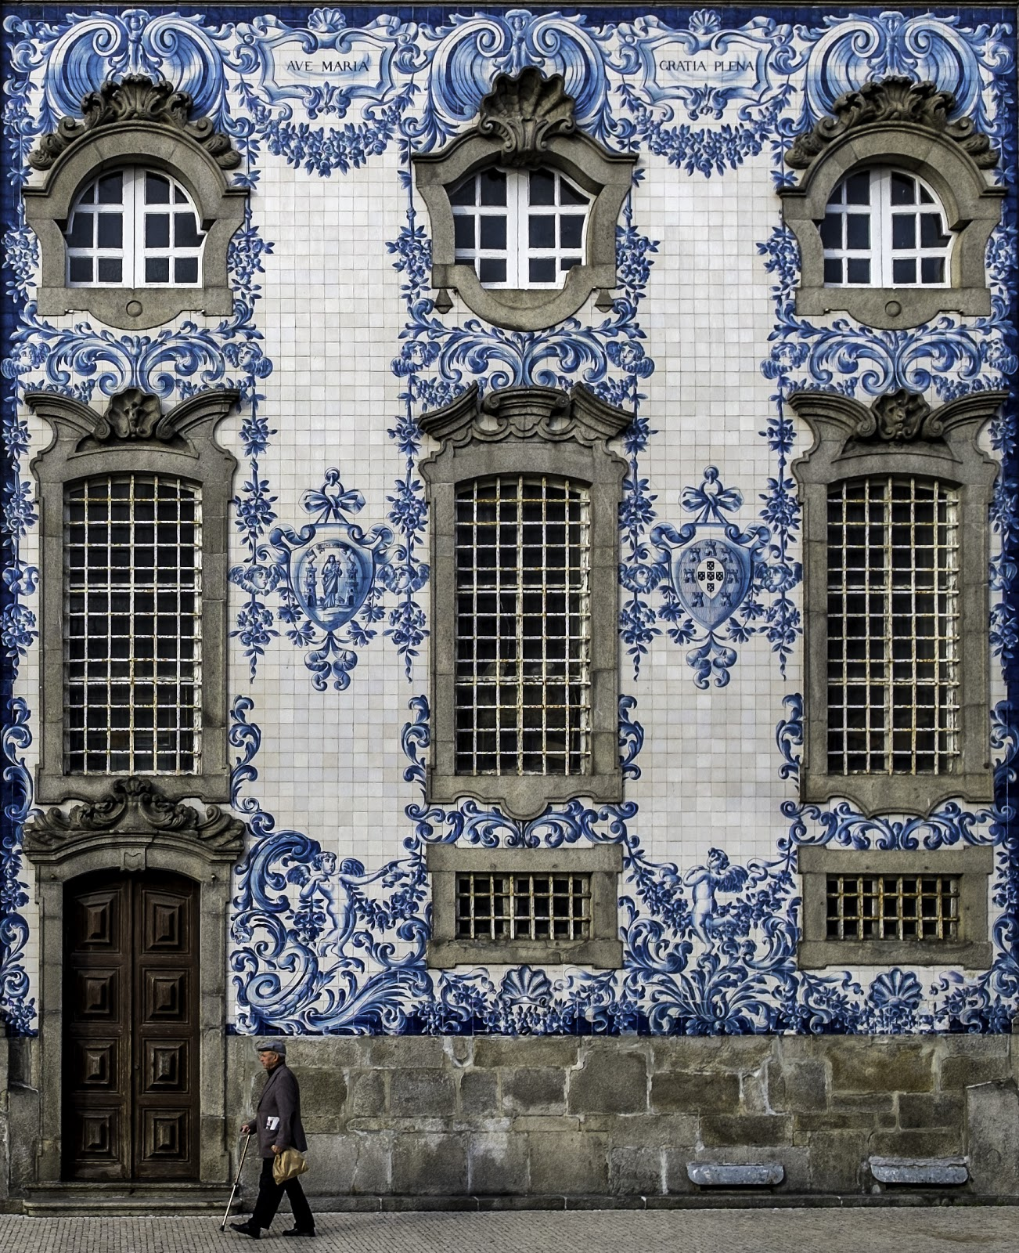
After learning about azulejos in Portugal, Elena is making her own tile artwork. This rectangle shows the project Elena is tiling. Each tile has a side length of 1 inch.
How many tiles are needed to tile the whole rectangle? Explain or show your reasoning.
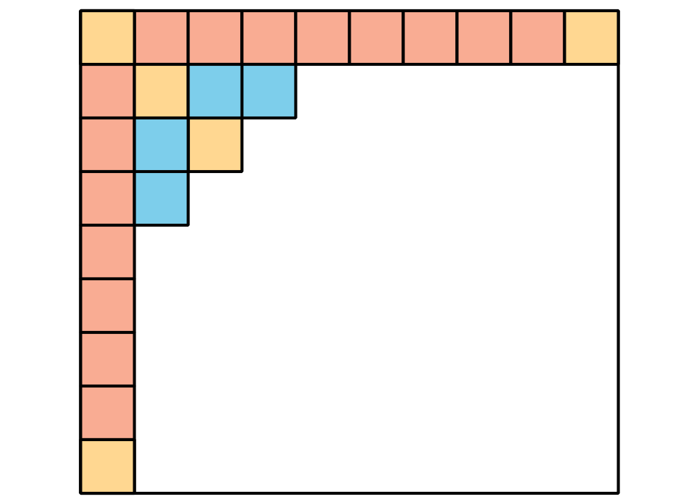

8.2: No More Squares
What is the area of the rectangle in square meters?
- The tick marks on the sides of the rectangle are 1 meter apart.
- What is the area of this rectangle in square meters?
- The top side of this rectangle is marked off in meter lengths. The left side is labeled with the length in meters.
- What is the area of this rectangle in square meters?
© CC BY 2021 Illustrative Mathematics®

