Lesson 7: Meters and Centimeters
- Let’s explore lengths in meters and centimeters.

Warm-up: Notice and Wonder: Big Bug, Little Bug
What do you notice? What do you wonder?
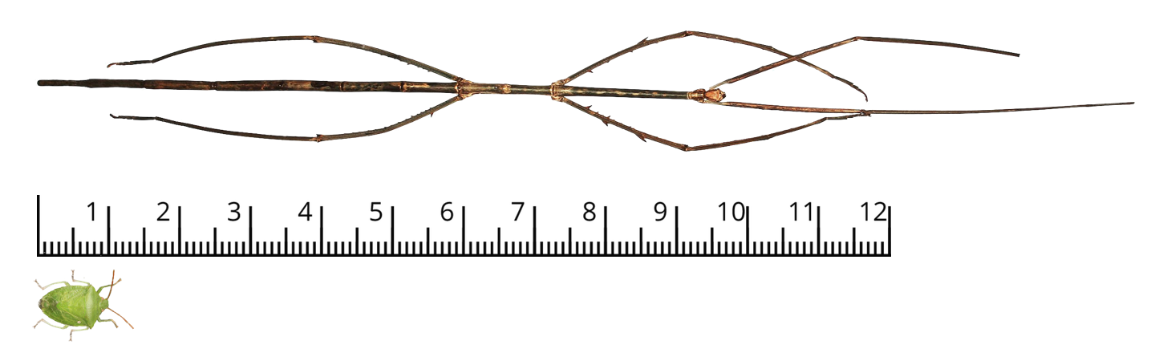

7.1: How Long is One Meter?
- Use the centimeter paper to build a strip that is 100 centimeters long. You will need scissors and tape.
- If you do it precisely, your paper strip will be 1 meter long.
- List 5 items in the classroom that you think are about 1 meter long.
- Then, use your paper strip to check how close your prediction is to 1 meter.
- Decide whether each of the following is more than 1 meter, less than 1 meter, or about 1 meter.
  - The stick insect in the warm-up activity
  - The step you make when walking
  - The step you make when running
  - Your arm span
- Be prepared to explain how you know.

7.2: In and Around the School
Priya took some measurements in meters and recorded them in the table, but she made some errors when converting them to centimeters. She also left out one measurement.
 | measurement in meters | measurement in centimeter
a. height of door | 2 | 200
b. height of hallway | 3 | 30
c. width of hallway | 5 | 500
d. length of gym | 18 | 180
e. length of hallway | 27 | 2,700
f. length of playground | 50
- Find and correct Priya’s conversion errors. Be prepared to explain how you know.
- Fill in the length of the playground in centimeters. Write an equation to represent your thinking.
© CC BY 2021 Illustrative Mathematics®

