Unit 7 Lesson 13: Find Angle Measurements

WU Notice and Wonder: Corner Pieces (Warm up)

Student Task Statement
What do you notice? What do you wonder?
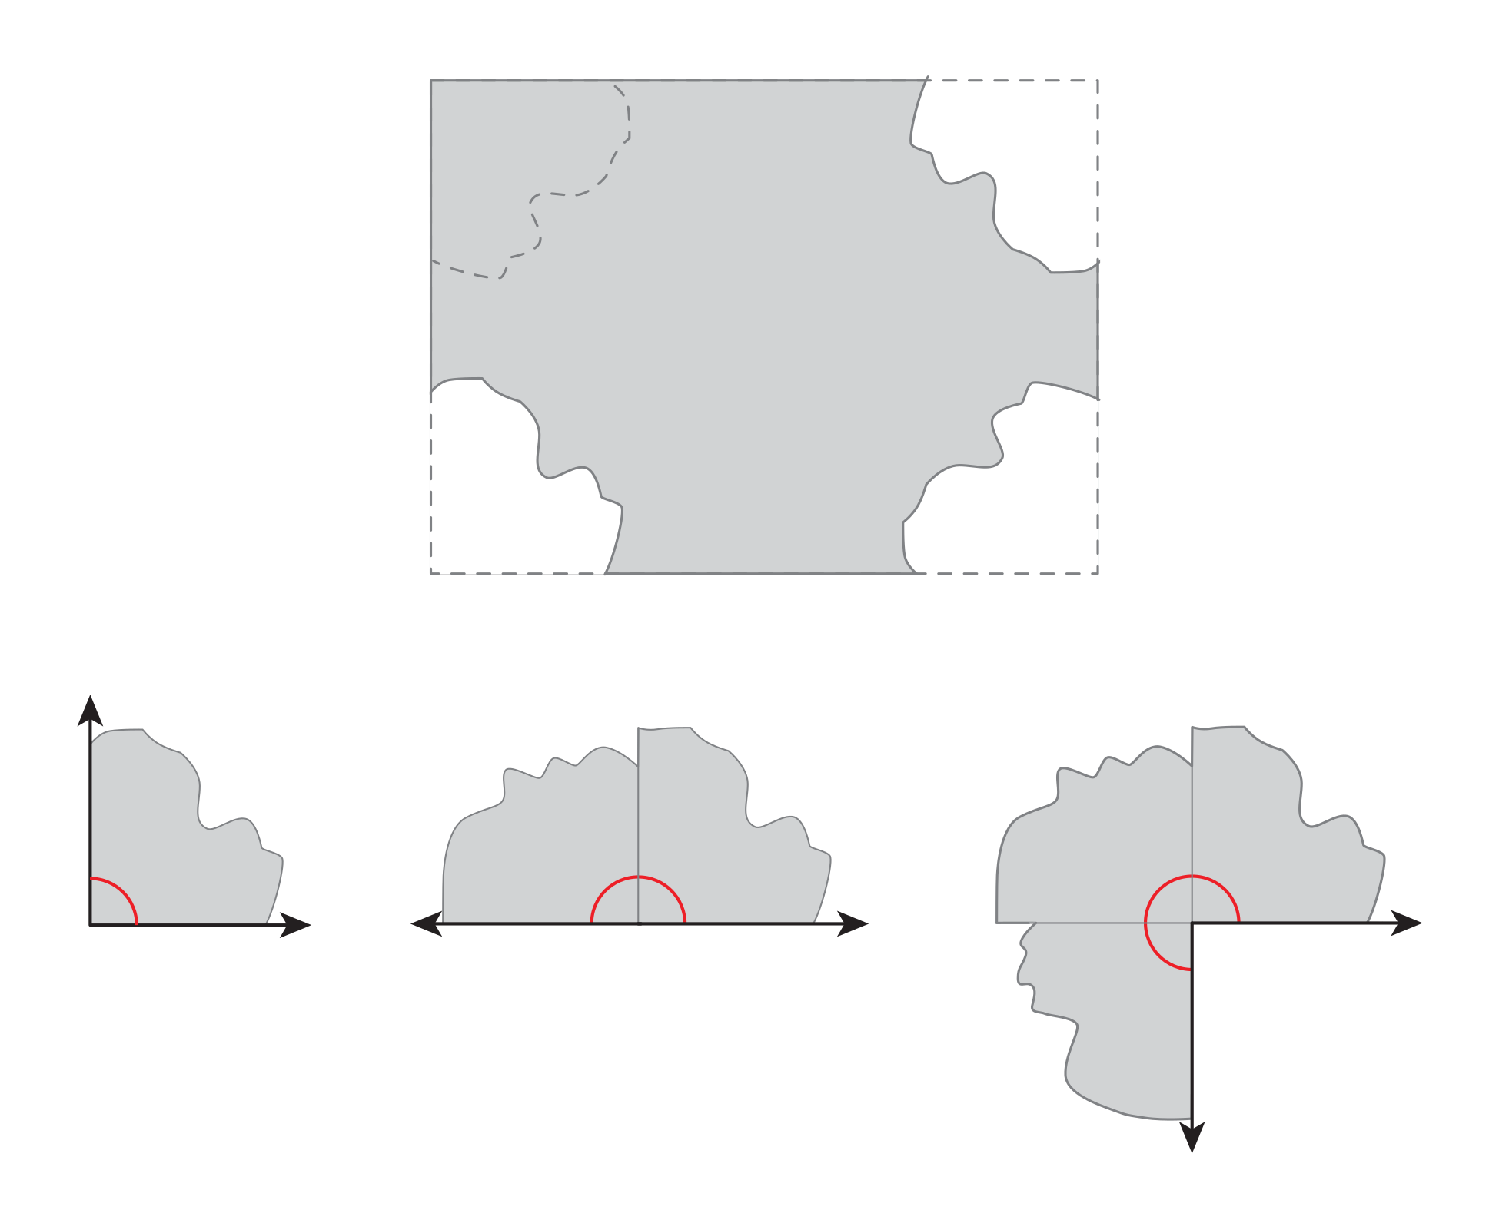

1 How Big Are These Angles?

Student Task Statement
Your teacher will give you materials that can help you find angle measurements.
- Use the materials and what you know about a right angle to find the size of angles $p$, $q$, $r$, and $s$. Be prepared to explain or show your reasoning.
- 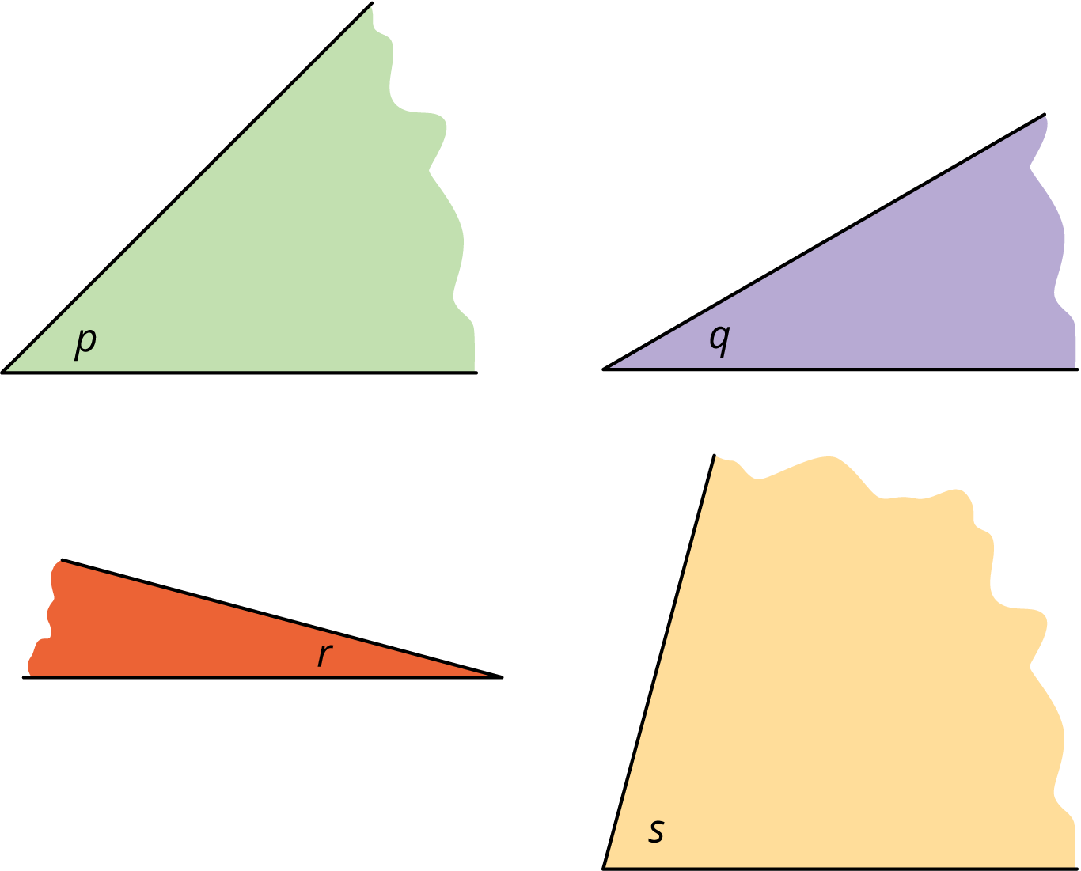
- Next, use the measurements of angles $p$, $q$, $r$, and $s$ to find the measurements of the following angles.
- 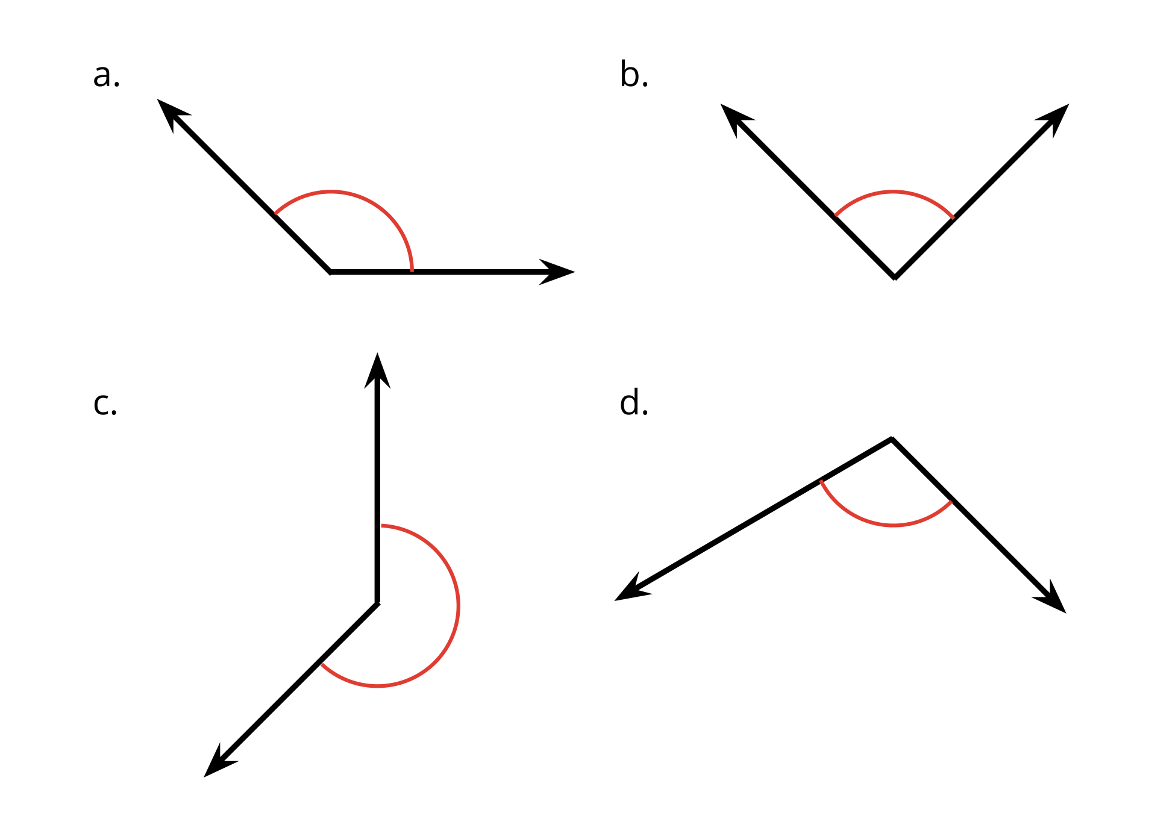

2 Angles in a Kite

Student Task Statement
Your teacher will give you a square sheet of paper. Follow the steps to fold the paper into a kite. Fold as precisely as possible.
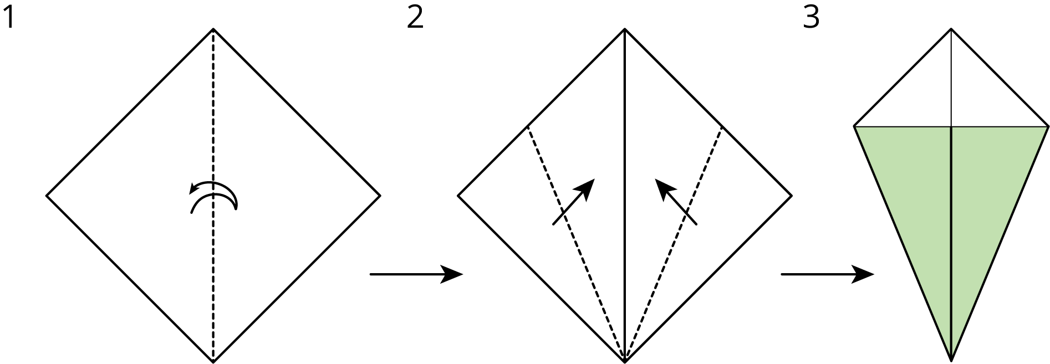
Can you find the measurement of each labeled angle on the kite? If so, show your reasoning. If not, explain why not.
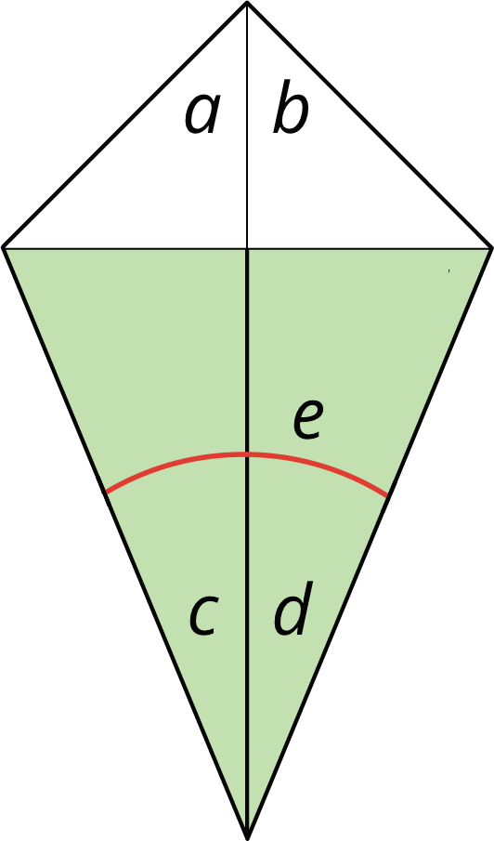

Images for Activity Synthesis
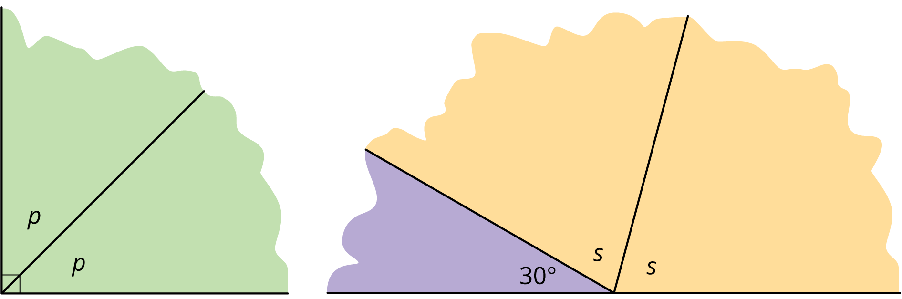
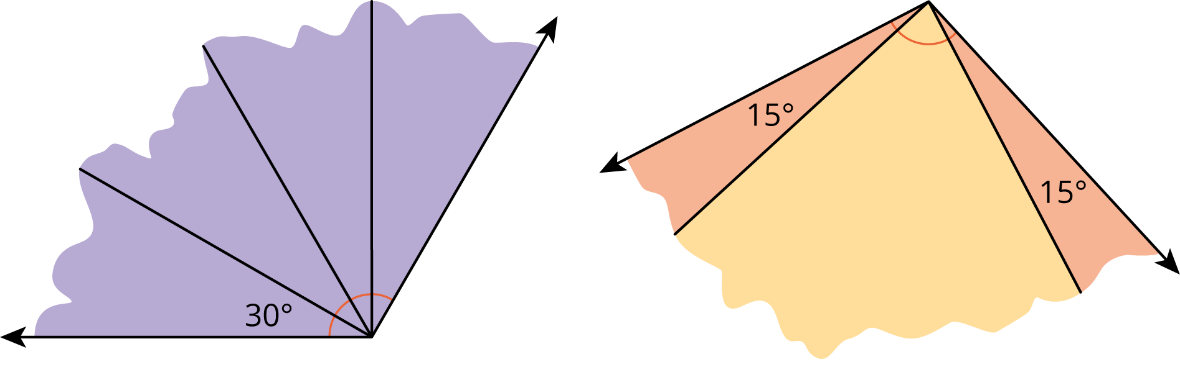
© CC BY 2021 Illustrative Mathematics®

