Lesson 2: Transformations as Functions
- Let’s compare transformations to functions.

2.1: Math Talk: Transforming a Point
Mentally find the coordinates of the image of $A$ under each transformation.
- Translate $A$ by the directed line segment from $(0,0)$ to $(0,2)$.
- Translate $A$ by the directed line segment from $(0,0)$ to $(\text{-}4,0)$.
- Reflect $A$ across the $x$-axis.
- Rotate $A$ 180 degrees clockwise using the origin as a center.

2.2: Inputs and Outputs
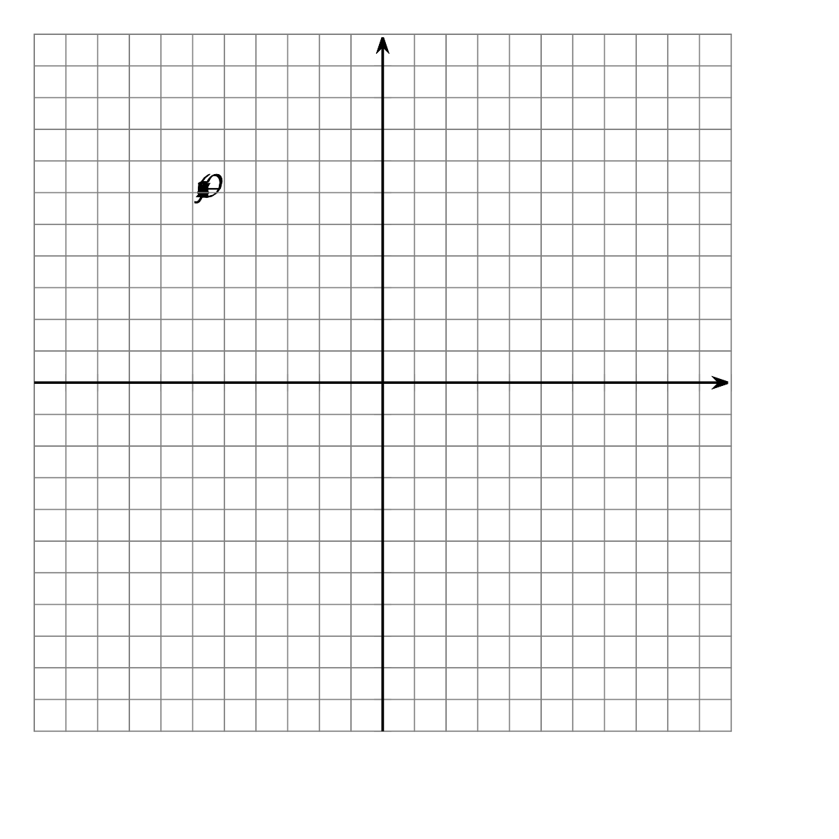
- For each point $(x,y)$, find its image under the transformation $(x+12,y−2)$.
  - $A=(\text{-}10,5)$
  - $B=(\text{-}4,9)$
  - $C=(\text{-}2,6)$
- Next, sketch triangle $ABC$ and its image on the grid. What transformation is $(x,y)→(x+12,y−2)$?
- For each point $(x,y)$ in the table, find $(2x,2y)$.
- $(x,y)$ | - $(2x,2y)$
- $(\text{-}1,\text{-}3)$
- $(\text{-}1,1)$
- $(5,1)$
- $(5,\text{-}3)$
- Next, sketch the original figure (the $(x,y)$ column) and image (the ($2x,2y)$ column). What transformation is $(x,y)→(2x,2y)$?

2.3: What Does it Do?
- Here are some transformation rules. Apply each rule to quadrilateral $ABCD$ and graph the resulting image. Then describe the transformation.
  - Label this transformation $Q$: $(x,y)→(2x,y)$
  - Label this transformation $R$: $(x,y)→(x,\text{-}y)$
  - Label this transformation $S$: $(x,y)→(y,\text{-}x)$

Are you ready for more?
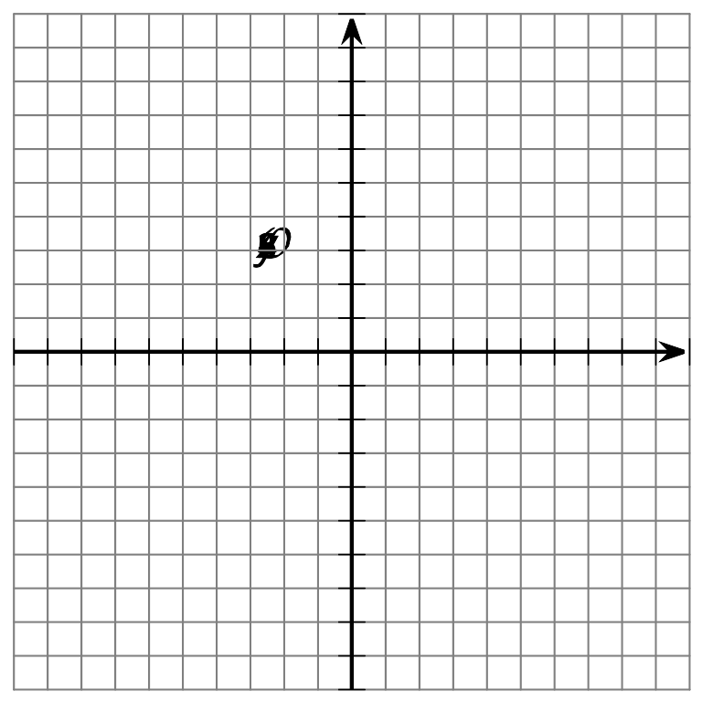
- Plot the quadrilateral with vertices $(4,\text{-}2),(8,4),(8,\text{-}6),$ and $(\text{-}6,\text{-}6)$. Label this quadrilateral $A$.
- Plot the quadrilateral with vertices $(\text{-}2,4),(4,8),(\text{-}6,8),$ and $(\text{-}6,\text{-}6)$. Label this quadrilateral $A^{′}$.
- How are the coordinates of quadrilateral $A$ related to the coordinates of quadrilateral $A^{′}$?
- What single transformation takes quadrilateral $A$ to quadrilateral $A^{′}$?

Lesson 2 Summary
Square $ABCD$ has been translated by the directed line segment from $(\text{-}1,1)$ to $(4,0)$. The result is square $A^{′}B^{′}C^{′}D^{′}$.
Here is a list of coordinates in the original figure and corresponding coordinates in the image. Do you see the rule for taking points in the original figure to points in the image?
original figure | image
$A=(\text{-}1,1)$ | $A^{′}=(4,0)$
$B=(1,1)$ | $B^{′}=(6,0)$
$C=(1,\text{-}1)$ | $C^{′}=(6,\text{-}2)$
$D=(\text{-}1,\text{-}1)$ | $D^{′}=(4,\text{-}2)$
$Q=(\text{-}0.5,1)$ | $Q^{′}=(4.5,0)$
This table looks like a table that shows corresponding inputs and outputs of a function. A transformation is a special type of function that takes points in the plane as inputs and gives other points as outputs. In this case, the function’s rule is to add 5 to the $x$-coordinate and subtract 1 from the $y$-coordinate.
We write the rule this way: $(x,y)→(x+5,y−1)$.
© CC BY 2019 by Illustrative Mathematics®

