Unit 6 Lesson 6: Building Quadratic Functions to Describe Situations (Part 2)

1 Sky Bound

Student Task Statement
A cannon is 10 feet off the ground. It launches a cannonball straight up with a velocity of 406 feet per second.
Imagine that there is no gravity and that the cannonball continues to travel upward with the same velocity.
- Complete the table with the heights of the cannonball at different times.
- seconds | - 0 | - 1 | - 2 | - 3 | - 4 | - 5 | - $t$
- distance above ground (feet) | - 10
- Write an equation to model the distance in feet, $d$, of the ball $t$ seconds after it was fired from the cannon if there was no gravity.

2 Tracking a Cannonball

Student Task Statement
Earlier, you completed a table that represents the height of a cannonball, in feet, as a function of time, in seconds, if there was no gravity.
- This table shows the actual heights of the ball at different times.
- seconds | - 0 | - 1 | - 2 | - 3 | - 4 | - 5
- distance above ground (feet) | - 10 | - 400 | - 758 | - 1,084 | - 1,378 | - 1,640
- Compare the values in this table with those in the table you completed earlier. Make at least 2 observations.

  - Plot the two sets of data you have on the same coordinate plane.
  - 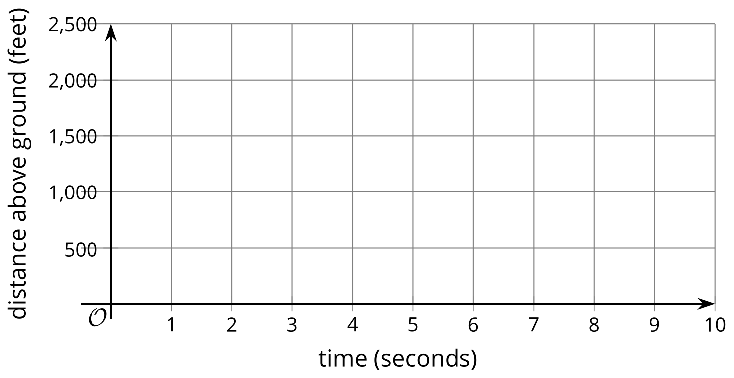
  - How are the two graphs alike? How are they different?
- Write an equation to model the actual distance $d$, in feet, of the ball $t$ seconds after it was fired from the cannon. If you get stuck, consider the differences in distances and the effects of gravity from a previous lesson.

3 Graphing Another Cannonball

Student Task Statement
The function defined by $d=50+312t−16t^{2}$ gives the height in feet of a cannonball $t$ seconds after the ball leaves the cannon.
- What do the terms 50, $312t$, and $\text{-}16t^{2}$ tell us about the cannonball?
- Use graphing technology to graph the function. Adjust the graphing window to the following boundaries: $0<x<25$ and $0<y<2,​000$.
- Observe the graph and:
  - Describe the shape of the graph. What does it tell us about the movement of the cannonball?
  - Estimate the maximum height the ball reaches. When does this happen?
  - Estimate when the ball hits the ground.
- What domain is appropriate for this function? Explain your reasoning.
© CC BY 2019 by Illustrative Mathematics®

