Lesson 9 Practice Problems
- What is the length of segment $DF$?
- 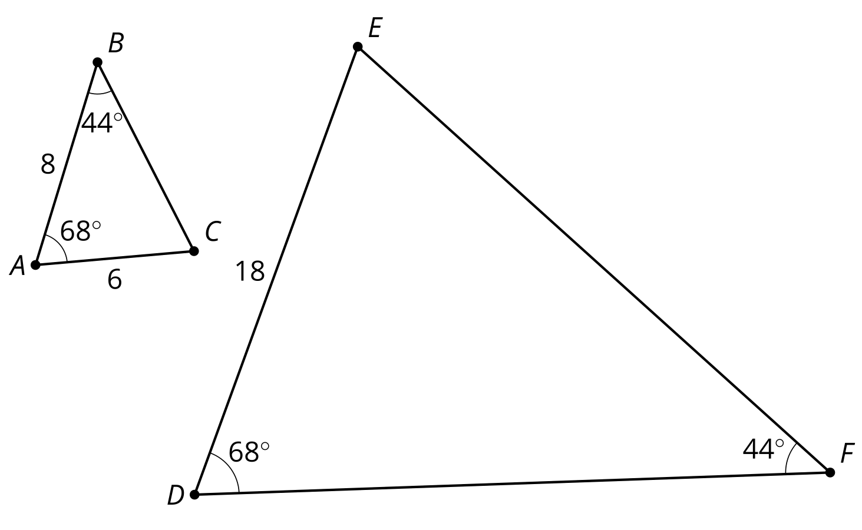
- In triangle $ABC$, angle $A$ is 35º and angle $B$ is 20º. Select all triangles which are similar to triangle $ABC$.
  - triangle $DEF$ where angle $D$ is 35º and angle $E$ is 20º
  - triangle $GHI$ where angle $G$ is 35º and angle $I$ is 30º
  - triangle $JKL$ where angle $J$ is 35º and angle $L$ is 125º
  - triangle $MNO$ where angle $N$ is 20º and angle $O$ is 125º
  - triangle $PQR$ where angle $Q$ is 20º and angle $R$ is 30º
- Decide whether triangles $ABC$ and $DEC$ are similar. Explain or show your reasoning.
- 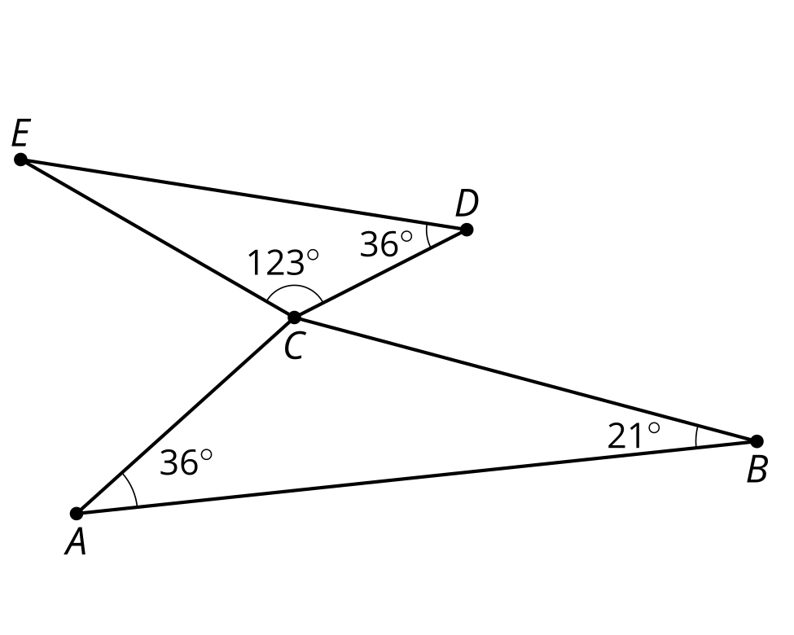
- Lin is trying to convince Andre that all circles are similar. Help her write a valid justification for why all circles are similar.
- (From Unit 3, Lesson 8.)
- Must these parallelograms be similar? Explain your reasoning.
- ​​​​​
- (From Unit 3, Lesson 8.)
- Determine if each statement must be true, could possibly be true, or definitely can't be true. Explain or show your reasoning.
  - An equilateral triangle and a right triangle are similar.
  - A right triangle and an isosceles triangle are similar.
- (From Unit 3, Lesson 7.)
- Quadrilaterals $Q$ and $P$ are similar.
- What is the scale factor of the dilation that takes $P$ to $Q$?
- 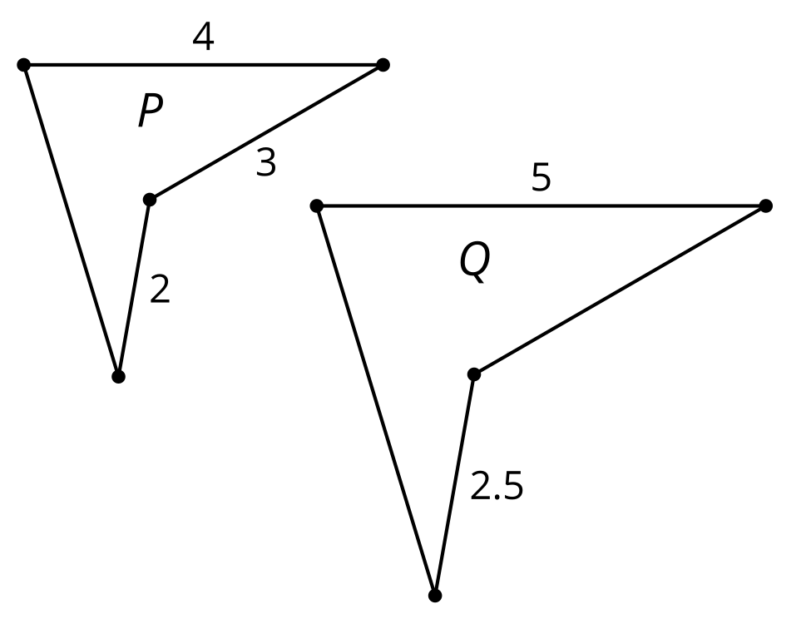
  - $\frac{3}{5}$
  - $\frac{4}{5}$
  - $\frac{5}{4}$
  - $\frac{5}{3}$
- (From Unit 3, Lesson 6.)
- The circle centered at $Q$ is a scaled copy of the circle centered at $R$.
  - Find the scale factor.
  - Find the value of $x$.
- 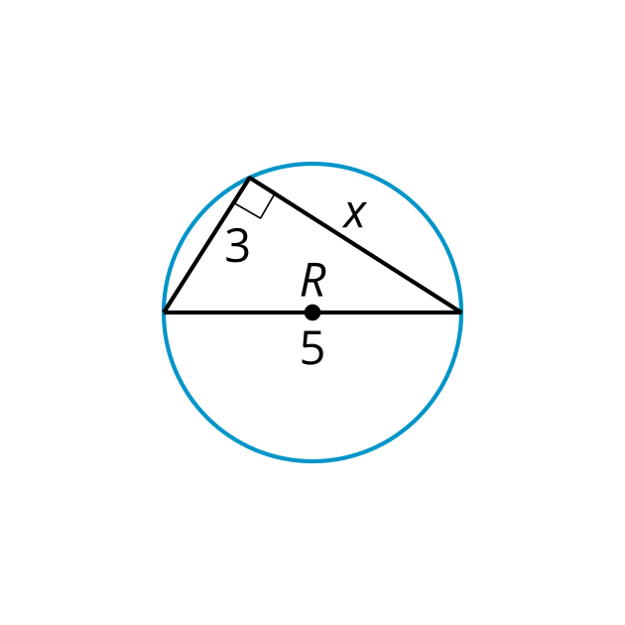
- 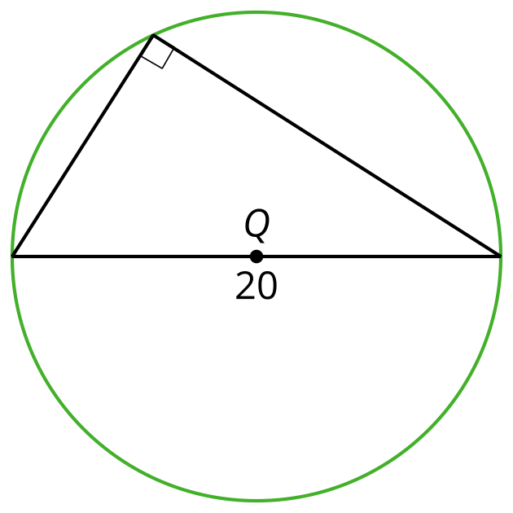
- (From Unit 3, Lesson 1.)
© CC BY 2019 by Illustrative Mathematics®

