Lesson 9: Measure to Find the Area
- Let’s measure the sides of rectangles and find the area.

Warm-up: Notice and Wonder: Groups and Arrays
What do you notice? What do you wonder?

9.1: Measure to Find Area
Use a ruler to measure the rectangles. Then, calculate the area of the rectangles in square centimeters.
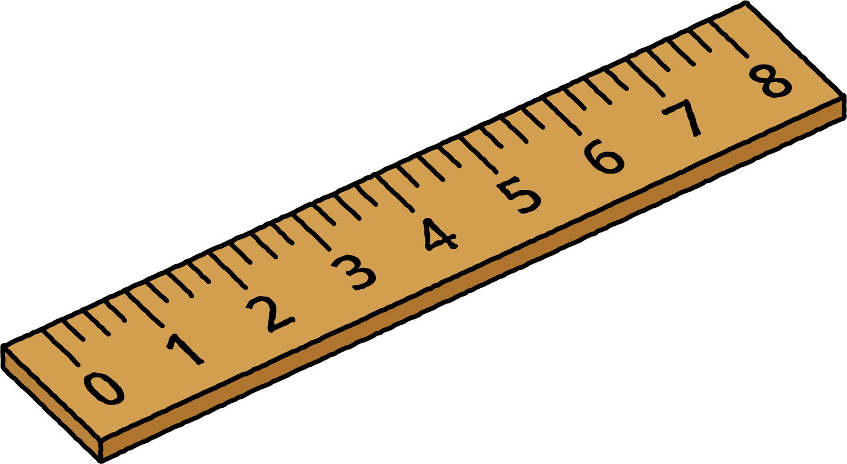
A
B
C

9.2: Create a Rectangle
Your teacher will give you some tape. Use it to create a rectangle with your assigned area.
- Area 1: 4 square feet
- Area 2: 6 square feet
- Area 3: 9 square feet
- Area 4: 10 square feet
- Area 5: 12 square feet
- Area 6: 16 square feet
© CC BY 2021 Illustrative Mathematics®

