Lesson 8: Meters and Kilometers
- Let’s explore measurements in meters and kilometers.

Warm-up: Number Talk: Times Hundreds and Thousands
Find the value of each expression mentally.
- $3×100$
- $40×100$
- $43×100$
- $43×1,​000$

8.1: How Long is One Kilometer?
There are 1,000 meters in 1 kilometer.
- The darkly shaded section of the track is the length of a 100-meter race. How many 100-meter races does it take to travel 1 kilometer?
- 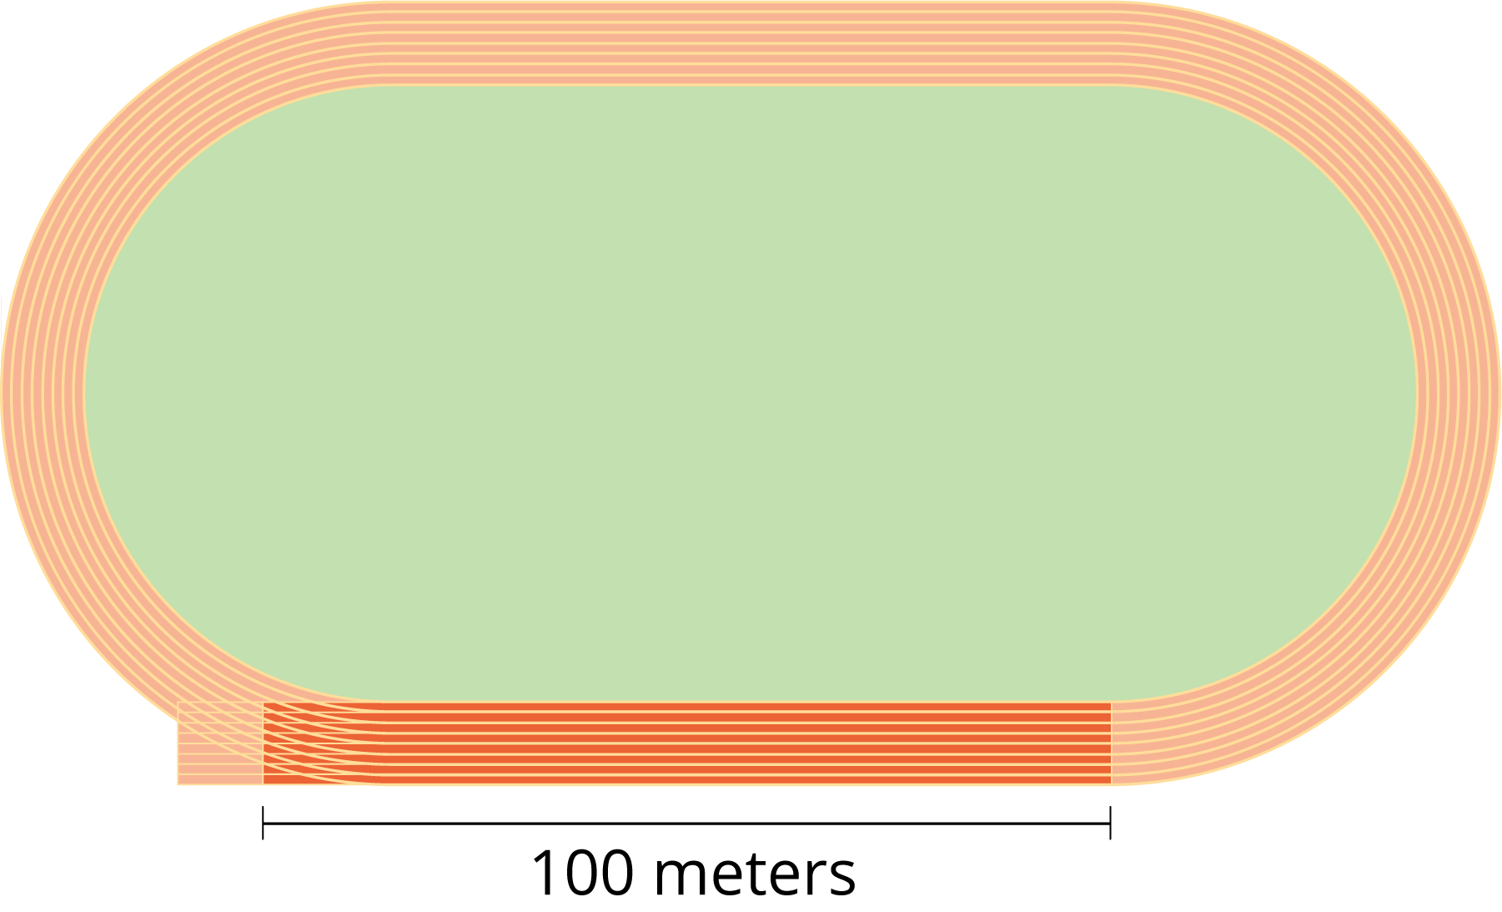
- Your teacher will give you images of something with a length or height measured in meters.
- About how many of the items given to you are needed to make 1 kilometer? Explain or show how you know.
- Work with your group to write a number in the blank so that each statement is true.
  - One kilometer is the length of (about, exactly) __________ soccer fields.
  - One kilometer is the length of (about, exactly) __________ Statues of Liberty.
  - One kilometer is the length of (about, exactly) __________ Olympic-size swimming pools.
  - One kilometer is the length of (about, exactly) __________ basketball courts.
- Estimate where you might end up if you travel 1 kilometer from your school’s front door.

8.2: Meters and Kilometers
- Complete the table with the missing lengths in meters or kilometers.
- kilometers (km) | - meters (m)
- $\frac{1}{2}$ | - 000000000000
- 1 | - 1,000
- 5
 | - 6,000
- $8\frac{1}{2}$
- 10
 | - 12,000
- 27
- Andre says 100 meters is longer than 10 kilometers. Do you agree or disagree? Explain or show your reasoning.
- Which is greater? Be prepared to explain how you know.
  - 2,000 meters or 3 kilometers
  - 500 meters or 1 kilometer
  - 14 kilometers or 14,000 meters
  - 8 kilometers or 80,000 meters
© CC BY 2021 Illustrative Mathematics®

