Unit 7 Lesson 14: Reasoning about Angles (Part 1)

WU Which One Doesn’t Belong: Time After Time (Warm up)

Student Task Statement
Which one doesn’t belong?
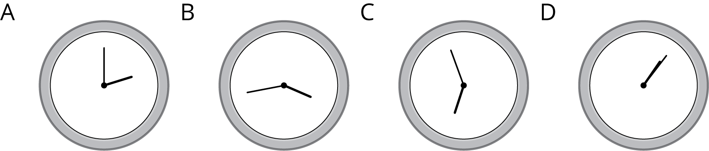

1 Draw a Clock

Student Task Statement
Kiran is drawing a clock. He draws a pair of perpendicular lines to find the placement of the numbers 3, 6, 9, and 12 around the circle.
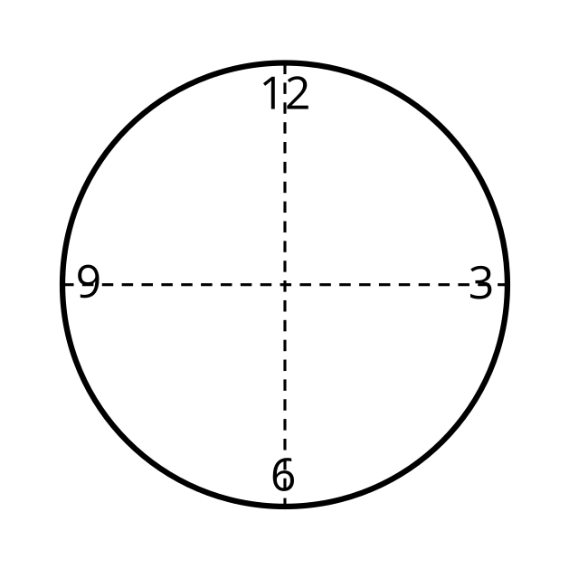
- How many degrees is each angle he has drawn so far? Explain how you know.
- Help Kiran find the exact placement of the numbers “1” and “2” on the clock.
  - How many new lines does he need to draw?
  - What angles should be formed between the two lines he has already drawn and the new ones?
  - Draw the lines precisely and place the numbers “1” and “2” on the drawing.
- Measure and draw as many lines as needed to complete the clock drawing so that all the numbers are precisely placed where they should be.

2 Tick Tock

Student Task Statement
- What angles are formed by the hour and minute hands of the clock at these times?
  - 6 o’clock
  - 8 o’clock
  - 9 o’clock
  - 11 o’clock
  - 12 o’clock
- How many degrees has the minute hand turned when it moves from 2:00 to 2:05?
- What about from 2:05 to 2:30? Explain how you know.
- The minute hand of the clock is vertical at 7 p.m. Sometime later, it makes an angle that is ${120}^{∘}$ from where it was at 7 p.m. What time could it be?
- How many degrees does the minute hand turn in:
  - 10 minutes?
  - 1 minute?
  - 4 minutes?

Images for Activity Synthesis
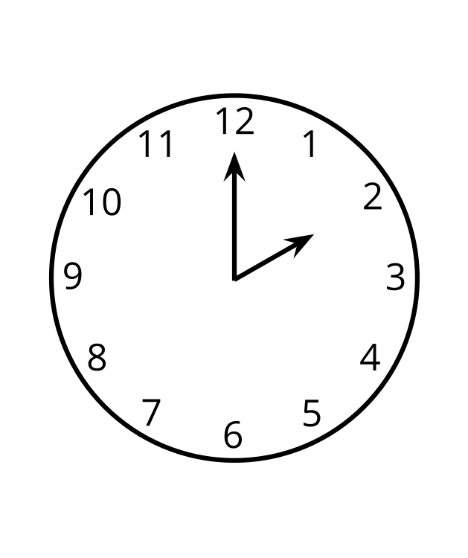
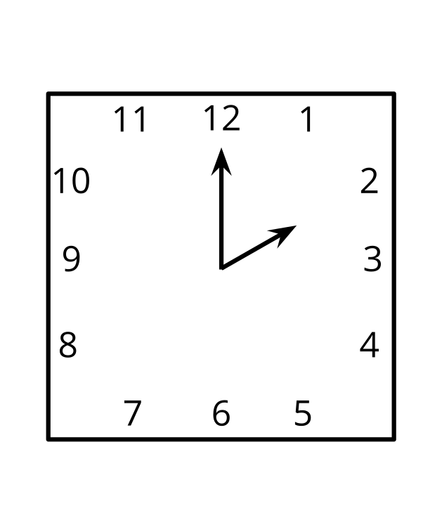
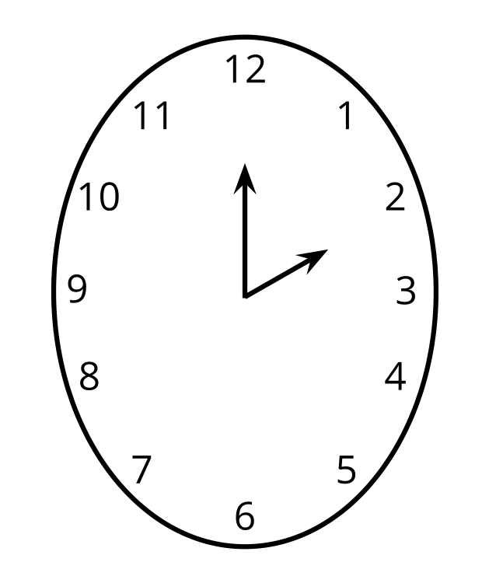
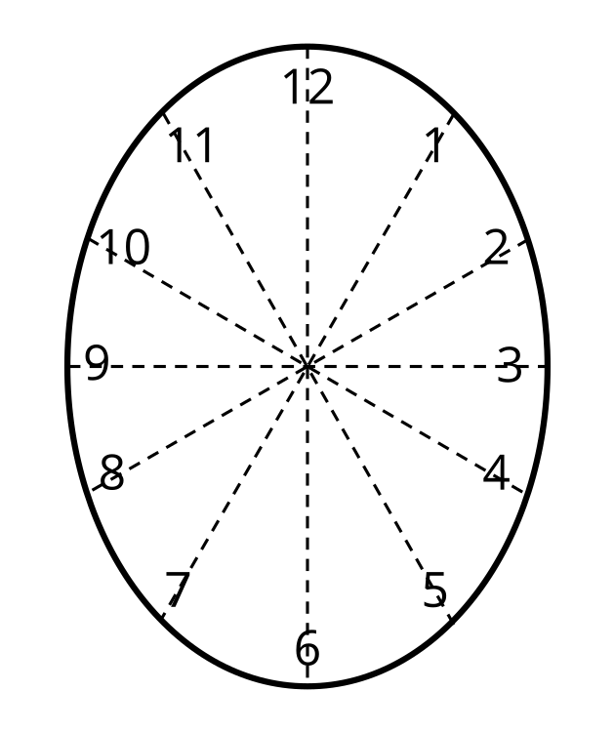
© CC BY 2021 Illustrative Mathematics®

