Lesson 5: Representemos datos en gráficas de barras con escala

Standards Alignments
Addressing | 3.MD.B, 3.MD.B.3
Building Towards | 3.MD.B.3

Teacher-facing Learning Goals
- Represent data using scaled bar graphs.

Student-facing Learning Goals
- Hagamos una gráfica de barras con escala.

Lesson Purpose
The purpose of this lesson is for students to create a scaled bar graph.
In a previous lesson, students collected categorical class data and learned how to create a scaled picture graph. Students now make connections between scaled picture graphs and scaled bar graphs, and expand the idea of a scale that is more than one to bar graphs. In this lesson students choose a scale of 2 or 5 for their bar graph.
Math Community
Tell students that, at the end of the lesson, they will be asked to identify specific examples of norms they experienced as they did math.

Access for:

Students with Disabilities
- Engagement (Activity 2)

English Learners
- MLR7 (Activity 2)

Instructional Routines
Number Talk (Warm-up)

Materials to Gather
- Materials from a previous lesson: Activity 2

Lesson Timeline
Warm-up | 10 min
Activity 1 | 10 min
Activity 2 | 25 min
Lesson Synthesis | 10 min
Cool-down | 5 min

Teacher Reflection Question
Based on students’ prior work with scaled picture graphs, what strategy did you anticipate today? What strategy did you not anticipate?

Cool-down
(to be completed at the end of the lesson) 5min
Completa una gráfica de barras con escala

Standards Alignments
Addressing | 3.MD.B.3

Student-facing Task Statement
A unos estudiantes que estaban de visita en el zoológico les preguntaron: “¿Cuál es tu animal favorito del zoológico?”.
Sus respuestas se muestran en esta tabla:
animal | número de estudiantes
elefante | 17
tigre | 10
jirafa | 14
nutria | 4
Usa los datos de la tabla para completar la gráfica de barras con escala.
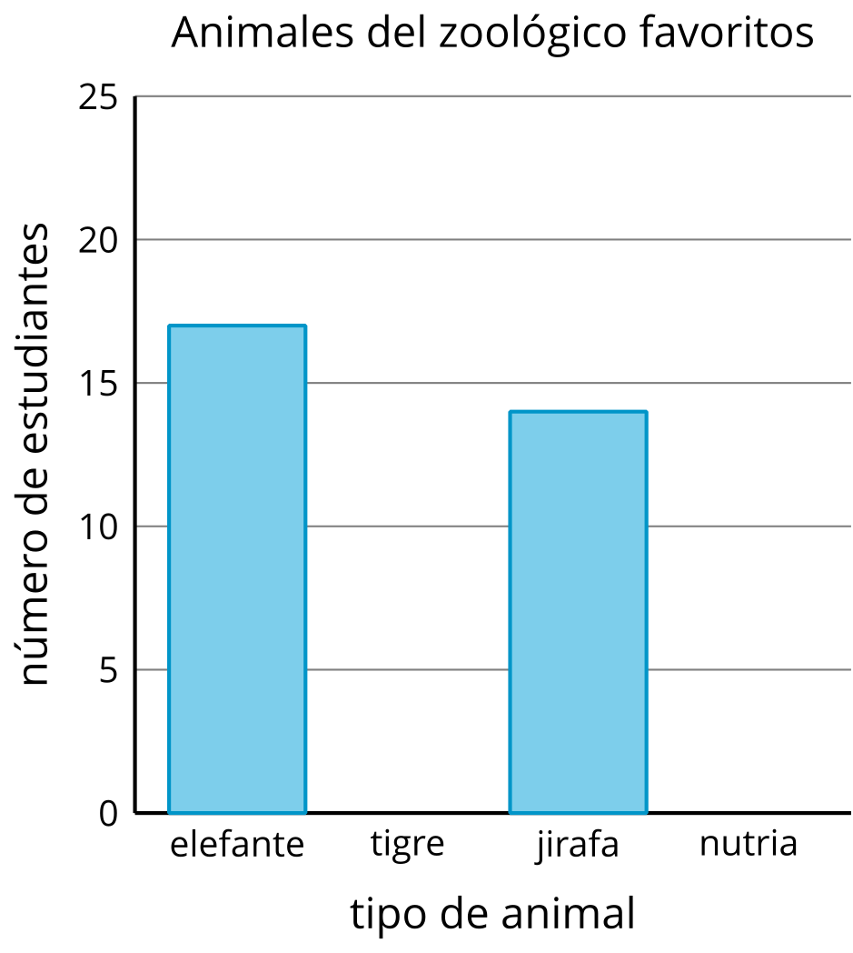

Student Responses
Student bar graphs should show 10 students chose tigers and 4 students chose otters.
