Lesson 6 Practice Problems
- $f\left(x\right)=\left(x+3\right)\left(x−4\right)$ and $g\left(x\right)=\frac{1}{3}\left(x+3\right)\left(x−4\right)$. The graphs of each are shown here.
- 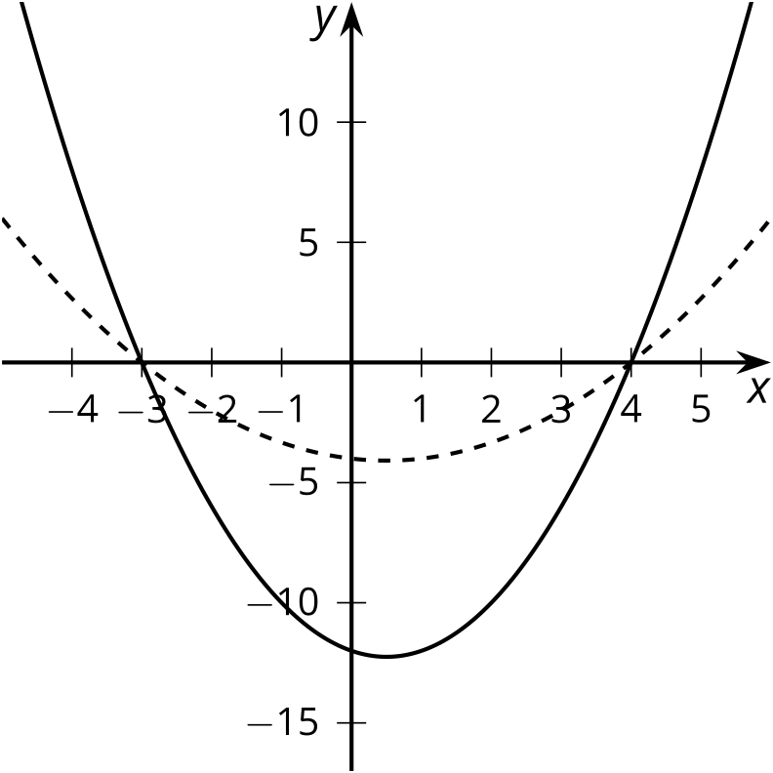
  - Which graph represents which polynomial function? Explain how you know.
- For each polynomial function, rewrite the polynomial in standard form. Then state its degree and constant term.
  - $f\left(x\right)=\left(x+1\right)\left(x+3\right)\left(x−4\right)$
  - $g\left(x\right)=3\left(x+1\right)\left(x+3\right)\left(x−4\right)$
- Tyler incorrectly says that the constant term of $\left(x+4\right)\left(x−4\right)$ is zero.
  - What is the correct constant term?
  - What is Tyler’s mistake? Explain your reasoning.
- Which of these standard form equations is equivalent to $\left(x+1\right)\left(x−2\right)\left(x+4\right)\left(3x+7\right)$?
  - $x^{4}+10x^{3}+15x^{2}−50x−56$
  - $x^{4}+10x^{3}+15x^{2}−50x+56$
  - $3x^{4}+16x^{3}+3x^{2}−66x−56$
  - $3x^{4}+16x^{3}+3x^{2}−66x+56$
- Select all polynomial expressions that are equivalent to $5x^{3}+7x−4x^{2}+5$.
  - $13x^{5}$
  - $5x^{3}−4x^{2}+7x+5$
  - $5x^{3}+4x⋅2+7x+5$
  - $5+4x−7x^{2}+5x^{3}$
  - $5+7x−4x^{2}+5x^{3}$
- (From Unit 2, Lesson 2.)
- Select all the points which are relative minimums of this graph of a polynomial function.
- 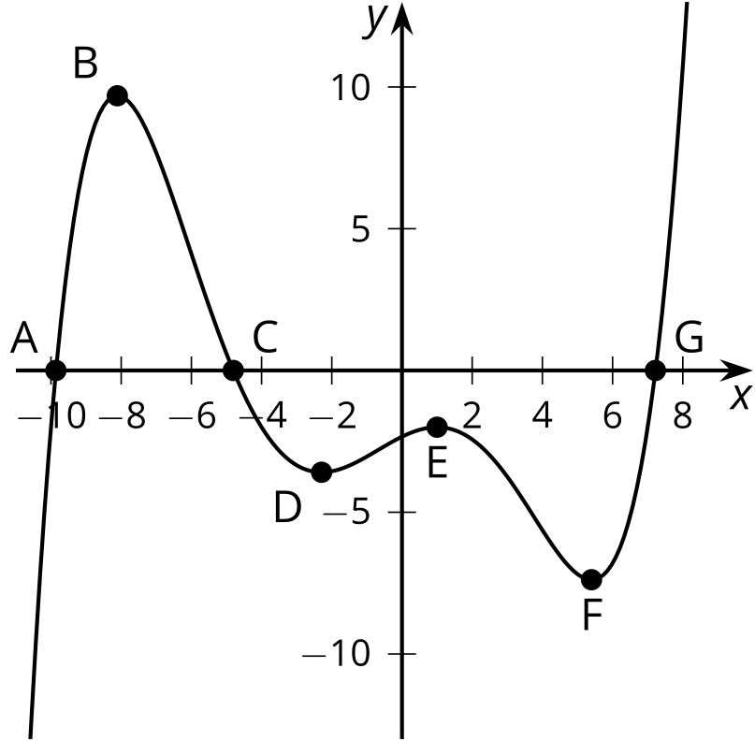
  - Point $A$
  - Point $B$
  - Point $C$
  - Point $D$
  - Point $E$
  - Point $F$
  - Point $G$
- (From Unit 2, Lesson 3.)
- What are the $x$-intercepts of the graph of $y=\left(3x+8\right)\left(5x−3\right)\left(x−1\right)$?
- (From Unit 2, Lesson 5.)
© CC BY 2019 by Illustrative Mathematics®

