Lesson 10: Solve Area Problems
- Let’s solve area problems.

Warm-up: Number Talk: One More Group
Find the value of each expression mentally.
- $5×2$
- $6×2$
- $5×6$
- $6×6$

10.1: Paint a Wall
Noah is painting a wall in a community garden. The wall is shaped like a rectangle. A diagram of the wall is shown here.
Paint is sold in 3 different sizes:
- A small container will cover 3 square meters.
- A medium container will cover 10 square meters.
- A large container will cover 40 square meters.
What should Noah buy? Explain your reasoning.
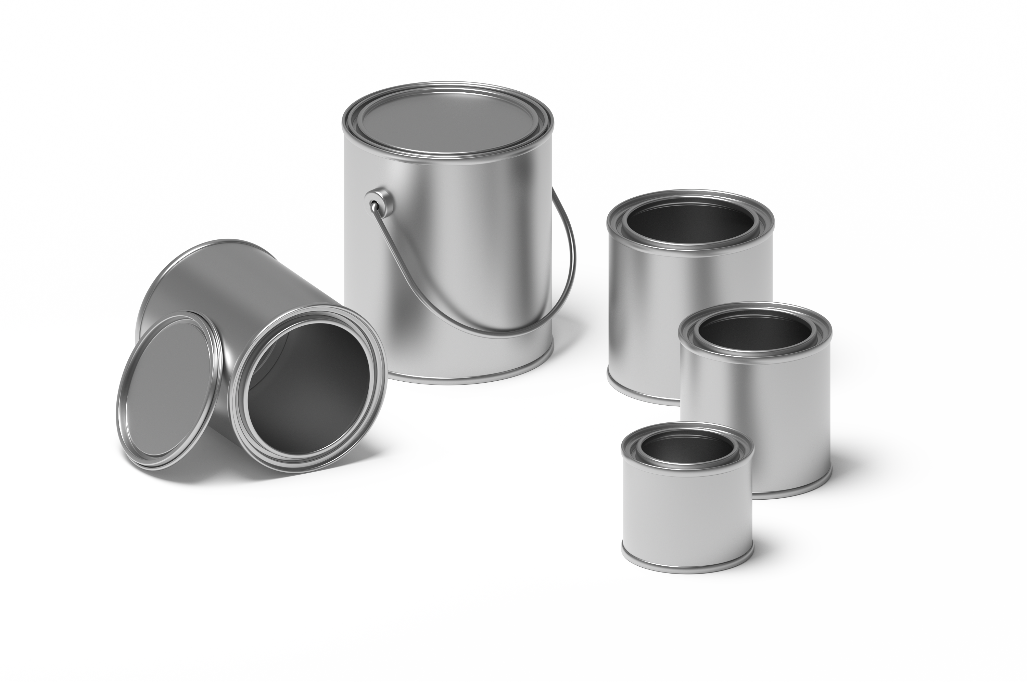

10.2: Create a Garden
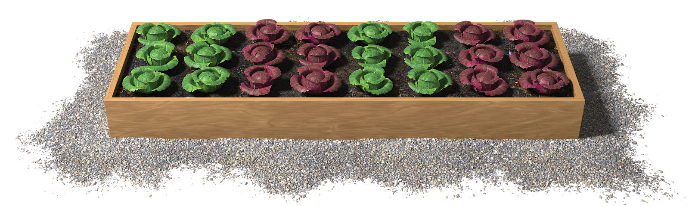
- Elena is planning how to use her rectangular space in the community garden. She needs a space that is at least 20 square feet to fit her plants. She has enough soil for a garden that is 30 square feet. The space she has available has to be 3 feet on one side.
- What are the possible sizes for her garden?
- Create a poster to show your thinking. Organize it so it can be followed by others.
- As you look at the posters with your group:
  - Describe how another group solved the problem in a different way than your group did.
  - Write three things you saw that helped you understand how other students solved the problem.

Section Summary
Section Summary
In this section, we learned how area is related to multiplication. We multiplied the side lengths of a rectangle to find its area.
$6×3=18$
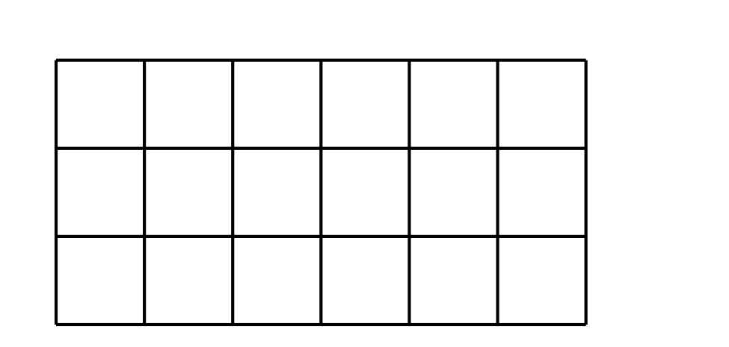
We also learned about how different square units are useful for measuring area in different situations and solved problems involving area.
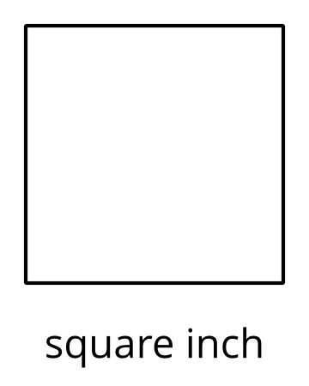
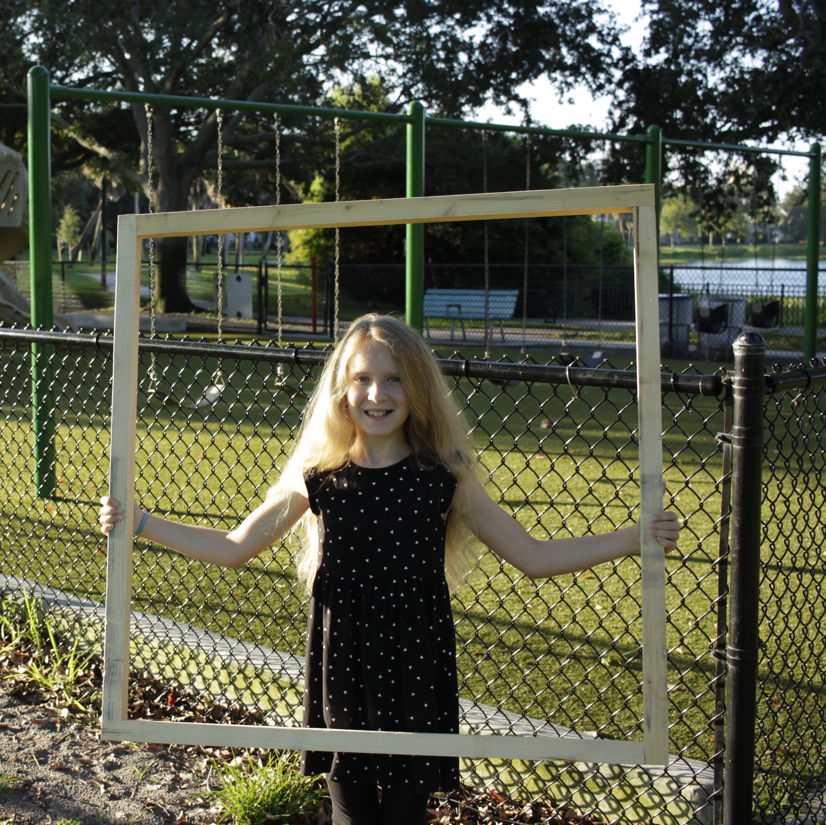
square meter
© CC BY 2021 Illustrative Mathematics®

