Lesson 9: Grams and Kilograms, Liters and Milliliters
- Let’s explore measurements in grams, kilograms, liters and milliliters.

Warm-up: Which One Doesn’t Belong: Meter, Meter on the Page
Which one doesn’t belong?
- 2 m
- 2,000 meters
- 200 centimeters

9.1: A Whole Lot of Paper Clips
One paper clip weighs 1 gram.
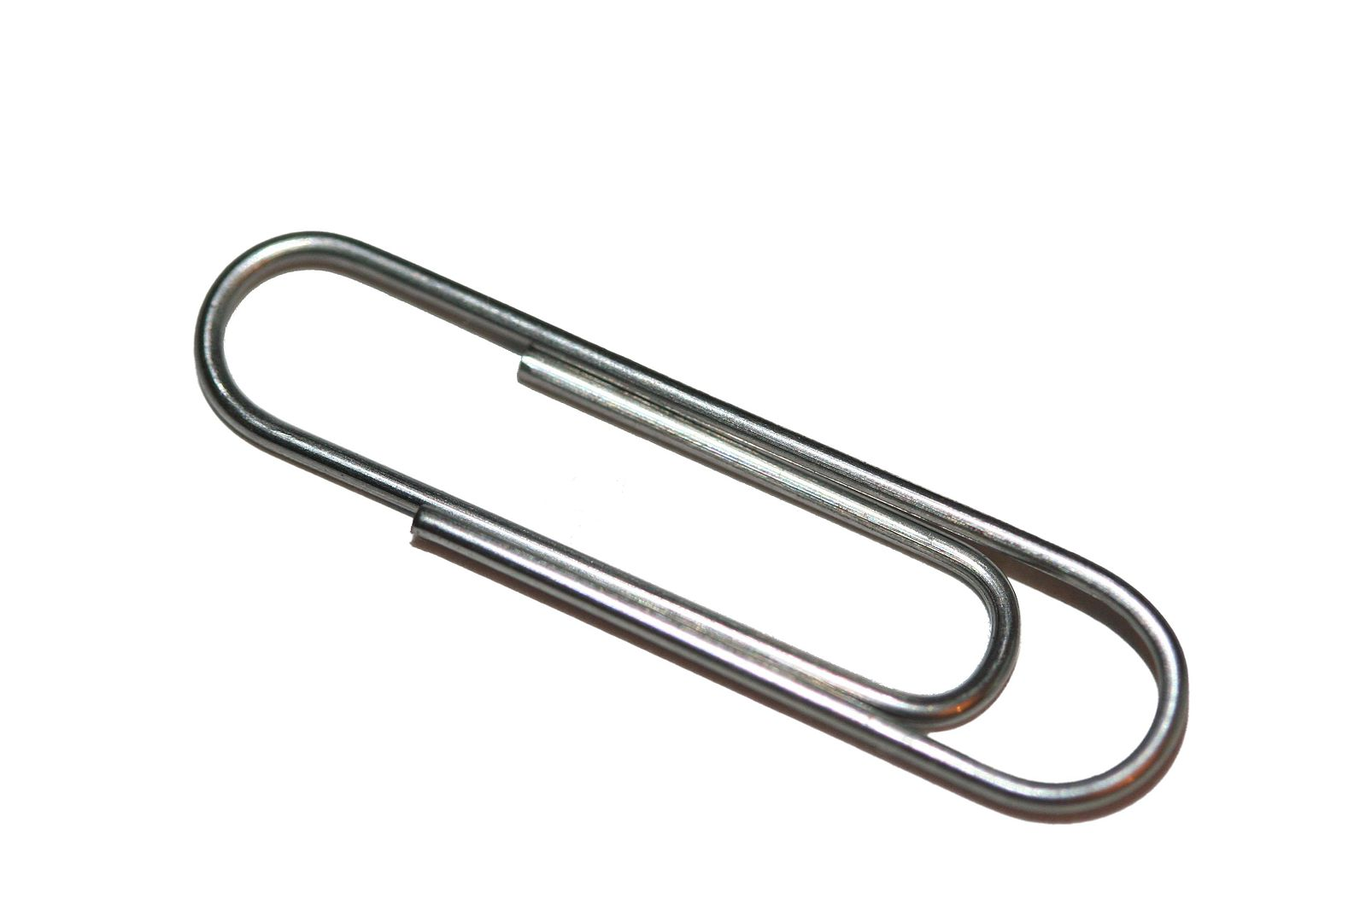
- How many grams are the paper clips in each image?
- a.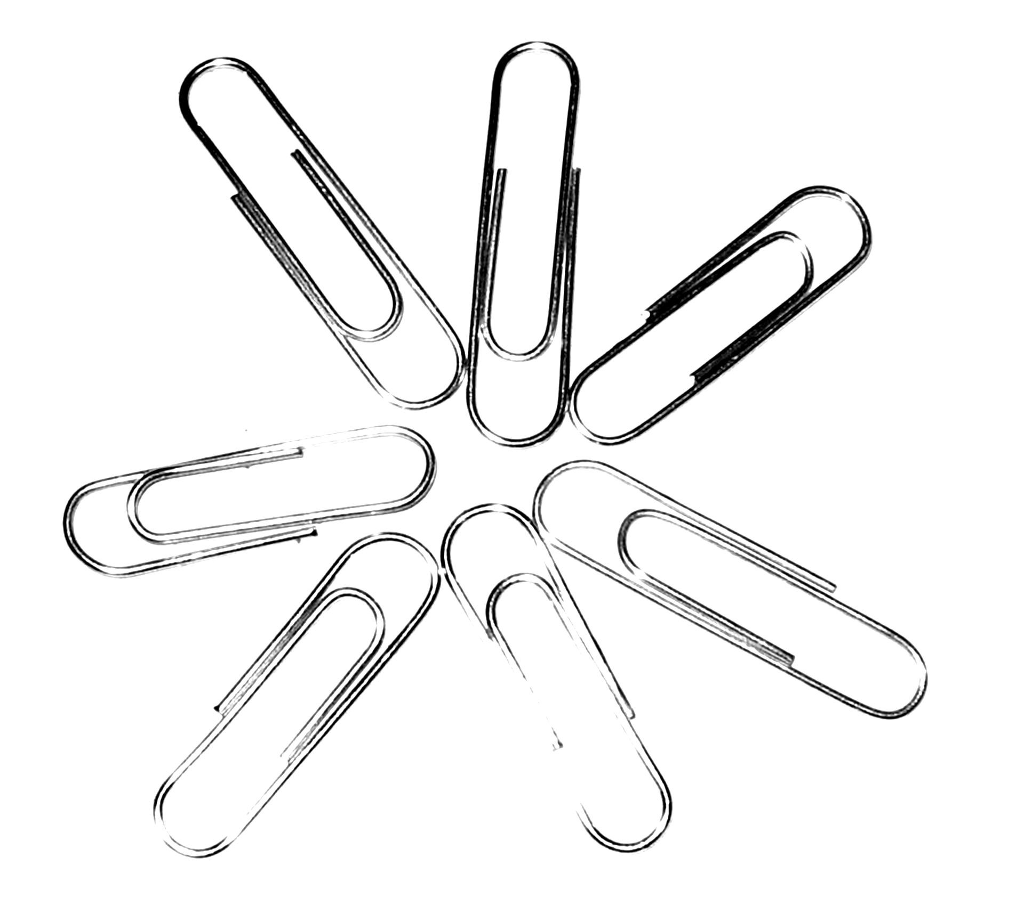
- b.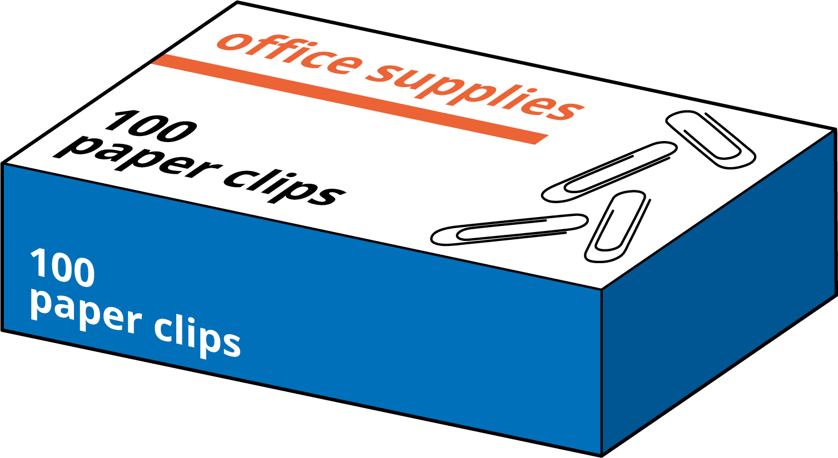
- c.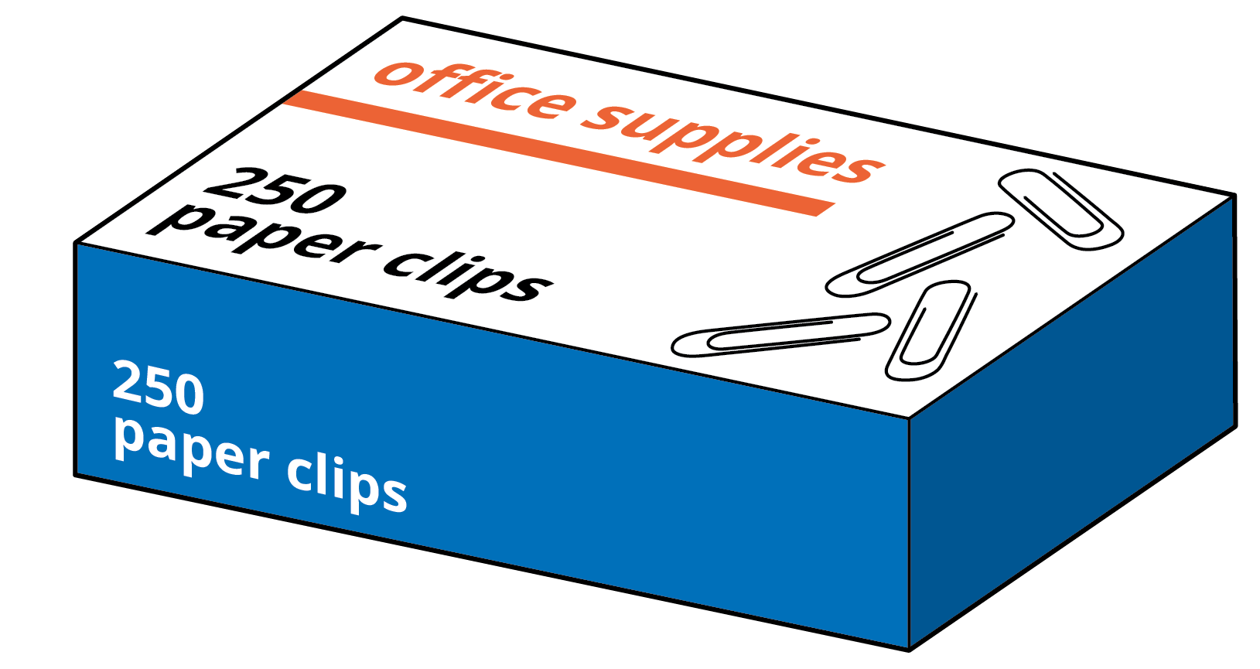
- The paper clips in this image weigh 1 kilogram.
- 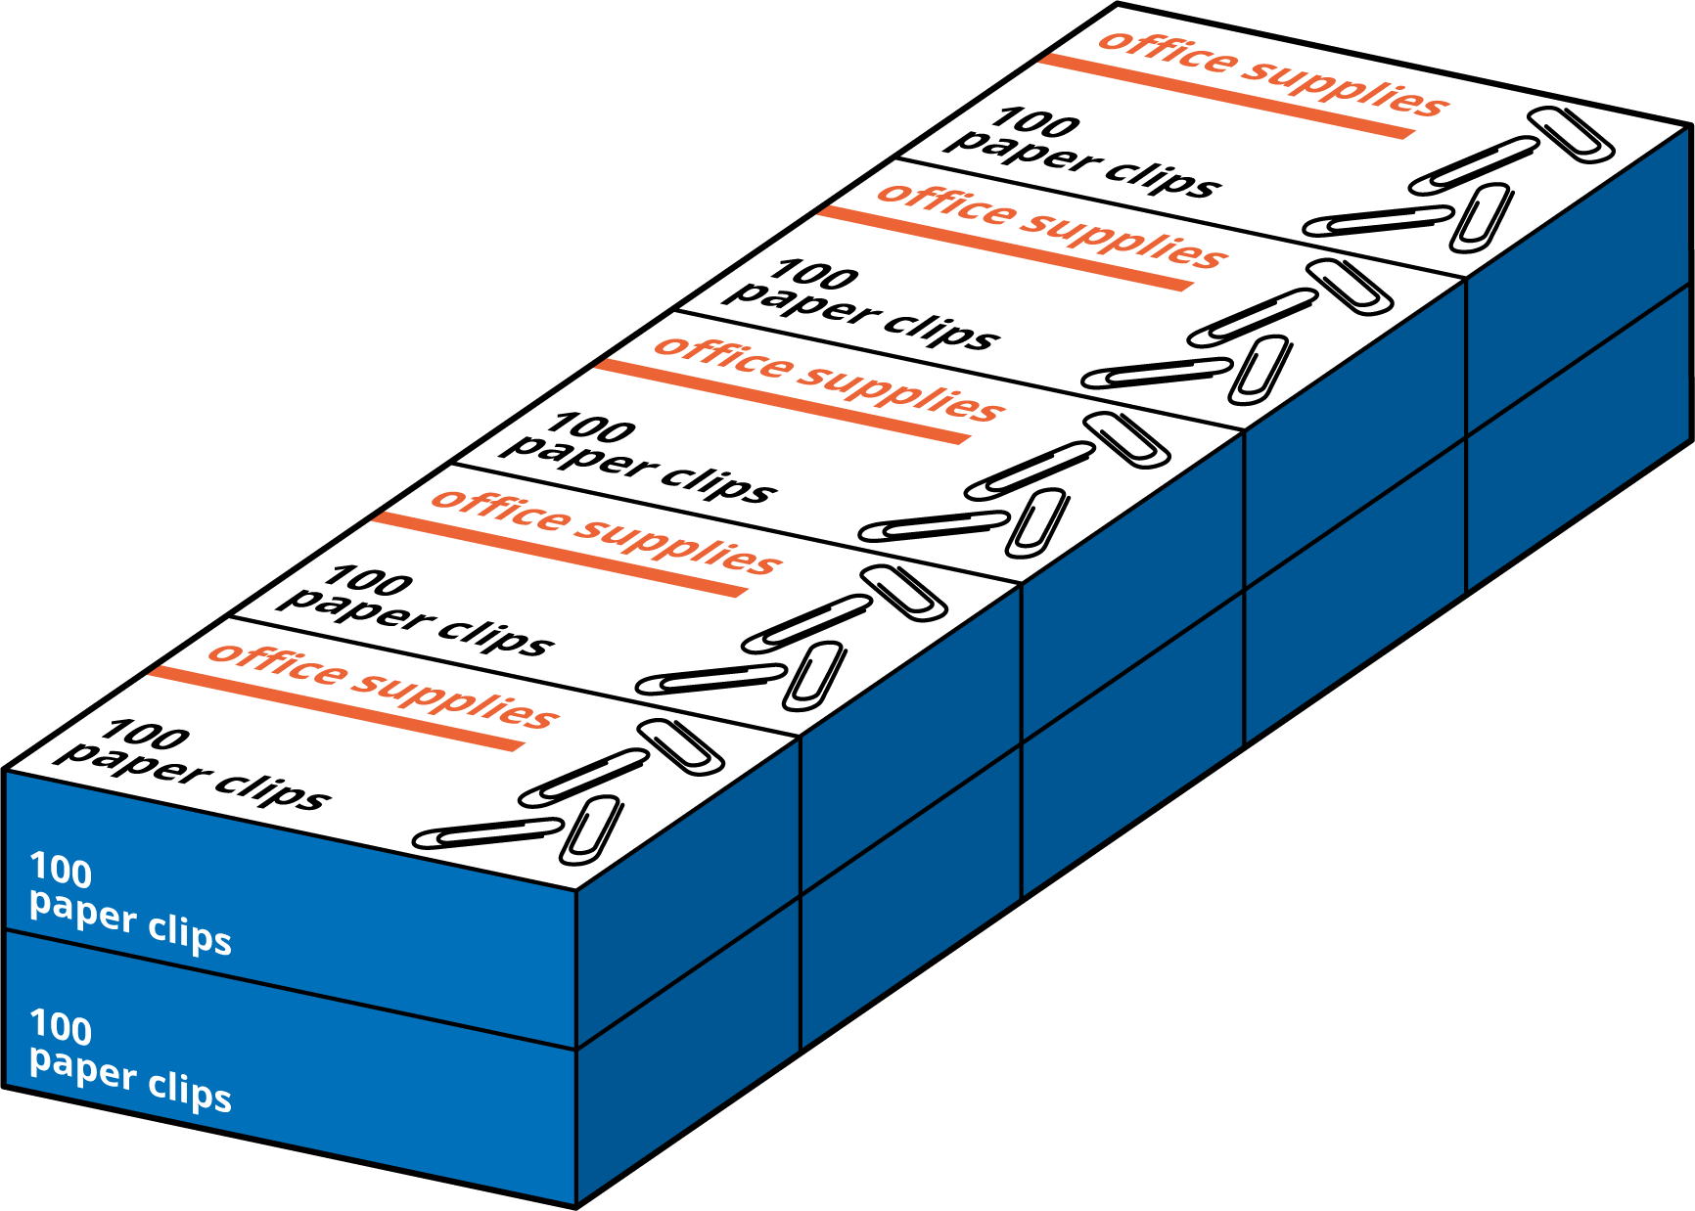
- What is the relationship between kilograms and grams?
- Complete the table with the missing amounts in grams.
- kilograms (kg) | - grams (g)
- 2
- 7
- 15
- $\frac{1}{2}$
- $9\frac{1}{2}$
- Which weighs more? Be prepared to explain how you know.
  - 8 kilograms or 8 boxes with 100 paper clips in each box
  - 1,250 paper clips or 1 kilogram
  - 500 grams or 2 boxes of 250 paper clips in each box
  - $\frac{1}{2}$ kilogram or 500 paper clips

9.2: Liters and Milliliters
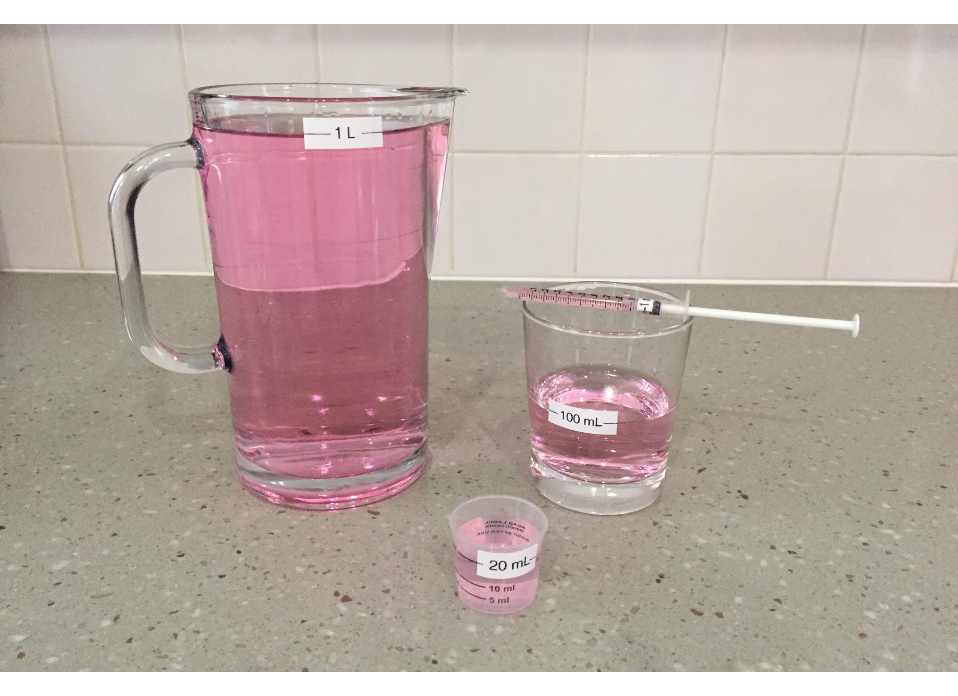

  - Estimate: How many times do we fill the 100-milliliter glass to get 1 liter of liquid? (Assume that each time the liquid is filled to the 100-milliliter line.)
  - Write a sentence to describe the relationship between milliliters and liters.
- How many times do we need to fill each of these containers to get 1 liter?
  - A 1-milliliter medicine dropper
  - A 250-milliliter measuring cup
  - A 20-milliliter cup
- Complete the table with the missing amounts in liters or milliliters.
- liters (L) | - milliliters (mL)
- 1
- 4
- 7
- 16
- 0000000000 | - 500
 | - 20,000
© CC BY 2021 Illustrative Mathematics®

