Unit 7 Lesson 15: Reasoning About Angles (Part 2)

WU How Many Do You See: Obtuse Angles (Warm up)

Student Task Statement
How many angles do you see in the folded paper heart?
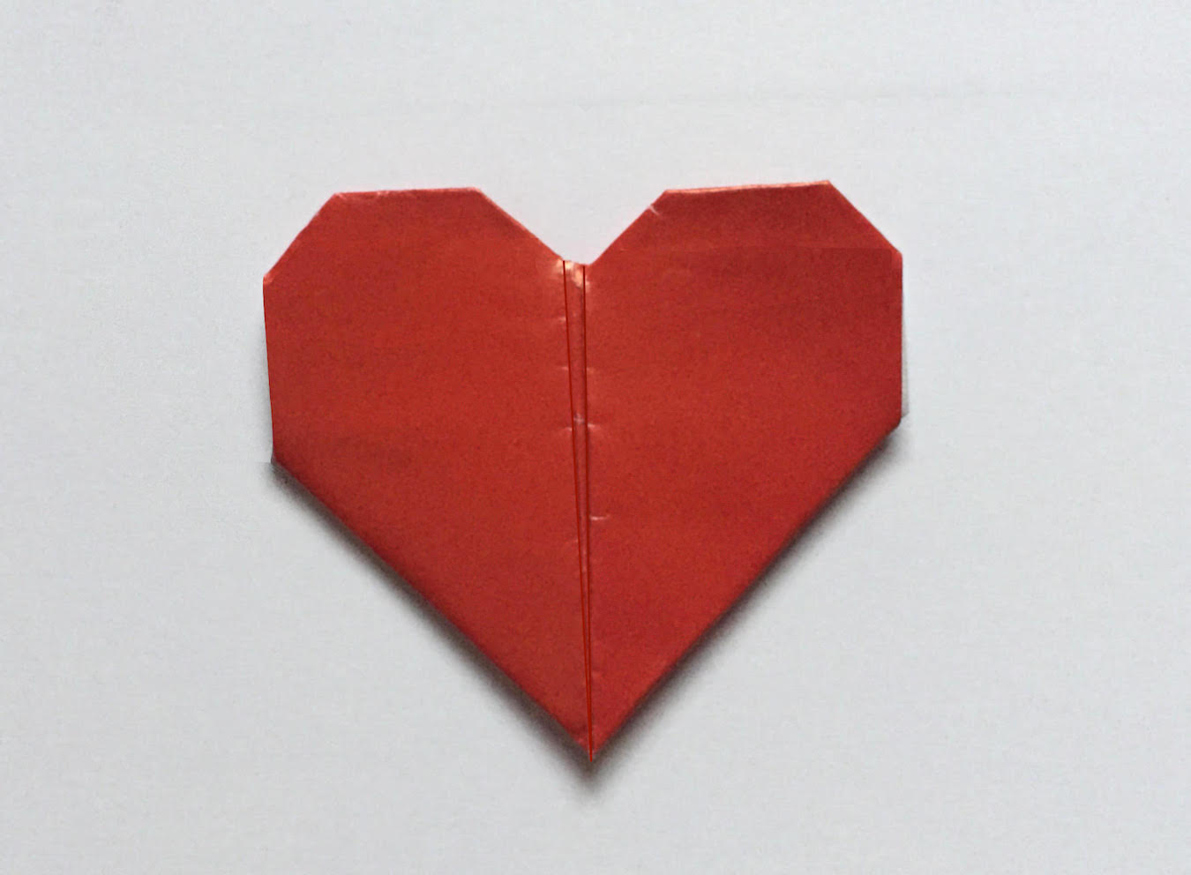

1 Shaded and Unshaded Angles

Student Task Statement
Find the measurement of each shaded angle. Show how you know.
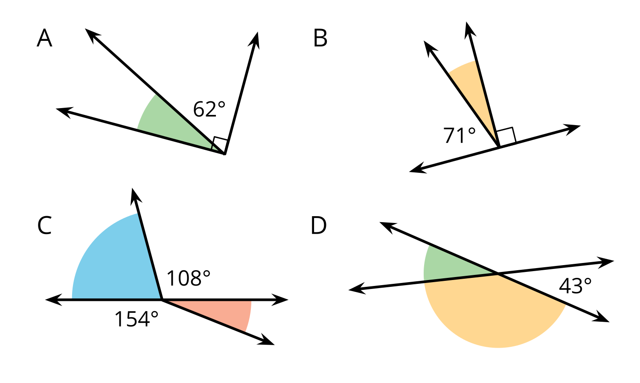

2 Info Gap: A Whole Bunch of Angles

Student Task Statement
Your teacher will give you either a problem card or a data card. Do not show or read your card to your partner.
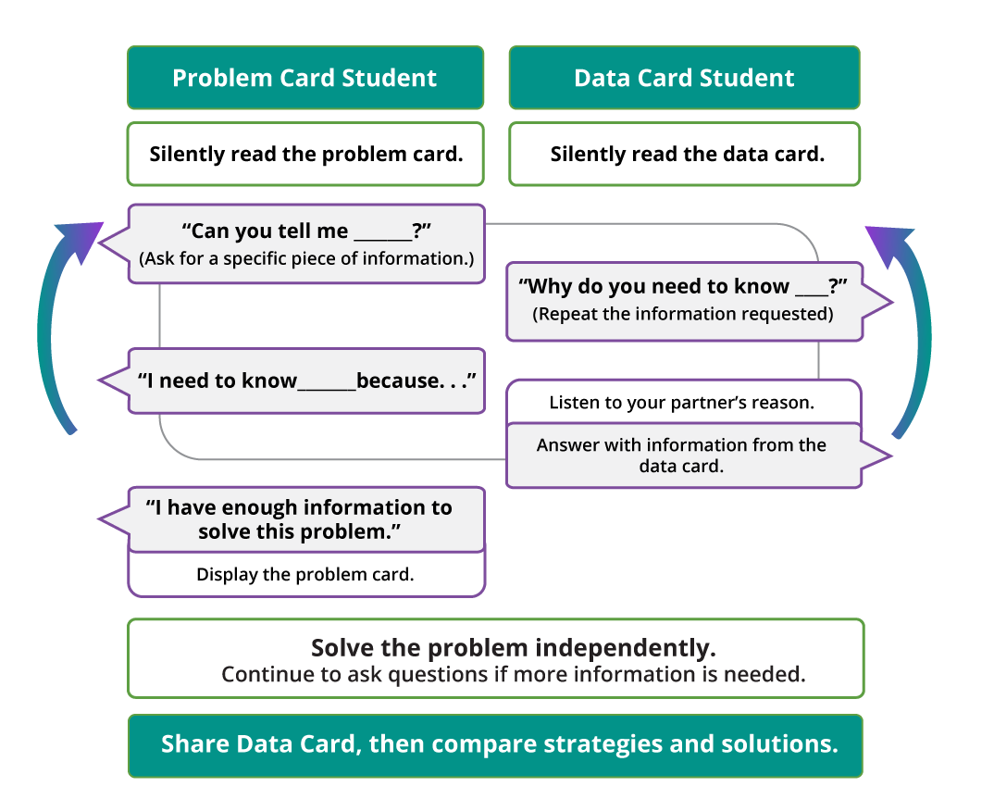
Pause here so your teacher can review your work. Ask your teacher for a new set of cards and repeat the activity, trading roles with your partner.

Images for Activity Synthesis
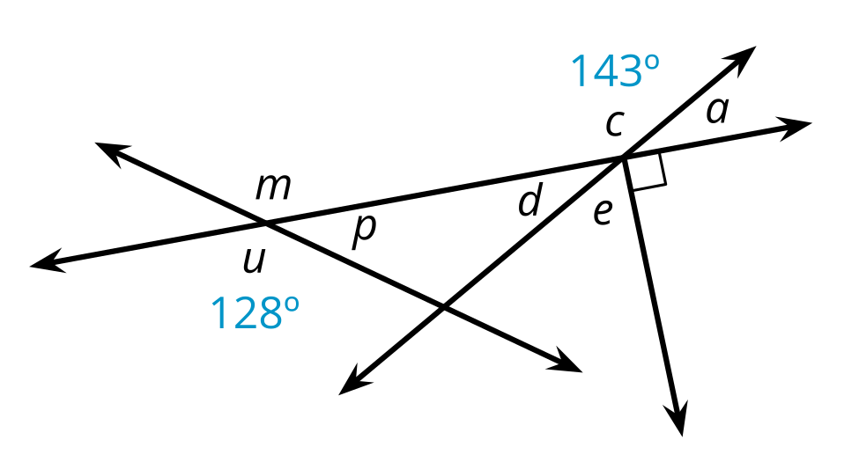
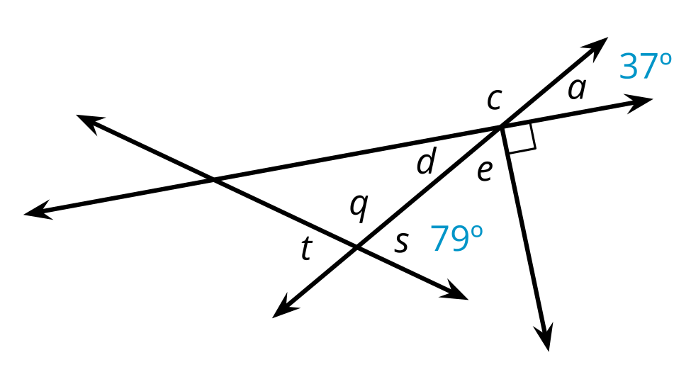
© CC BY 2021 Illustrative Mathematics®

