Unit 1 Lesson 12: Standard Deviation

1 Notice and Wonder: Measuring Variability (Warm up)

Student Task Statement
What do you notice? What do you wonder?

mean: 10, MAD: 1.56, standard deviation: 2
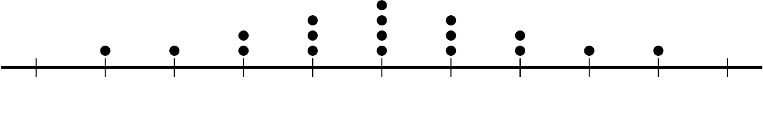

mean: 10, MAD: 2.22, standard deviation: 2.58
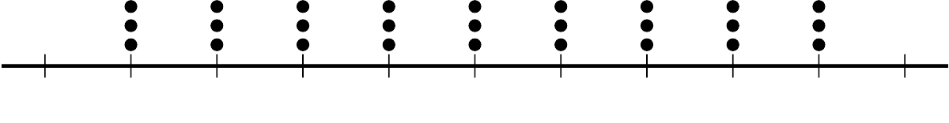
​​​​​​

mean: 10, MAD: 2.68, standard deviation: 2.92
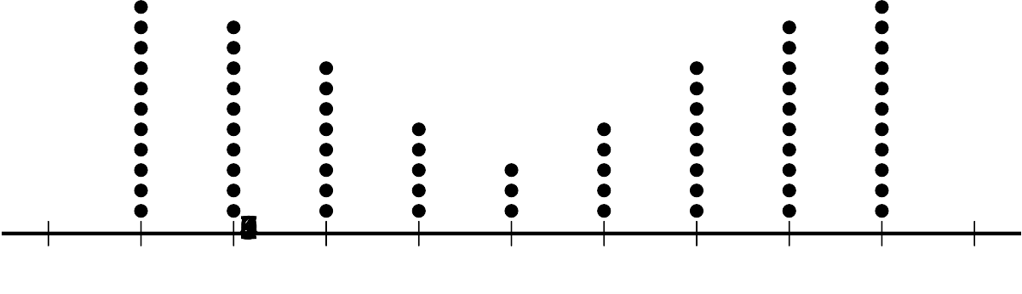

mean: 10, MAD: 1.12, standard deviation: 1.61
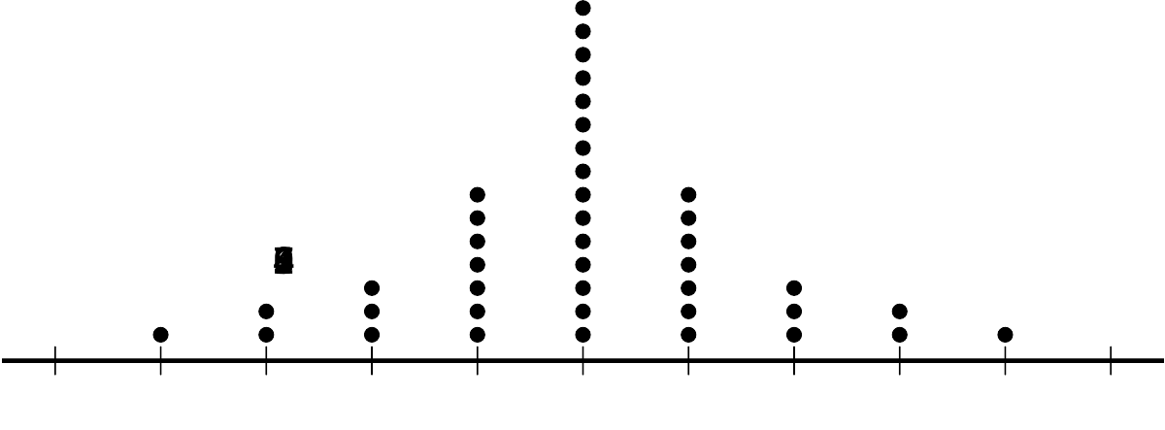

mean: 10, MAD: 2.06, standard deviation: 2.34
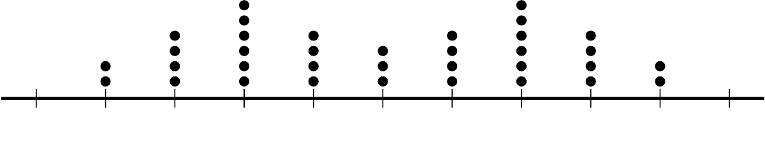

mean: 10, MAD: 0, standard deviation: 0
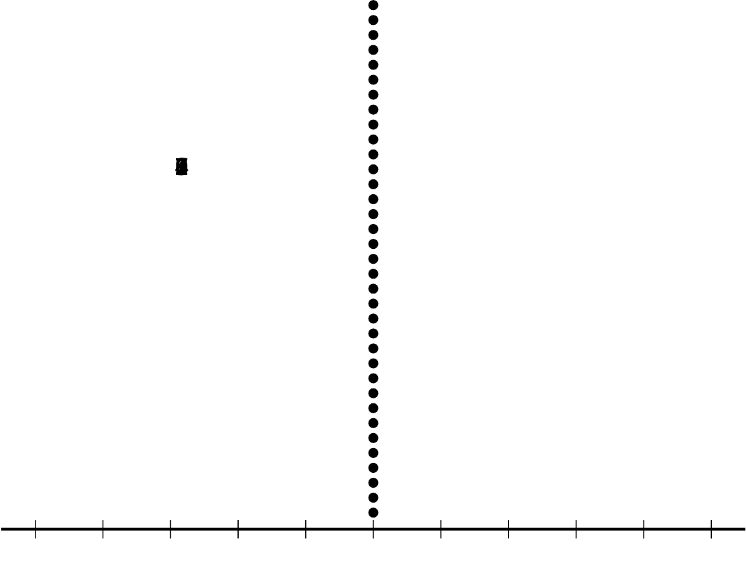

2 Investigating Standard Deviation

Student Task Statement
Use technology to find the mean and the standard deviation for the data in the dot plots.
- What do you notice about the mean and standard deviation you and your partner found for the three dot plots?
- Invent some data that fits the conditions. Be prepared to share your data set and reasoning for choice of values.
Partner 1
​Partner 2
Dot plots:
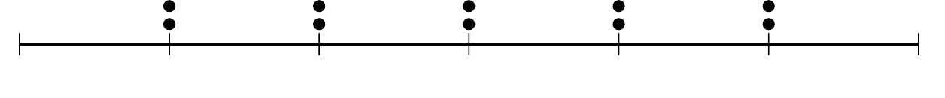
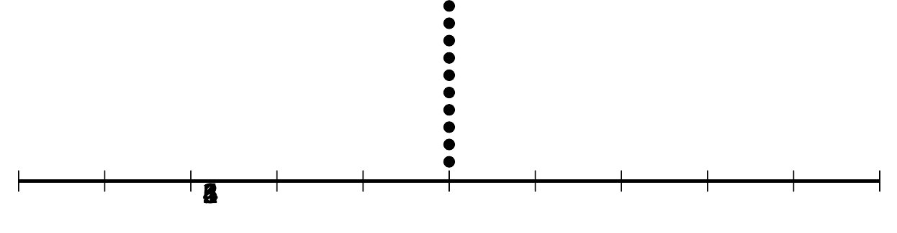
Dot plots:
​​​​​​
Conditions:
- 10 numbers with a standard deviation equal to the standard deviation of your first dot plot with a mean of 6.
- 10 numbers with a standard deviation three times greater than the data in the first row.
- 10 different numbers with a standard deviation as close to 2 as you can get in 1 minute.
Conditions:
- 10 numbers with a standard deviation equal to the standard deviation of your first dot plot with a mean of 12.
- 10 numbers with a standard deviation four times greater than the data in the first row.
- 10 different numbers with a standard deviation as close to 2 as you can get in 1 minute.

3 Investigating Variability

Student Task Statement
Begin with the data:
1, 2, 3, 4, 5, 6, 7, 8, 9, 10, 11, 12, 13, 14, 15, 16, 17, 18, 19, 20
- Use technology to find the mean, standard deviation, median, and interquartile range.
- How do the standard deviation and mean change when you remove the greatest value from the data set? How do they change if you add a value to the data set that is twice the greatest value?
- What do you predict will happen to the standard deviation and mean when you remove the least value from the data set? Check to see if your prediction was correct.
- What happens to the standard deviation and mean when you add a value to the data set equal to the mean? Add a second value equal to the mean. What happens?
- Add, change, and remove values from the data set to answer the question: What appears to change more easily, the standard deviation or the interquartile range? Explain your reasoning.

Activity Synthesis
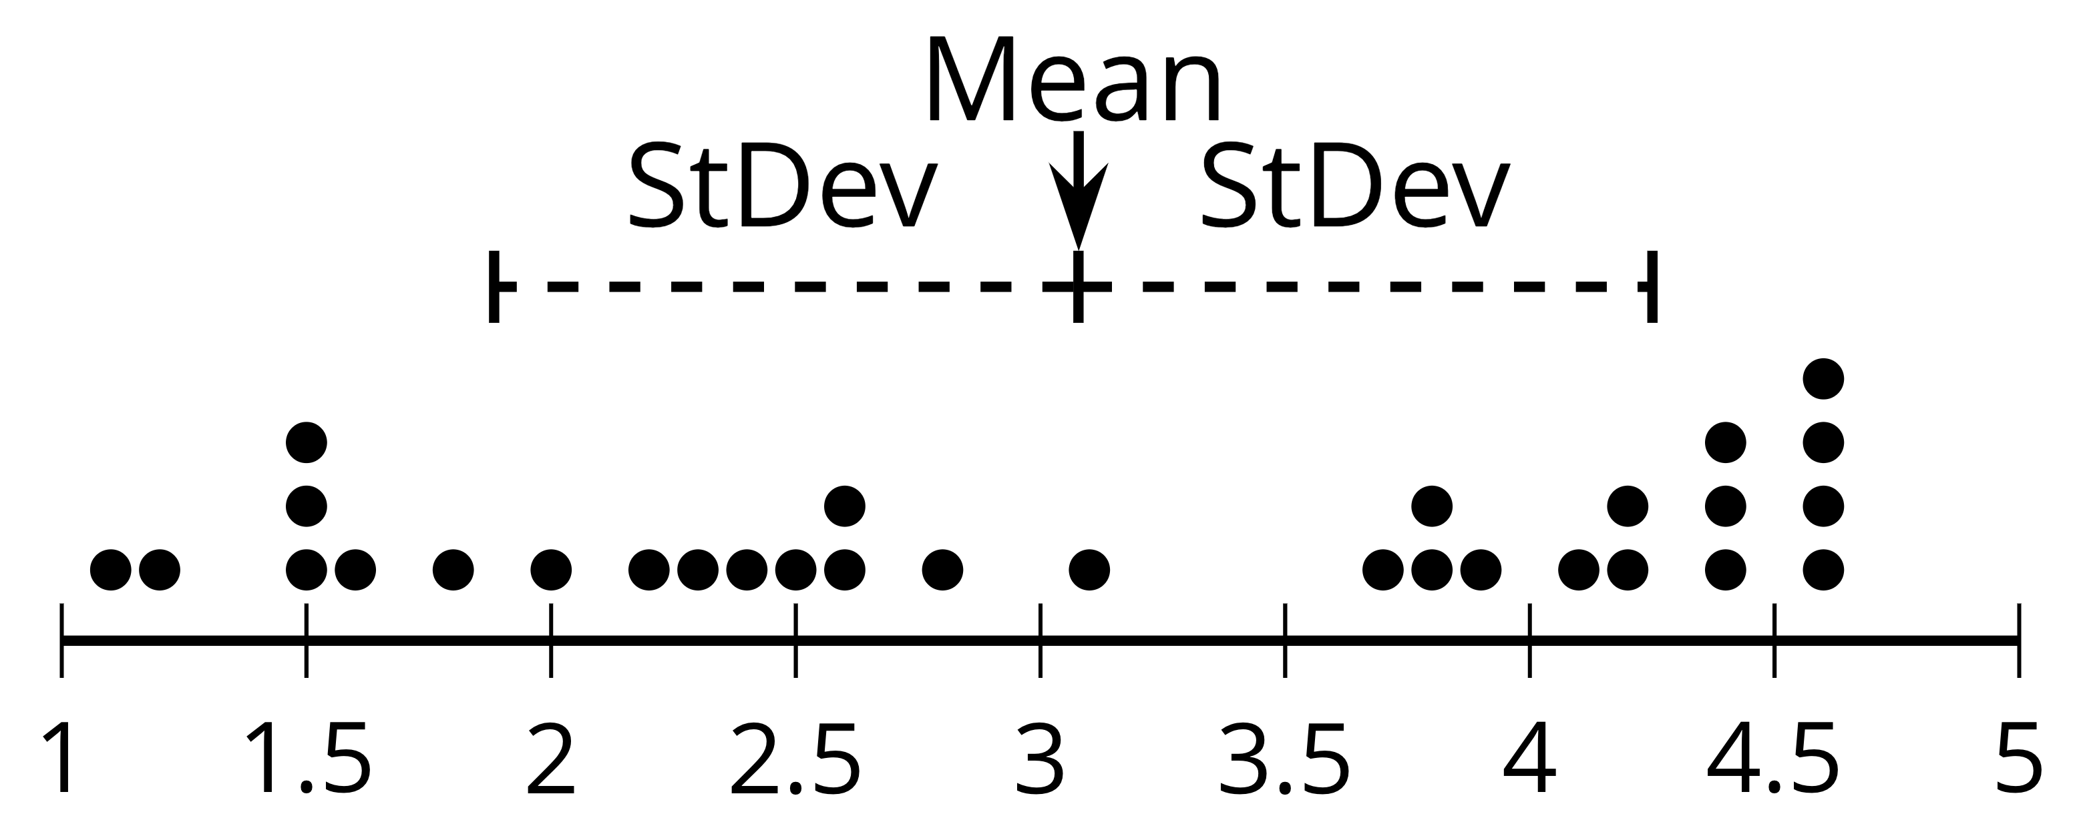
© CC BY 2019 by Illustrative Mathematics®

