Lesson 4: Distances and Circles
- Let’s build an equation for a circle.

4.1: Going the Distance
Andre says, “I know that I can find the distance between two points in the plane by drawing in a right triangle and using the Pythagorean Theorem. But I’m not sure how to find the lengths of the legs of the triangle when I can’t just count the squares on the graph.”
Explain to Andre how he can find the lengths of the legs in the triangle in the image. Then, calculate the distance between points $P$ and $Q$.

4.2: Circling the Problem
The image shows a circle with center $(6,10)$ and radius 17 units.
- The point $(14,25)$ looks like it might be on the circle. Verify if it really is on the circle. Explain or show your reasoning.
- The point $(22,3)$ looks like it might be on the circle. Verify if it really is on the circle. Explain or show your reasoning.
- In general, how can you check if a particular point $(x,y)$ is on the circle?

Are you ready for more?
The image shows segment $AB$ and several points.
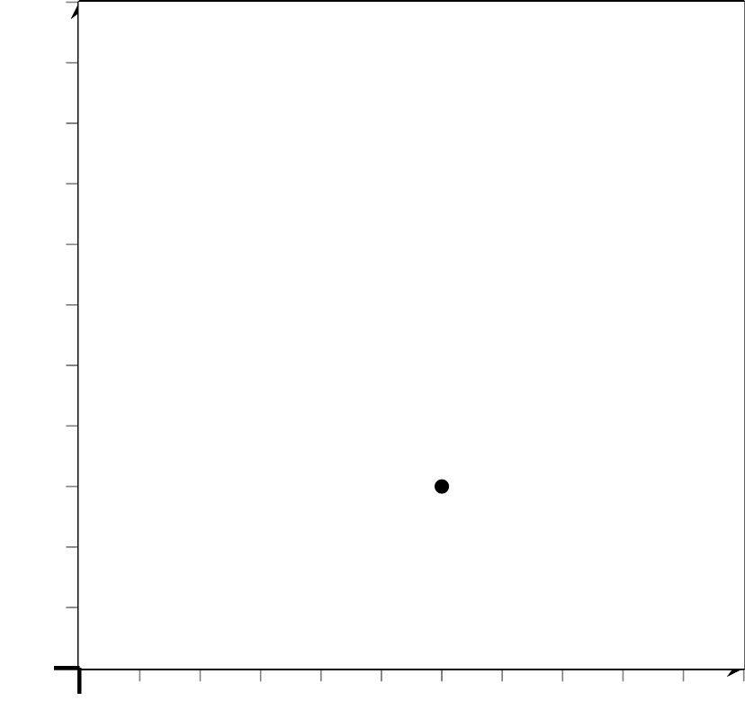
- Calculate the distance from each point to the endpoints of segment $AB$.
 | - point $A$ | - point $B$
- point $G$
- point $C$
- point $E$
- point $F$
- What do the distances tell you about points $G,E,C,$ and $F$ ?

4.3: Building an Equation for a Circle
The image shows a circle with center $(\text{-}3,6)$ and radius 13 units.
- Write an equation that would allow you to test whether a particular point $(x,y)$ is on the circle.
- Use your equation to test whether $(9,1)$ is on the circle.
- Suppose you have a circle with center $(h,k)$ and radius $r$. Write an equation that would allow you to test whether a particular point $(x,y)$ is on the circle.

Lesson 4 Summary
The diagram shows the point $(3,1)$, along with several points that are 5 units away from $(3,1)$. The set of all points 5 units away from $(3,1)$ is a circle with center $(3,1)$ and radius 5.
The point $(7,4)$ appears to be on this circle. To verify, calculate the distance from $(7,4)$ to $(3,1)$. If this distance is 5, then the point is on the circle. Let $d$ stand for the distance, and set up the Pythagorean Theorem: $(7−3)^{2}+(4−1)^{2}=d^{2}.$ Evaluate the left hand side to find that $25=d^{2}$. Now $d$ is the positive number that squares to make 25, which means $(7,4)$ really is 5 units away from $(3,1)$. This point is on the circle.
The point $(8,2)$ also looks like it could be on the circle. To find its distance from $(3,1)$, we can do a similar calculation: $(8−3)^{2}+(2−1)^{2}=d^{2}$. Evaluating the left side, we get $26=d^{2}$. This means that $d$ must be a little more than 5. So $(8,2)$ does not lie on the circle.
To check if any point $(x,y)$ is on the circle, we can use the Pythagorean Theorem to see if $(x−3)^{2}+(y−1)^{2}$ is equal to 5² or 25. Any point that satisfies this condition is on the circle, so the equation for the circle is $(x−3)^{2}+(y−1)^{2}=25$.
By the same reasoning, a circle with center $(h,k)$ and radius $r$ has equation $(x−h)^{2}+(y−k)^{2}=r^{2}$.
© CC BY 2019 by Illustrative Mathematics®

