Lesson 9: Diferencias de fracciones

Standards Alignments
Addressing | 4.NF.B.3.a, 4.NF.B.3.c

Teacher-facing Learning Goals
- Reason about subtraction of fractions with the same denominator using a number line.

Student-facing Learning Goals
- Exploremos diferencias de fracciones en una recta numérica.

Lesson Purpose
The purpose of this lesson is for students to use a number line to reason about subtraction of fractions with the same denominator.
Previously, students decomposed fractions into sums of other fractions and wrote equations to record the decompositions. They also used number lines to reason about addition of fractions with the same denominator. In this lesson, students use number lines to think about differences of fractions with the same denominator. They also practice reasoning about equivalence and decomposing fractions (including mixed numbers) mentally to facilitate subtraction.
As in earlier grades, students may think about subtracting as taking away a number from another number, or as finding an unknown addend. The way they represent differences of fractions on a number line may vary accordingly.

Access for:

Students with Disabilities
- Engagement (Activity 1)

English Learners
- MLR8 (Activity 1)

Instructional Routines
True or False (Warm-up)

Materials to Copy
- Make a Jump, Subtraction Edition (groups of 2): Activity 3

Lesson Timeline
Warm-up | 10 min
Activity 1 | 20 min
Activity 2 | 15 min
Activity 3 | 15 min
Lesson Synthesis | 10 min
Cool-down | 5 min

Teacher Reflection Question
Based on students’ work today, what did you learn about their understanding of the relationships between addition and subtraction? How will you use these insights to prepare for upcoming work?

Cool-down
(to be completed at the end of the lesson) 5min
Diferencias de quintos

Standards Alignments
Addressing | 4.NF.B.3.a, 4.NF.B.3.c

Student-facing Task Statement
Usa una recta numérica para representar cada diferencia y para encontrar su valor.
- $\frac{12}{5}−\frac{4}{5}$
- $2\frac{1}{5}−\frac{7}{5}$

Student Responses
- $\frac{12}{5}−\frac{4}{5}=\frac{8}{5}$ or $\frac{12}{5}−\frac{4}{5}=1\frac{3}{5}$. Sample responses:
- 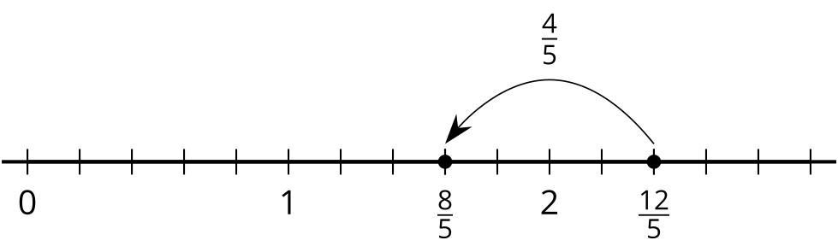
- 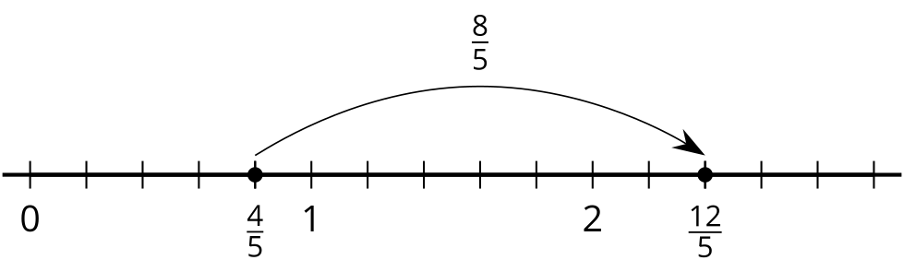
- $2\frac{1}{5}−\frac{7}{5}=\frac{4}{5}$. Sample responses:
- 
 