Lesson 4: Interpret This, Interpret That
- Let’s explore linear models

4.1: Math Talk: Units
Mentally calculate each value.
5 granola bars cost $20. How much is 1 worth?
A car travels at a constant speed and goes 100 miles in 2.5 hours. How fast is the car travelling in miles per hour?
Tyler can do 50 sit-ups in 4 minutes. What is his average sit-ups per minute?
3 ounces of yeast flakes costs $4.29. What is the cost for 1 ounce?

4.2: Absences and Scores
Here are a table and scatter plot representing the number of students’ absences and their final exam scores.
student | number of absences | final exam score
A | 1 | 94
B | 5 | 71
C | 1 | 98
D | 5 | 70
E | 3 | 67
F | 2 | 94
G | 6 | 71
H | 4 | 89
I | 5 | 77
J | 0 | 90
K | 2 | 91
L | 11 | 60

student | number of absences | final exam score
M | 7 | 68
N | 8 | 65
O | 20 | 42
P | 10 | 63
Q | 11 | 63
R | 20 | 50
S | 15 | 67
T | 16 | 40
U | 4 | 86
V | 8 | 82
W

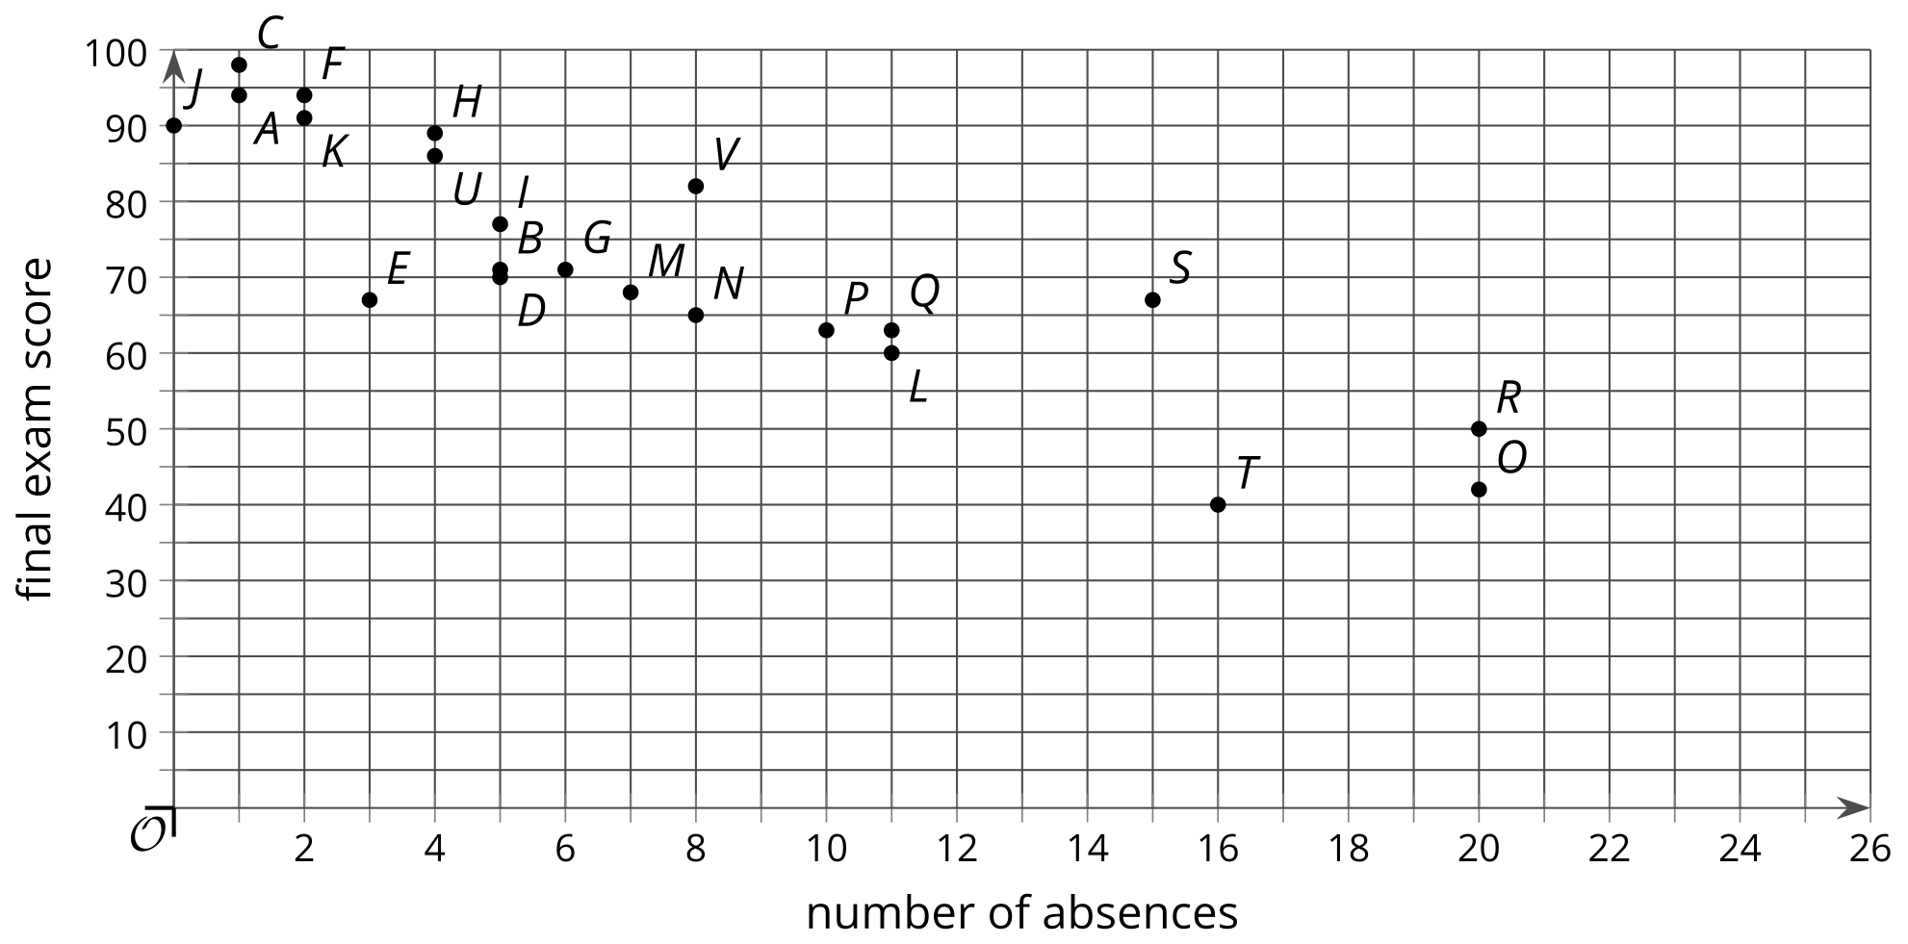
- What are the coordinates of the point in the scatter plot that represents student $G$?
- What are the coordinates of the point in the scatter plot that represents student $R$?
- What is the final exam score of the student who has perfect attendance?
- What are the final exam scores of the students with the most absences?
- How many absences does the student with the highest score have?
- How many absences does the student with the lowest score have?
- If student $W$ has 12 absences, what final exam score do you estimate the student will have? Plot this point on the scatter plot.

4.3: Elevator Weights
Here is a linear model of the weight of an elevator and the number of people on the elevator.
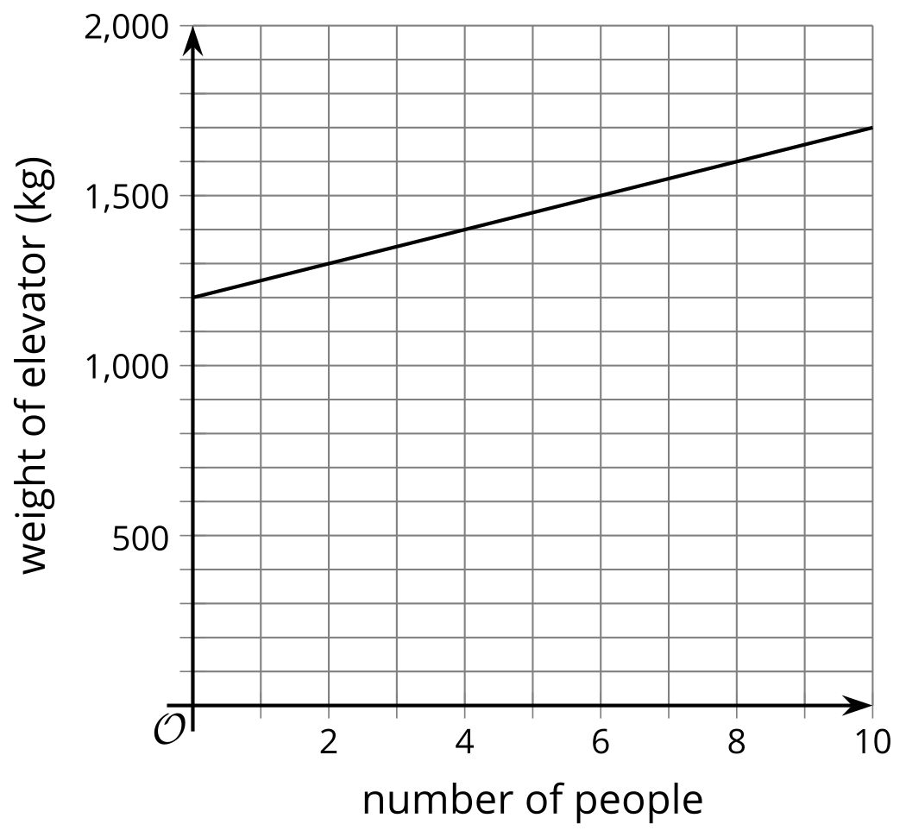
- Find these values. Explain your reasoning.
  - the weight of the elevator when 6 people are on it
  - the number of people on the elevator when it weighs 1,400 kg
  - the weight of the elevator when no people are on it
  - the increase in elevator weight for each additional person according to the model
- Which of your answers corresponds to the slope of the line in the graph?
- Which of your answers corresponds to the $y$-intercept of the line in the graph?
- This model can be represented with the equation $y=1,​200+50x$. An equation for a different model is written $y=70x+1,​000$. What are some things you can say about this new model?
© CC BY 2019 by Illustrative Mathematics®

