Lesson 14 Practice Problems
- Which of the following are right triangles?
  - Triangle $ABC$ with $AC=6$, $BC=9$, and $AB=12$
  - Triangle $DEF$ with $DE=8$, $EF=10$, and $FD=13$
  - Triangle $GHI$ with $GI=9$, $HI=12$, and $GH=15$
  - Triangle $JKL$ with $JL=10$, $KL=13$, and $JL=17$
- In right triangle $ABC$, a square is drawn on each of its sides. An altitude $CD$ is drawn to the hypotenuse $AB$ and extended to the opposite side of the square on $FE$. In class, we discussed Elena’s observation that $a^{2}=xc$ and Diego’s observation that $b^{2}=yc$. Mai observes that these statements can be thought of as claims about the areas of rectangles.
  - Which rectangle has the same area as $BGHC$?
  - Which rectangle has the same area as $ACIJ$?
- 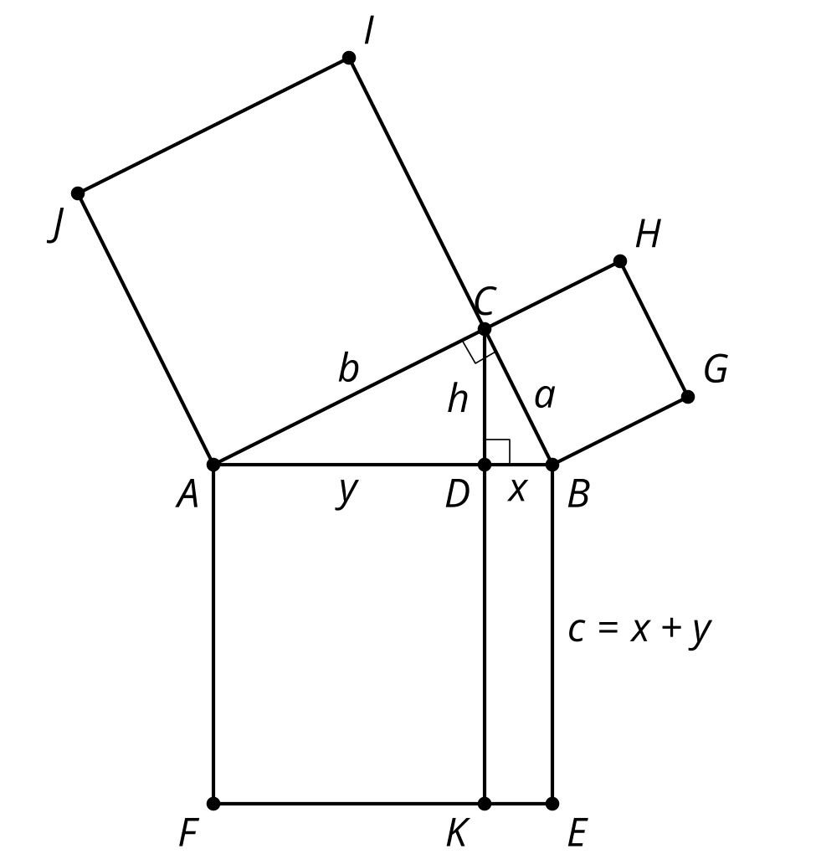
- Andre says he can find the length of the third side of triangle $ABC$ and it is 5 units. Mai disagrees and thinks that the side length is unknown. Do you agree with either of them? Show or explain your reasoning.
- 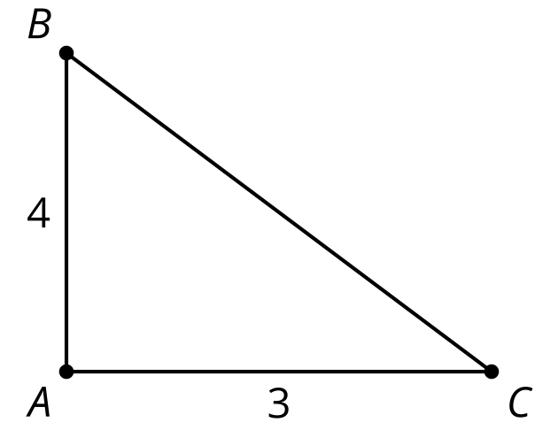
- In right triangle $ABC$, altitude $CD$ is drawn to its hypotenuse. Find 2 triangles which must be similar to triangle $ABC$.
- 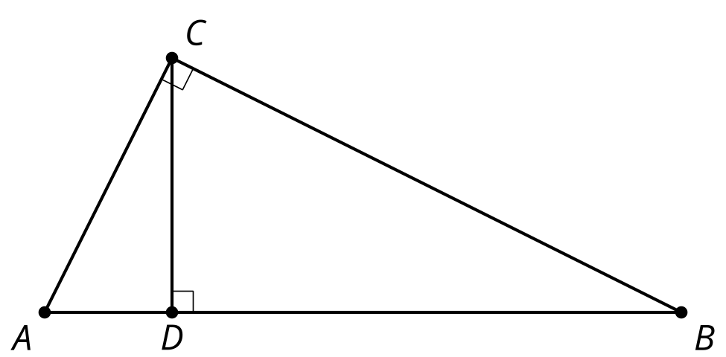
- (From Unit 3, Lesson 13.)
- In right triangle $ABC$, altitude $CD$ with length 6 is drawn to its hypotenuse. We also know $AD=12$. What is the length of $DB$?
- 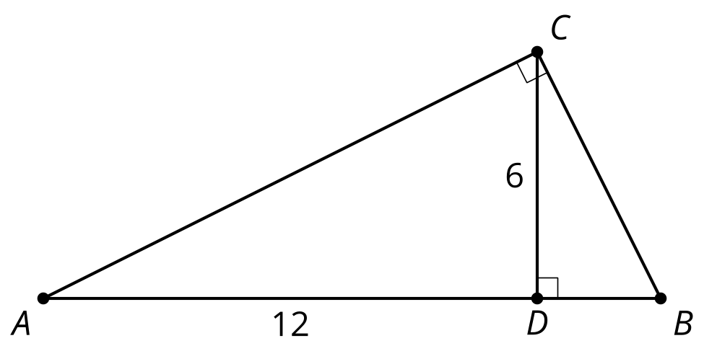
  - $\frac{1}{2}$
  - 3
  - 4
  - 6
- (From Unit 3, Lesson 13.)
- Lines $BC$ and $DE$ are both vertical. What is the length of $BD$?
- 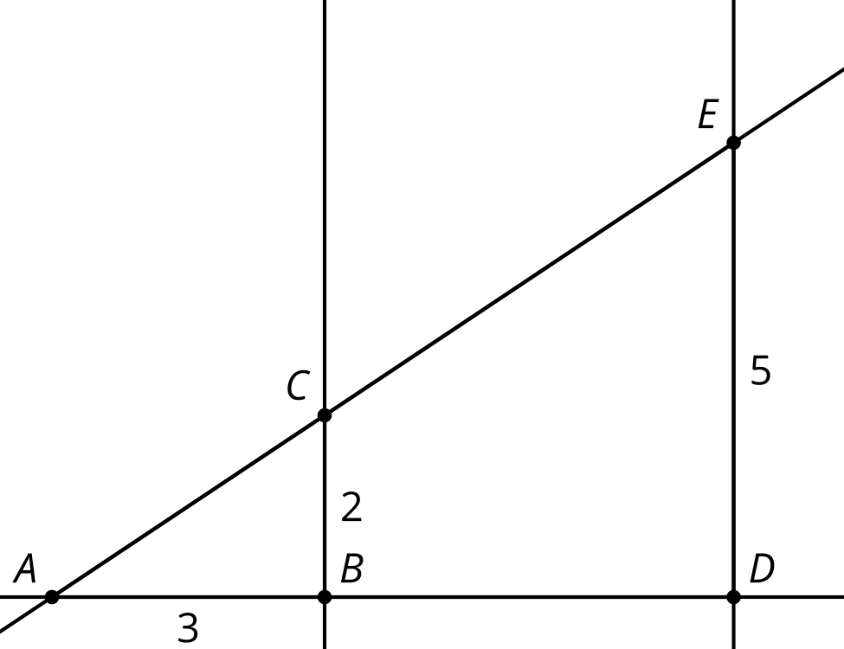
  - 4.5
  - 5
  - 6
  - 7.5
- (From Unit 3, Lesson 12.)
- In right triangle $ABC$, $AC=5$ and $BC=12$. A new triangle $DEC$ is formed by connecting the midpoints of $AC$ and $BC$.
- 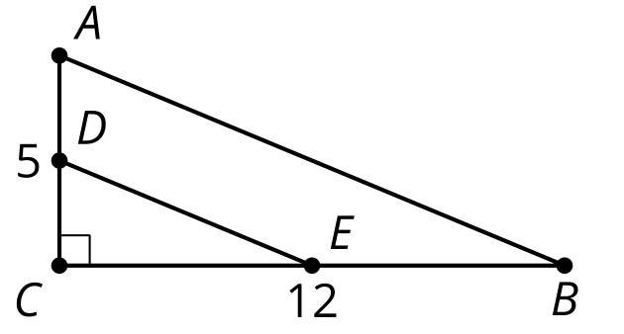
  - What is the area of triangle $ABC$?
  - What is the area of triangle $DEC$?
  - Does the scale factor for the side lengths apply to the area as well?
- (From Unit 3, Lesson 11.)
- Quadrilaterals $Q$ and $P$ are similar.
- What is the scale factor of the dilation that takes $Q$ to $P$?
- 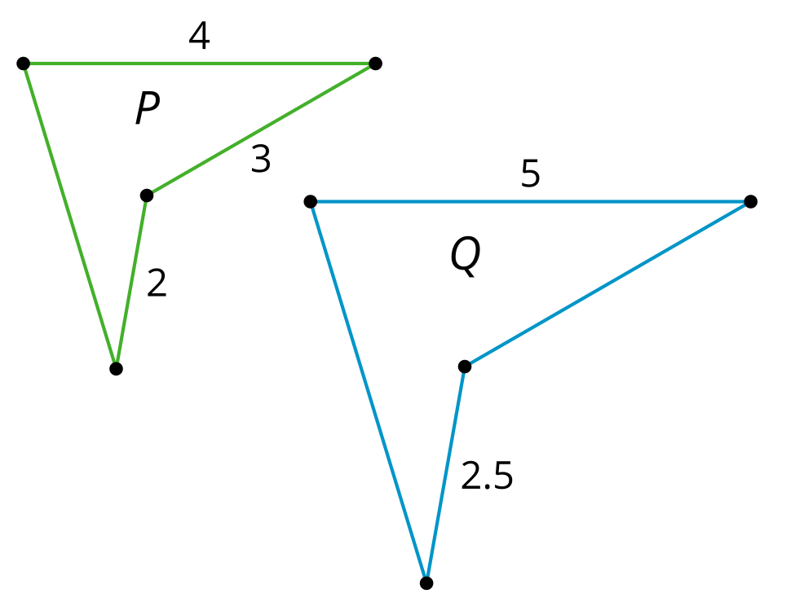
  - $\frac{2}{5}$
  - $\frac{3}{5}$
  - $\frac{4}{5}$
  - $\frac{5}{4}$
- (From Unit 3, Lesson 6.)
- Priya is trying to determine if triangle $ADC$ is congruent to triangle $CBA$. She knows that segments $AB$ and $DC$ are congruent She also knows that angles $DCA$ and $BAC$ are congruent. Does she have enough information to determine that the triangles are congruent? Explain your reasoning.
- 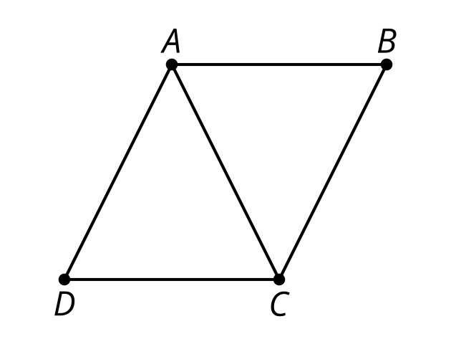
- (From Unit 2, Lesson 6.)
© CC BY 2019 by Illustrative Mathematics®

