Lesson 10 Practice Problems
- Draw a rough sketch of the graph of $g\left(x\right)=\left(x−3\right)\left(x+1\right)\left(7x−2\right)$.
- Draw a rough sketch of the graph of $f\left(x\right)={\left(x+1\right)}^{2}\left(x−4\right)$.
- Technology required. Predict the end behavior of each polynomial function, then check your prediction using technology.
  - $A\left(x\right)=\left(x+3\right)\left(x−4\right)\left(3x−7\right)\left(4x−3\right)$
  - $B\left(x\right)={\left(3−x\right)}^{2}\left(6−x\right)$
  - $C\left(x\right)=\text{-}\left(4−3x\right)\left(x^{4}\right)$
  - $D\left(x\right)={\left(6−x\right)}^{6}$
- Which term can be added to the polynomial expression $5x^{7}−6x^{6}+4x^{4}−4x^{2}$ to make it into a 10th degree polynomial?​​
  - 10
  - $5x^{3}$
  - $5x^{7}$
  - $x^{10}$
- (From Unit 2, Lesson 3.)
- $f\left(x\right)=\left(x+1\right)\left(x−6\right)$ and $g\left(x\right)=2\left(x+1\right)\left(x−6\right)$. The graphs of each are shown.
- 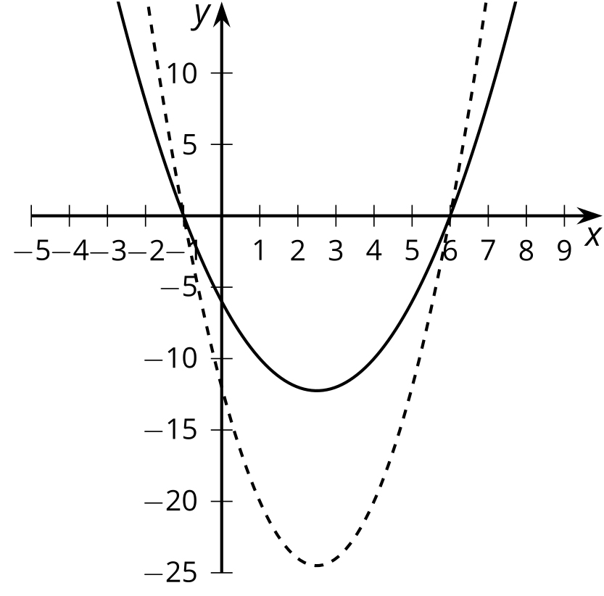
  - Which graph represents which polynomial function? Explain how you know.
- (From Unit 2, Lesson 6.)
- State the degree and end behavior of $f\left(x\right)=8x^{3}+2x^{4}−5x^{2}+9$. Explain or show your reasoning.
- (From Unit 2, Lesson 8.)
- The graph of a polynomial function $f$ is shown. Select all the true statements about the polynomial.
- 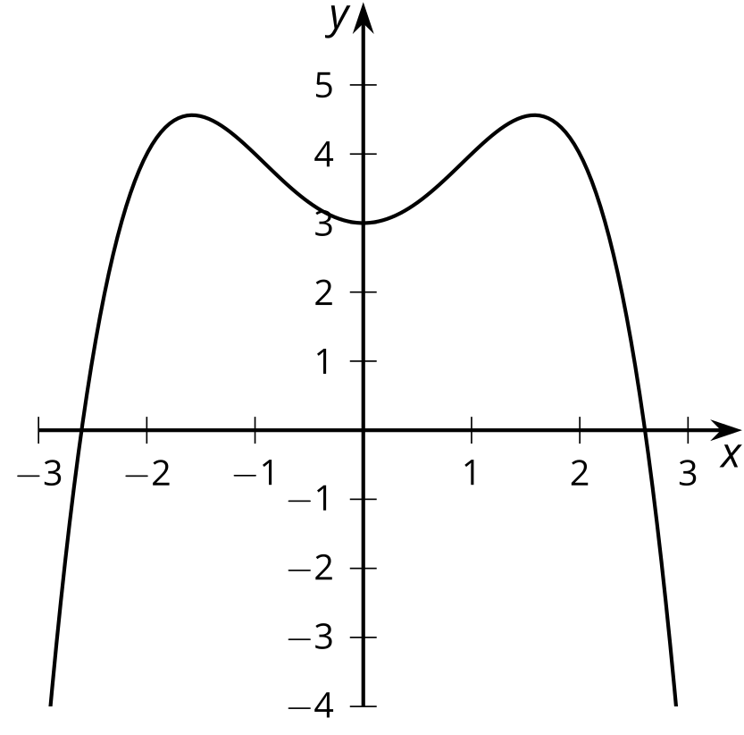
  - The degree of the polynomial is even.
  - The degree of the polynomial is odd.
  - The leading coefficient is positive.
  - The leading coefficient is negative.
  - The constant term of the polynomial is positive.
  - The constant term of the polynomial is negative.
- (From Unit 2, Lesson 9.)
© CC BY 2019 by Illustrative Mathematics®

