Lesson 14: Find the Area of Figures with Missing Sides
- Let’s find the area of figures with missing side lengths.

Warm-up: Notice and Wonder: Mystery Sides
What do you notice? What do you wonder?
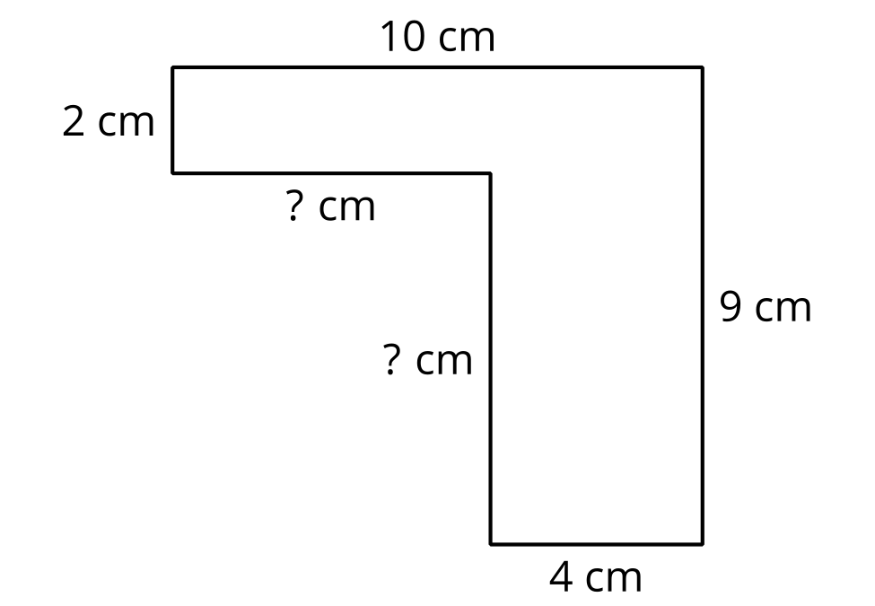

14.1: The Mystery Side
Tyler says that the missing side length is 5 meters because it looks longer than the sides that are 4 meters long.
Do you agree or disagree? Be prepared to explain your reasoning.
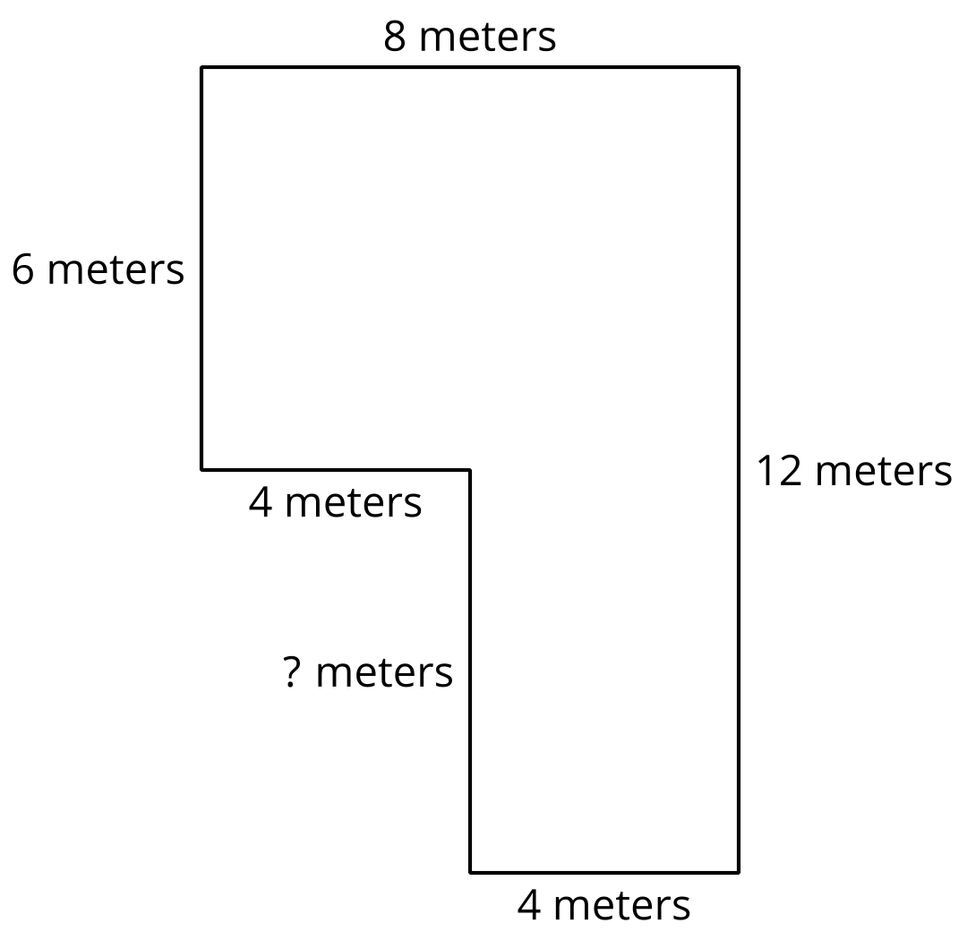

14.2: Practice with Mystery Sides
Find the area of each figure. Explain or show your reasoning.
A
B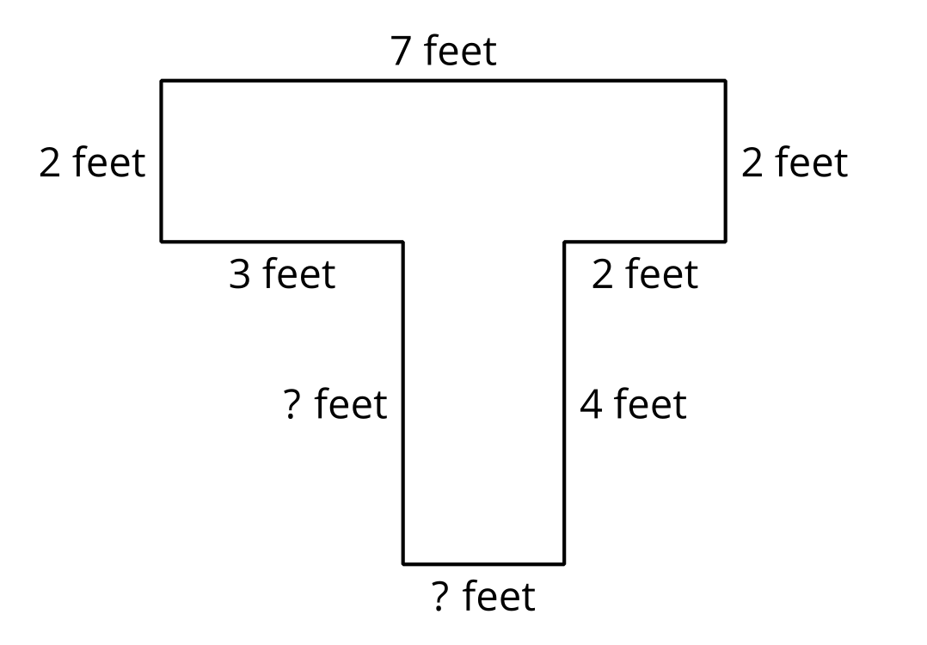

Section Summary
Section Summary
In this section, we found the area of figures that could be decomposed into rectangles. We added the area of each rectangle to find the area of the entire figure.
We also found missing side lengths by using what we know about opposite sides of rectangles.
© CC BY 2021 Illustrative Mathematics®

