Lesson 5: Connections between Representations
- Let’s look at the relationship of verbal descriptions, equations, tables, and graphs.

5.1: Math Talk: Evaluating Expressions
Evaluate mentally:
$6,​400−400x$ when $x$ is 0
$6,​400−400x$ when $x$ is 2
$6,​400⋅{\left(\frac{1}{10}\right)}^{x}$ when $x$ is 0
$6,​400⋅{\left(\frac{1}{10}\right)}^{x}$ when $x$ is 2

5.2: A Good Night’s Sleep
Is more sleep associated with better brain performance? A researcher collected data to determine if there was an association between hours of sleep and ability to solve problems. She administered a specially designed problem solving task to a group of volunteers, and for each volunteer, recorded the number of hours slept the night before and the number of errors made on the task.
The equation $n=40−4t$ models the relationship between $t$, the time in hours a student slept the night before, and $n$, the number of errors the student made in the problem-solving task.
- Use the equation to find the coordinates of 5 data points on a graph representing the model. Organize the coordinates in the table.
- Create a graph that represents the model.
- hours of sleep, $t$ | - number of errors, $n$
- 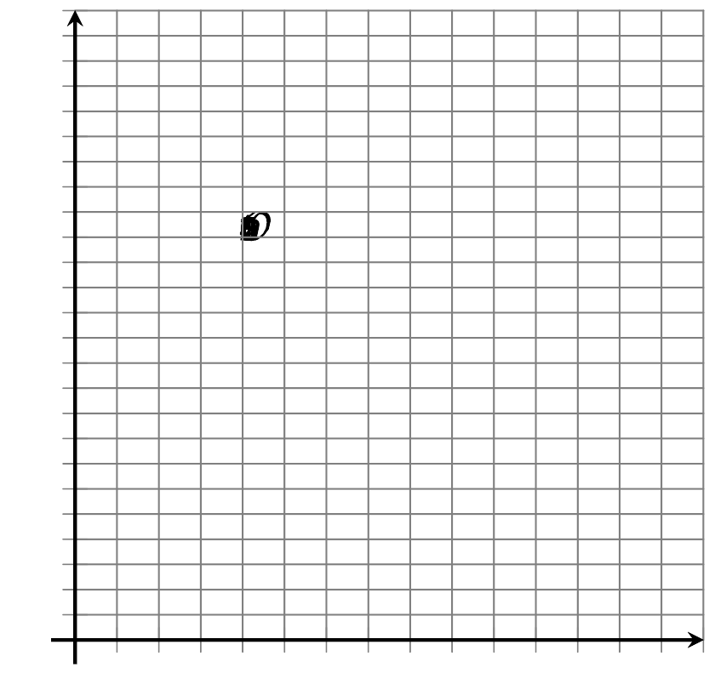
- In the equation $n=40−4t$, what does the 40 mean in this situation? Where can you see it on the graph?
- In the equation $n=40−4t$, what does the -4 mean in this situation? Where can you see it on the graph?
- How many errors would you expect a person to make who had slept 3.5 hours the night before?

5.3: What’s My Equation?
The sleep researcher repeated the study on two more groups of volunteers, collecting different data. Here are graphs representing the equations that model the different sets of data:

A
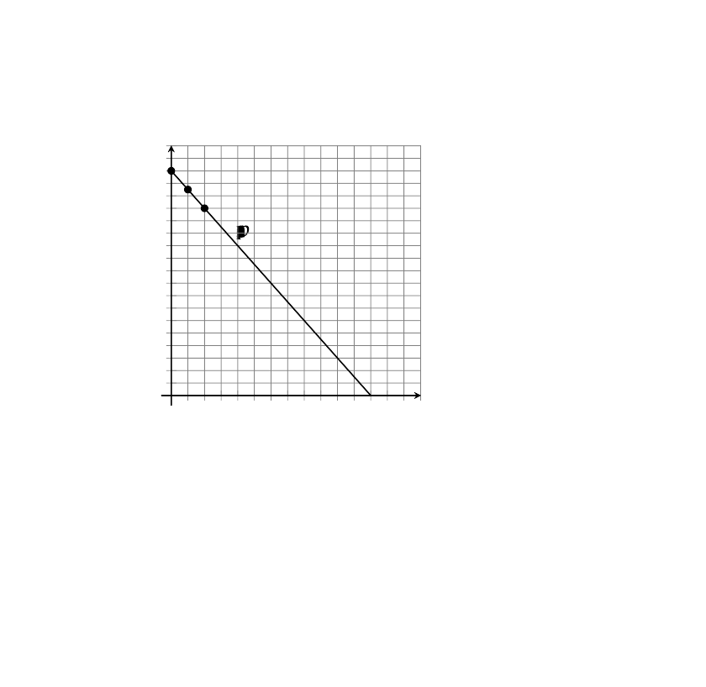

B
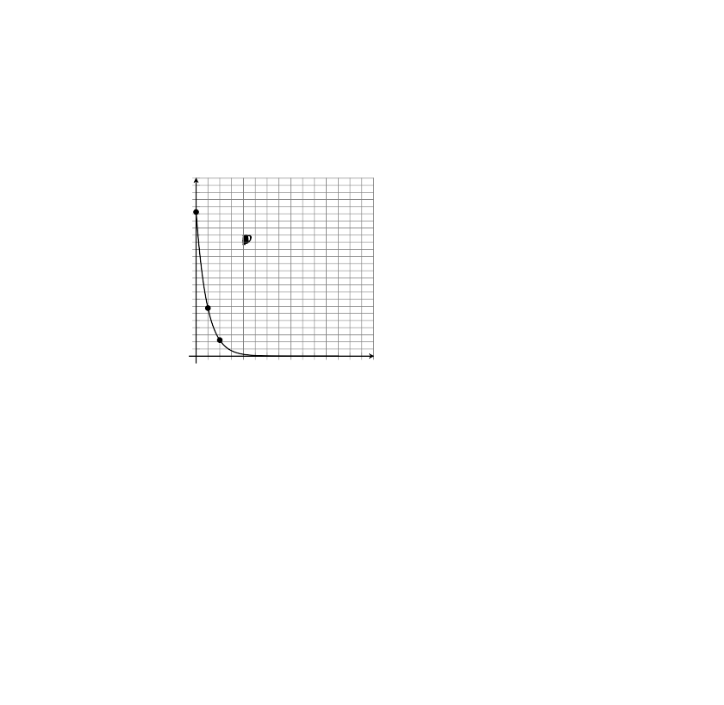
- Write an equation for Model A. Be prepared to explain how you know. Explain what the numbers mean in your equation.
- Model B is exponential.
  - How many errors did participants make with 0 hours of sleep?
  - How many errors with 1 hour of sleep?
  - What fraction of the errors from 0 hours of sleep is that?
- Complete the table for Model B for 3, 4, and 5 hours of sleep.
- $t$ | - 0 | - 1 | - 2 | - 3 | - 4 | - 5
- $n$ | - 81 | - 27 | - 9
- Which is an equation for Model B? If you get stuck, test some points!
$n=81−3t$
$n=81−\frac{1}{3}t$
$n=81⋅{\left(3\right)}^{t}$
$n=81⋅{\left(\frac{1}{3}\right)}^{t}$
© CC BY 2019 by Illustrative Mathematics®

