Lesson 13: Multi-step Measurement Problems with Fractions
- Let’s solve multi-step measurement problems.

Warm-up: True or False: Some Number Times a Fraction
Decide whether each statement is true or false. Be prepared to explain your reasoning.
- $16×\frac{1}{4}=4$
- $8×\frac{3}{4}=12$
- $32×\frac{2}{8}=8$
- $60×\frac{1}{12}=10$

13.1: Info Gap: Noah’s School Day (Part 1)
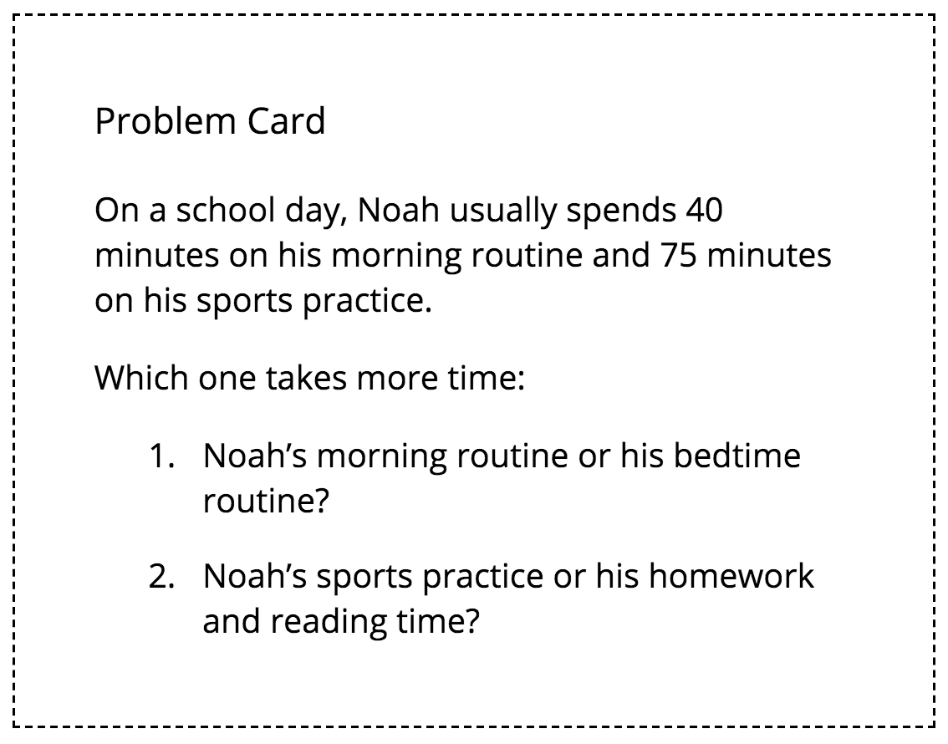

13.2: Info Gap: Noah’s School Day (Part 2)
Your teacher will give you either a problem card or a data card. Do not show or read your card to your partner.
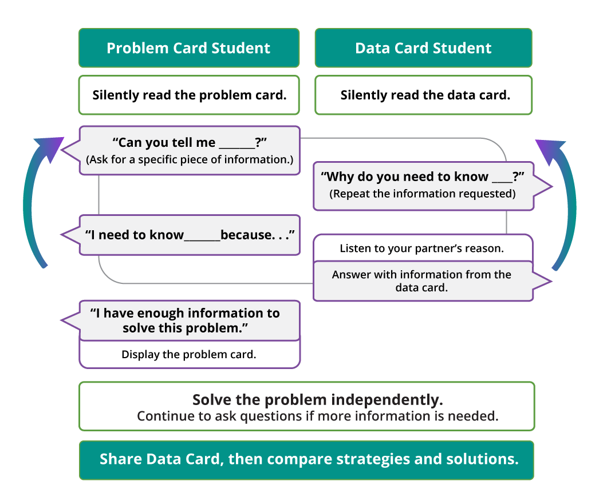
Pause here so your teacher can review your work.
Ask your teacher for a new set of cards and repeat the activity, trading roles with your partner.

13.3: Shopping List
Here are six ingredients that a shopper bought and some clues about each quantity.
The items are listed in order of weight, from least to greatest.
ingredient | pounds | ounces
rice noodles
shrimp
tapioca flour
tofu
carrots
brown rice
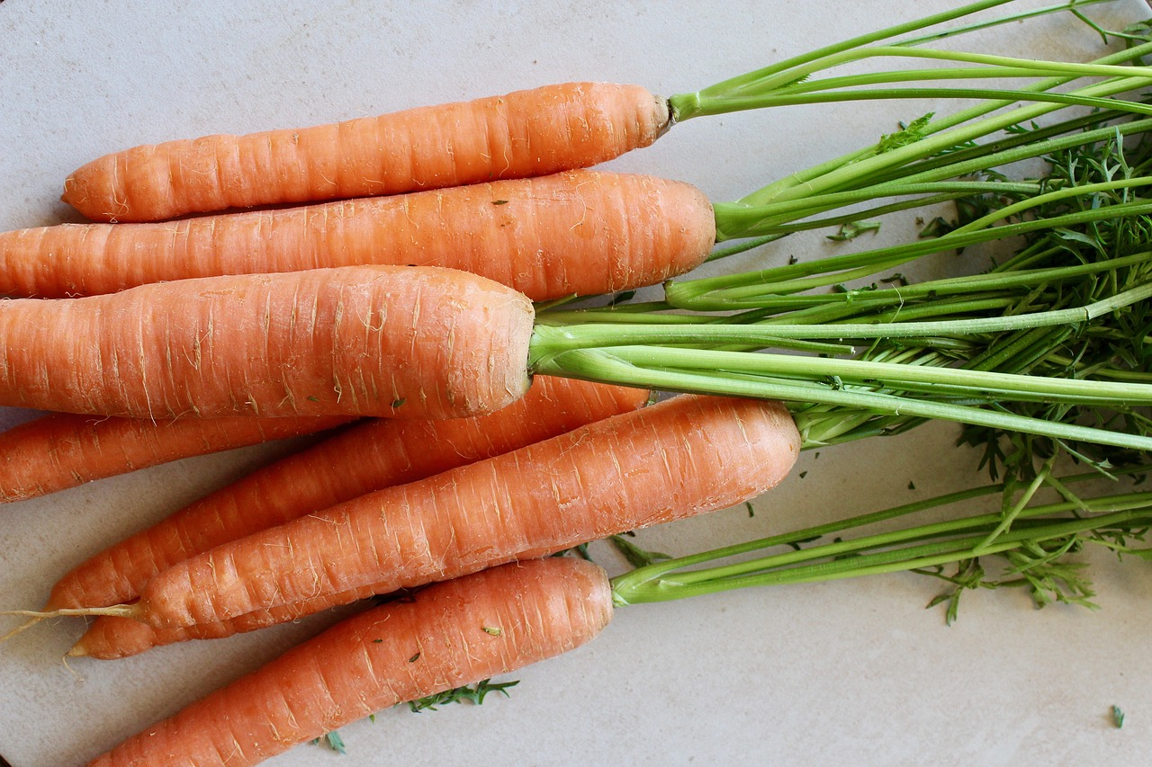
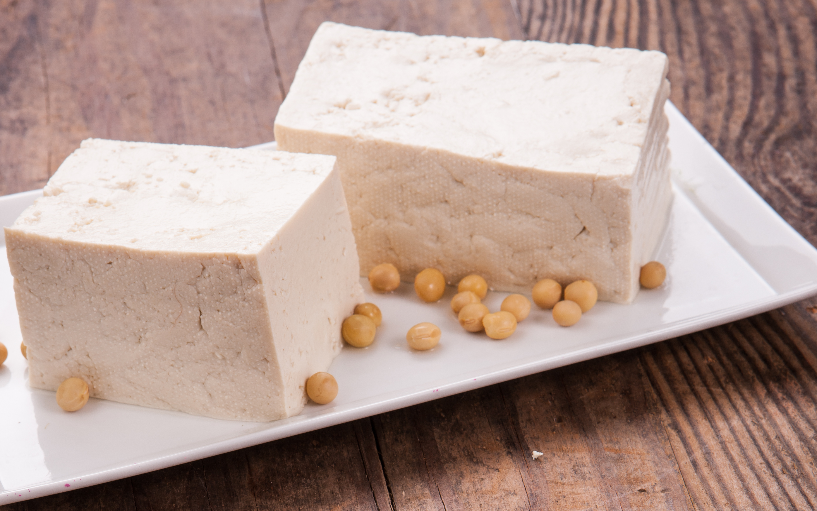
- The heaviest item weighs 4 times the weight of tofu.
- One ingredient weighs $\frac{1}{2}$ pound.
- The item that weighs 10 pounds is 10 times the weight of shrimp.
- The carrots are 3 times as heavy as the shrimp.
- The carrots are 2 times as heavy as the tapioca flour.
- Brown rice weighs 20 times as much as the weight of noodles.
Use the clues to find out the weight of each ingredient in both pounds and ounces.

Section Summary
Section Summary
In this section, we learned about various units for measuring length, distance, weight, capacity, and time. We saw how different units that measure the same property are related.
Here are the relationships that we saw:
- One meter (m) is 100 times as long as 1 centimeter (cm).
- One kilometer (km) is 1,000 times as long as 1 meter (m).
- One kilogram (kg) is 1,000 times as heavy as 1 gram (g).
- One liter (L) is 1,000 times as much as 1 milliliter (mL).
- One pound (lb) is 16 times as heavy as 1 ounce (oz).
- One hour is 60 times as long as 1 minute.
- One minute is 60 times as long as 1 second.
When given a measurement in one unit, we can find the value in another unit by reasoning and writing equations. For example, to express 5 kilograms in grams, we can write $5×1,​000=5,​000$. To express 4 pounds in ounces, we can write $4×16=64$.
Throughout the section, we used these relationships to convert measurements from one unit to another, to compare and order measurements, and to solve problems in different situations.
© CC BY 2021 Illustrative Mathematics®

