Unit 2 Lesson 11 Cumulative Practice Problems
- There is a proportional relationship between the number of months a person has had a streaming movie subscription and the total amount of money they have paid for the subscription. The cost for 6 months is $47.94. The point $(6,47.94)$ is shown on the graph below.
- 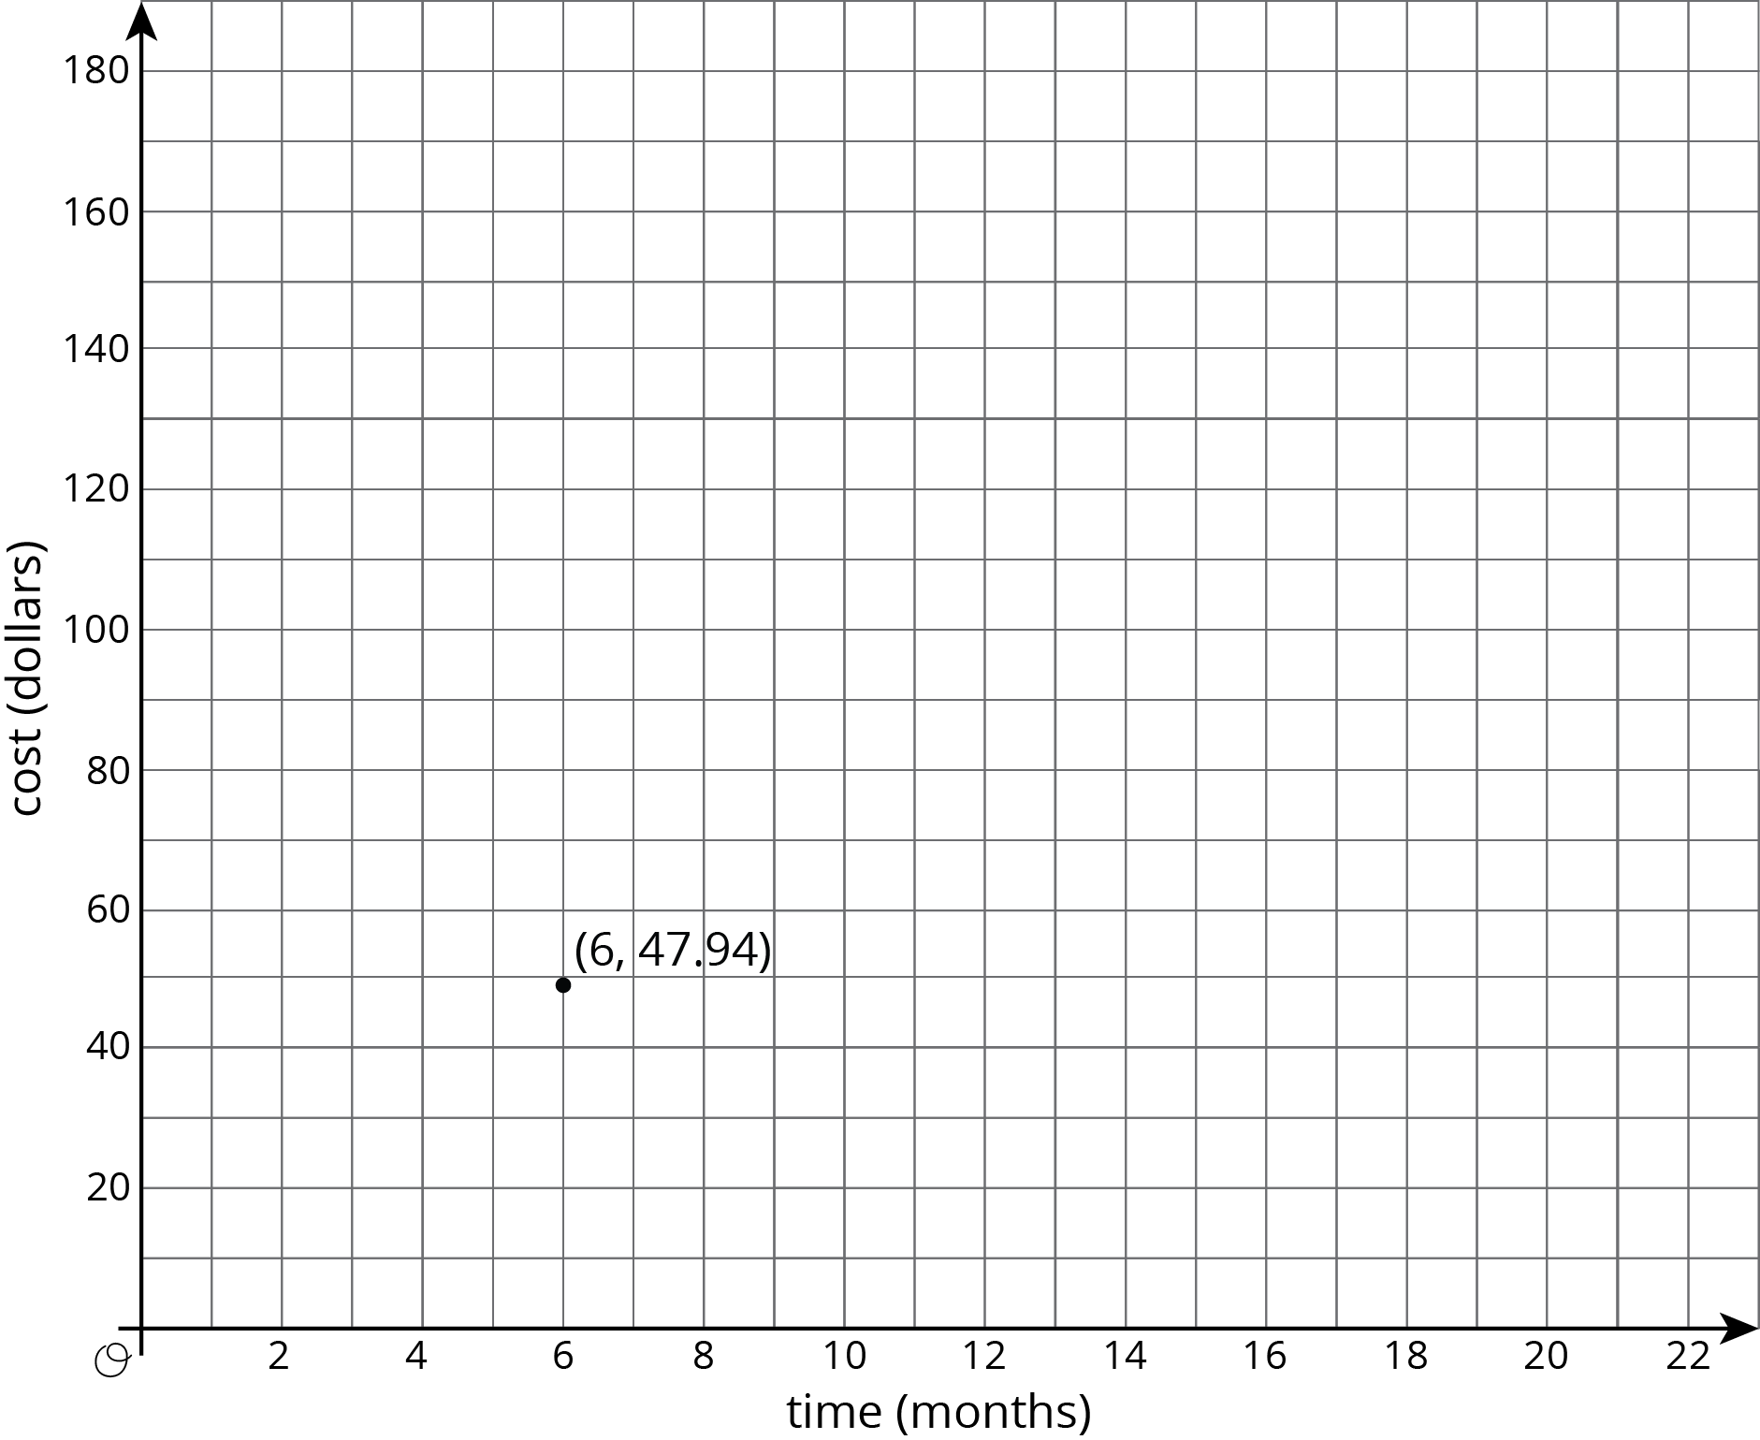
  - What is the constant of proportionality in this relationship?
  - What does the constant of proportionality tell us about the situation?
  - Add at least three more points to the graph and label them with their coordinates.
  - Write an equation that represents the relationship between $C$, the total cost of the subscription, and $m$, the number of months.
- The graph shows the amounts of almonds, in grams, for different amounts of oats, in cups, in a granola mix. Label the point $(1,k)$ on the graph, find the value of $k$, and explain its meaning.
- 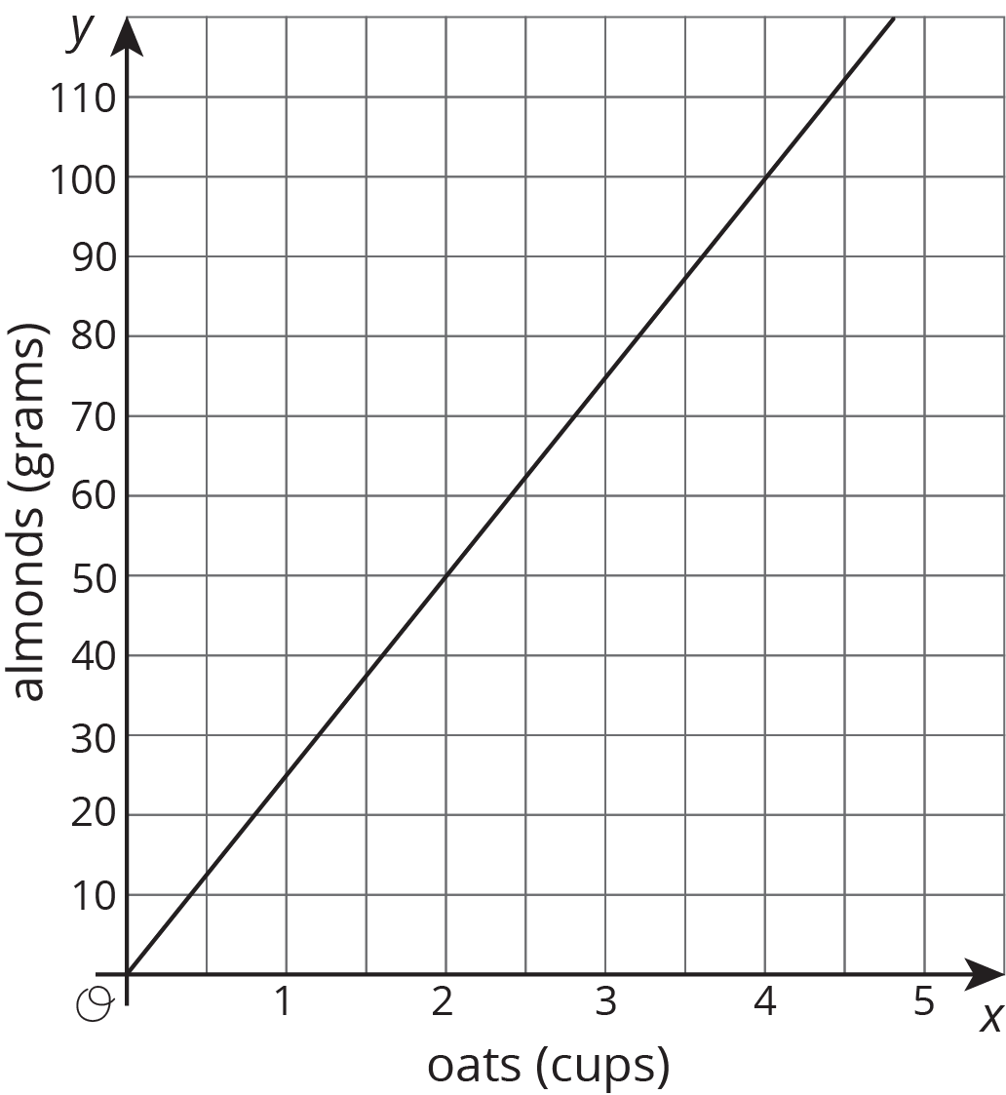

- To make a friendship bracelet, some long strings are lined up then taking one string and tying it in a knot with each of the other strings to create a row of knots. A new string is chosen and knotted with the all the other strings to create a second row. This process is repeated until there are enough rows to make a bracelet to fit around your friend's wrist.
- Are the number of knots proportional to the number of rows? Explain your reasoning.
- (From Unit 2, Lesson 9.)
- What information do you need to know to write an equation relating two quantities that have a proportional relationship?
- (From Unit 2, Lesson 9.)
© CC BY Open Up Resources. Adaptations CC BY IM.

