Unit 7 Lesson 13: Shapes and Play

WU Notice and Wonder: A Park (Warm up)

Student Task Statement
What do you notice? What do you wonder?
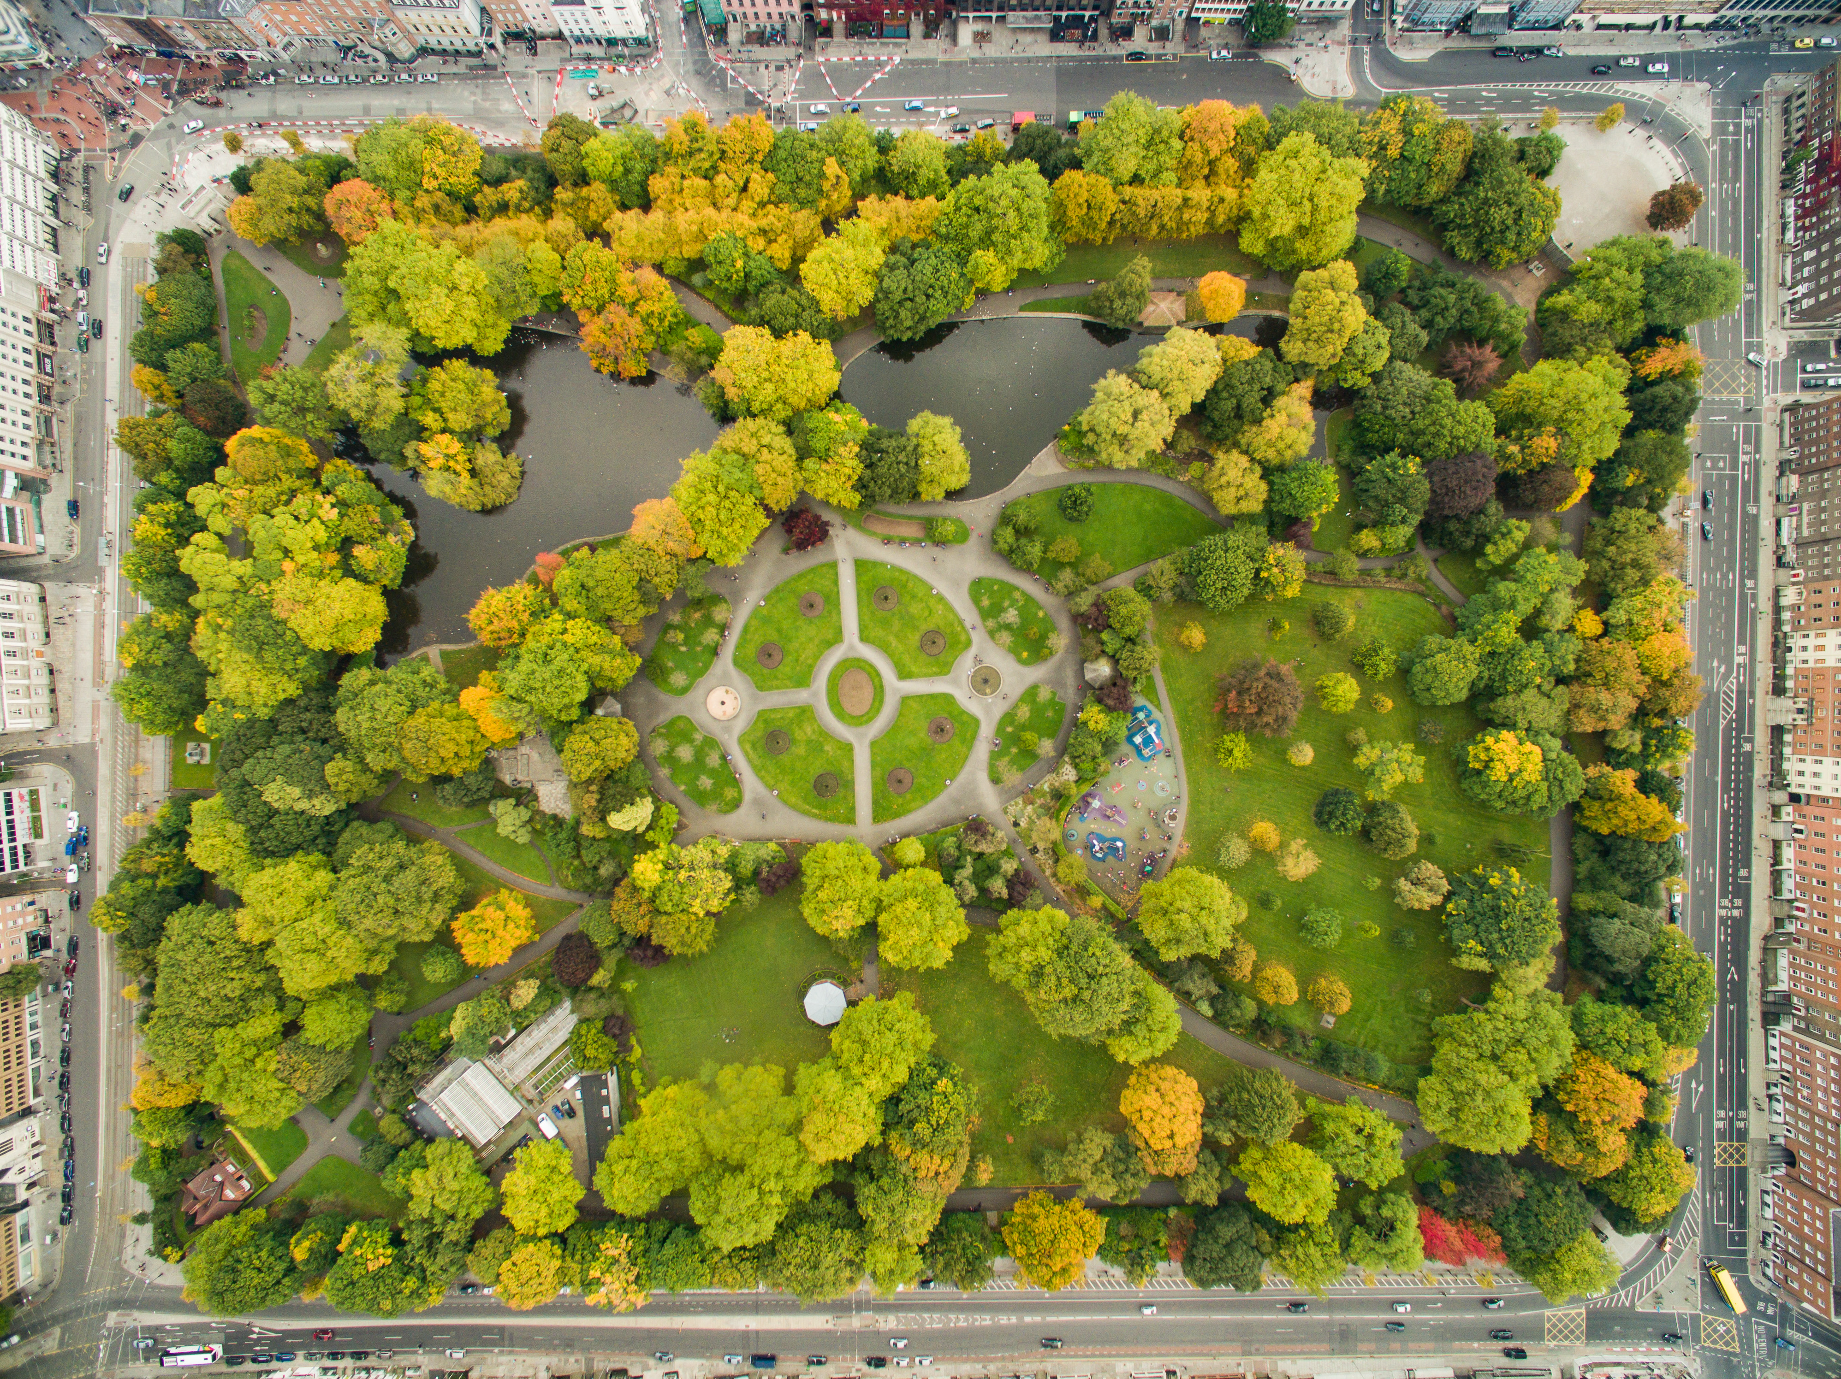

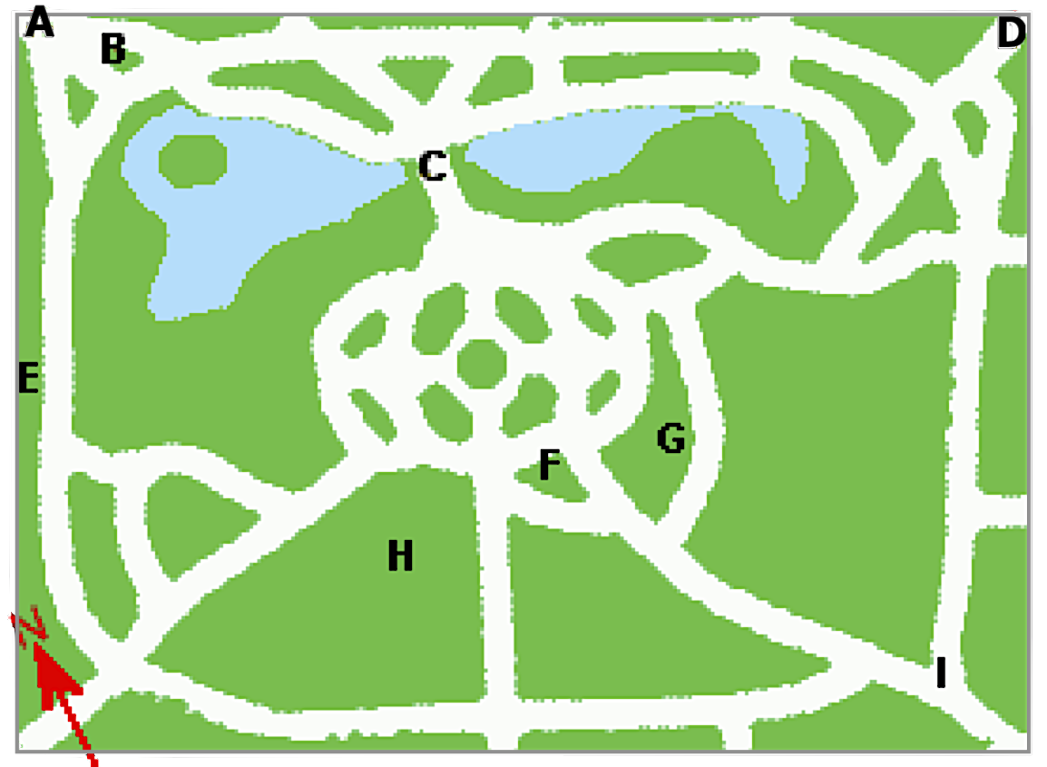

1 Design a Park

Student Task Statement
Your teacher will give you some dot paper for drawing.
- The distance from 1 dot to another horizontally or vertically represents 1 yard. Connect dots on the grid horizontally or vertically to design a small park that has 5 of these features:
  - basketball court
  - soccer goal
  - swings
  - a slide
  - an open area
  - picnic table
  - water play area
  - skate park
  - a feature of your choice
- Describe the area and the perimeter of 3 features in the park.

2 Park Problems

Student Task Statement
Solve each problem. Explain or show your reasoning.
- A rectangular playground is 6 yards by 14 yards.
  - How much fencing is needed to fence in the playground?
  - What is the area of the playground?
  - Give another pair of side lengths that would have the same perimeter, but a different area.
- A rectangular open area in a park is going to have an area of 48 square yards. Give 2 possible perimeters for the rectangular area.
© CC BY 2021 Illustrative Mathematics®

