Lesson 2: Growth Patterns
- Let’s explore growth patterns

2.1: How Big Can the Garden Be?
A homeowner wants to build a garden with concrete tiles around the outside. He has room for the garden to vary in length but not width. He’s not sure what size he wants the garden to be. Here are sketches of gardens that are 1, 2, and 3 meters long. The homeowner needs to know how many concrete tiles will be needed for different possible garden lengths.
- Create a table to show how many tiles will be needed if the garden is 1, 2, 3, 4, or 5 meters long.
- Describe the way the pattern is growing.

2.2: Representing Relationships
The equation $C=\frac{5}{9}\left(F−32\right)$ describes the relationship between Celsius and Fahrenheit temperatures.
- Describe the relationship in words.
- Complete the table showing corresponding temperatures in Celsius and Fahrenheit.
- Make a graph that represents the relationship.
- temperature in degrees Fahrenheit | - temperature in degrees Celsius
- 23
- 41
- 50
- 104
- 122
- 212
- 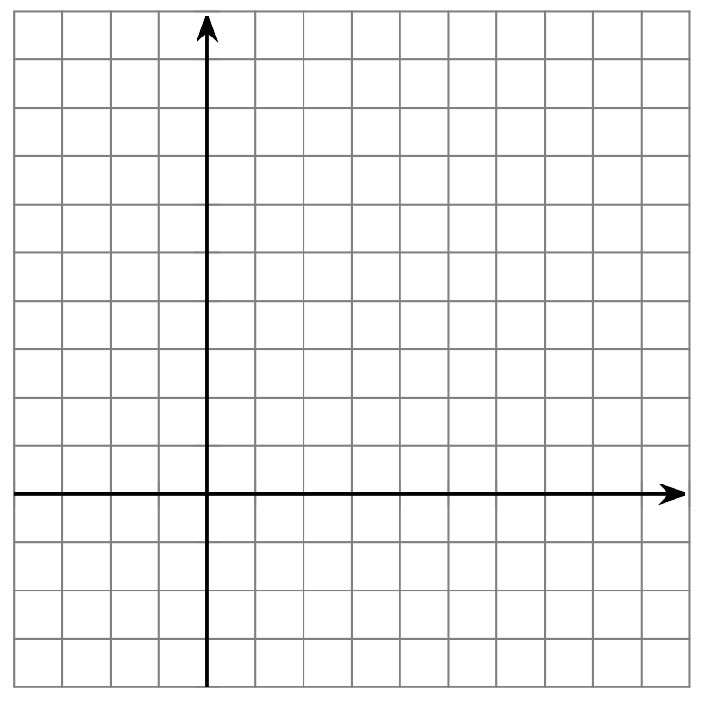
- Which representation would you use to answer each question (the equation, table, or graph)? Be prepared to explain your reasoning.
  - The temperature of an oven in Fahrenheit when it is set to ${100}^{∘}\text{ C}$.
  - You are in Canada and the forecast is ${30}^{∘}\text{C}$. Will it be cold, warm, or hot outside?
  - The outside temperature is $\text{-}4^{∘}\text{F}$. How would this temperature be reported in Celsius?

2.3: Whose Representation is That?
Your teacher will give you a set of cards. Each card has either a verbal description, a table, or a graph. Find the three cards that represent the same situation. If one of the three representations for a situation is missing, use the blank cards to create that representation.
© CC BY 2019 by Illustrative Mathematics®

